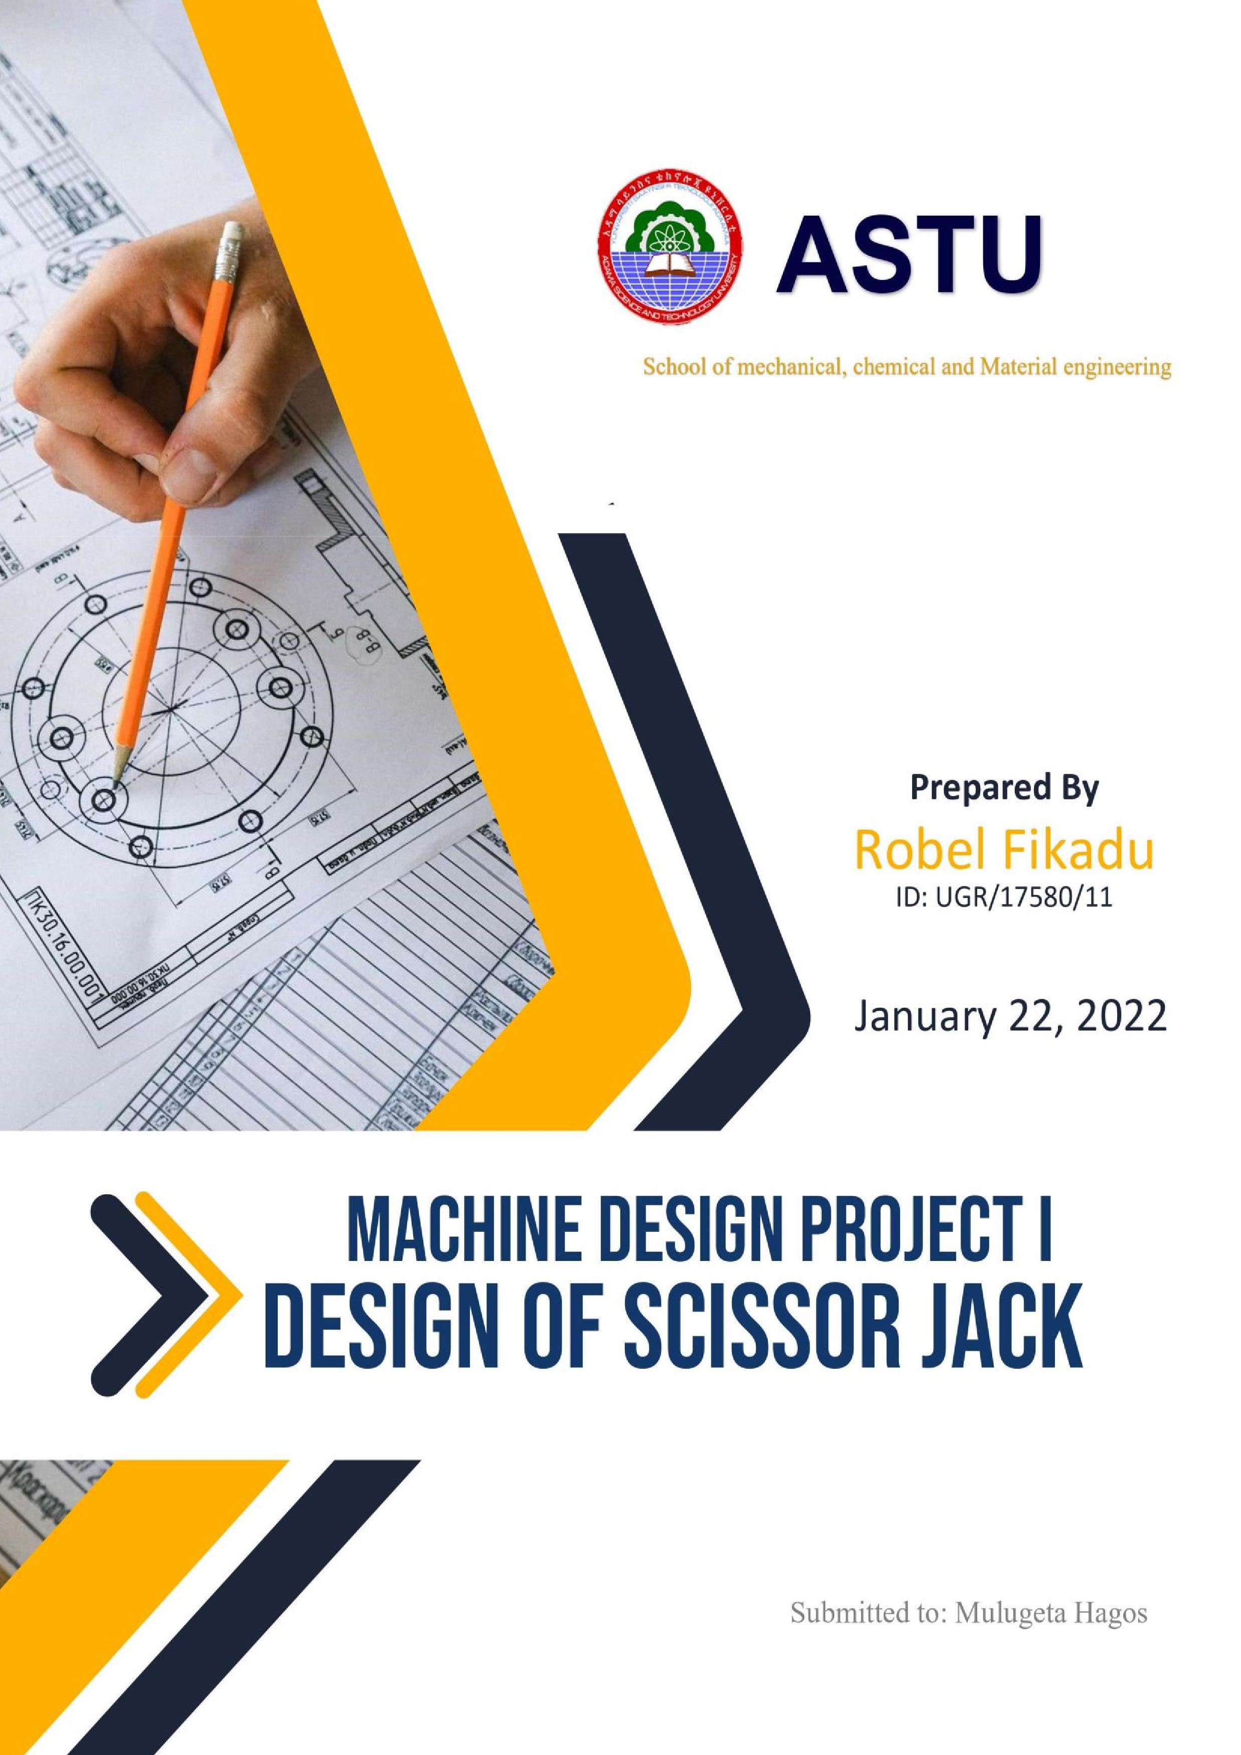

**D**

**fsdfsdfsdfsd**

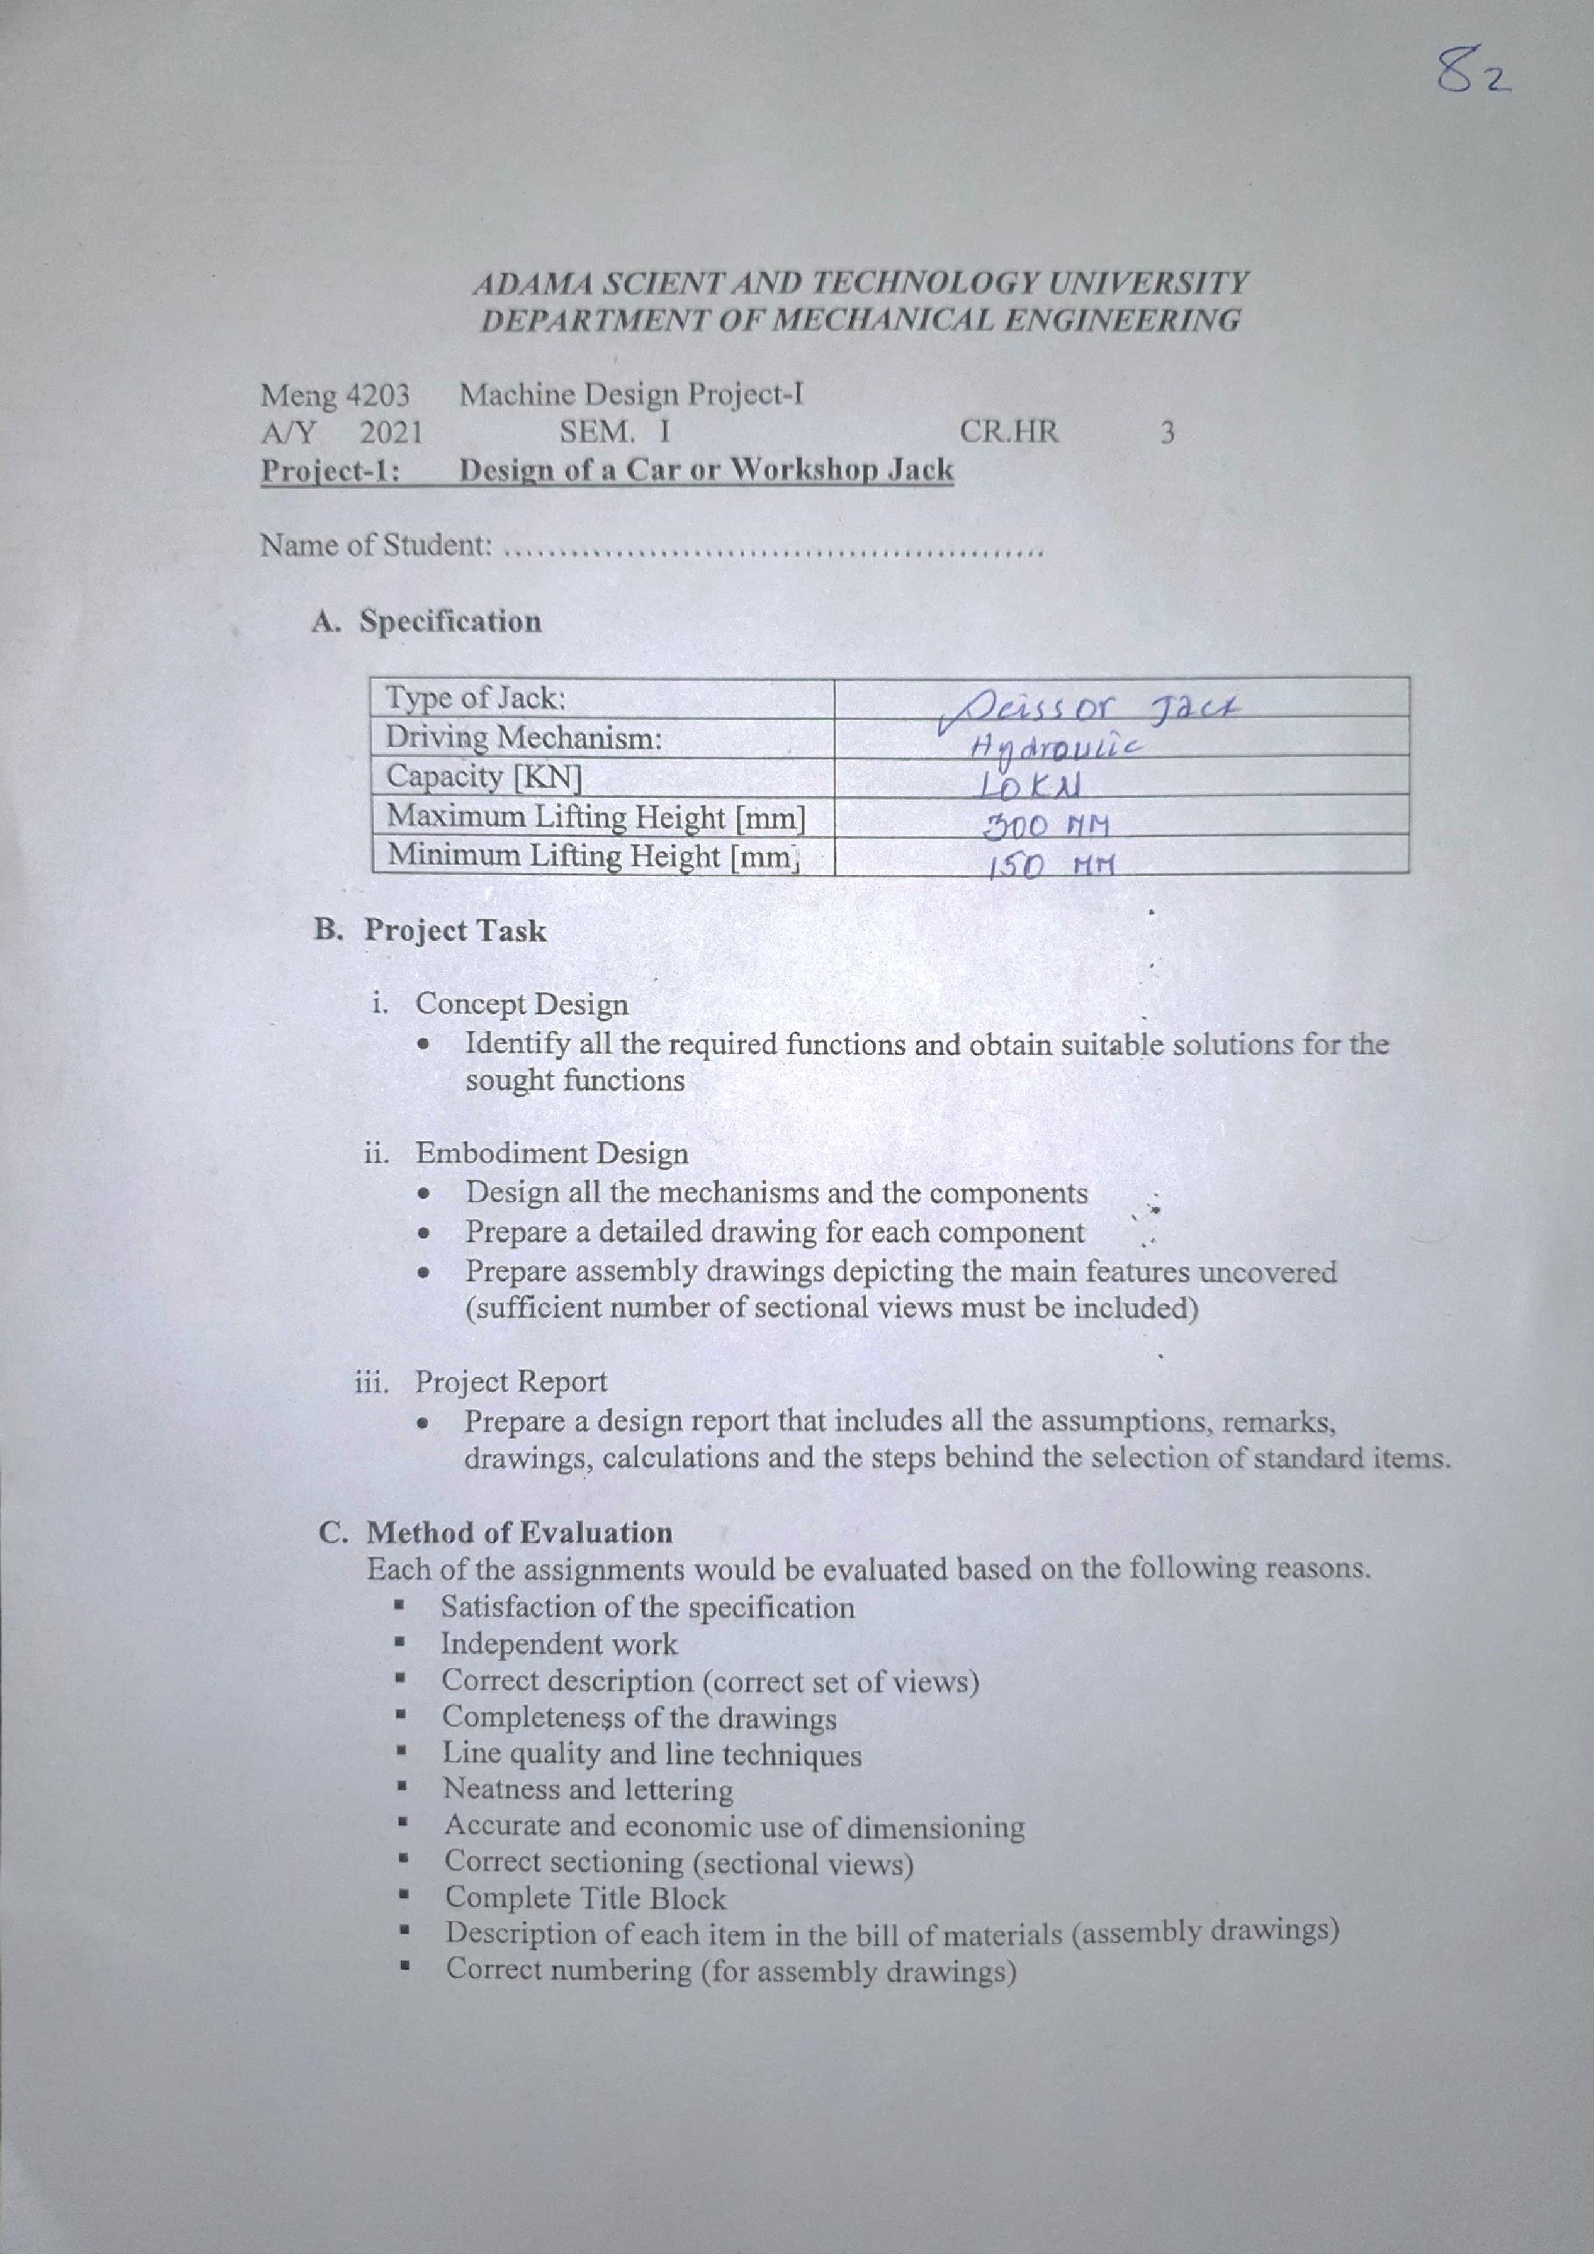

# Acknowledgement

Foremost, I would like to express my sincere gratitude to my advisor Mulugeta hagos for the continuous support of my machine design I project, for his patience, motivation, enthusiasm, and immense knowledge. His guidance helped me in all the time of research. I could not have imagined having a better advisor and mentor for my project.

Besides my advisor, I would like to thank my friends who has helped throughout the project when I had difficulties. And for their moral support.

# Abstract

This project is mainly focused on force acting on the hydraulic scissor lift when it is extended and contracted. Generally, a hydraulic scissor lift is used for lifting and holding heavy weight components. Material selection plays a key role in designing a machine and also influence on several factor such as durability, reliability, strength, resistance which finally leads to increase he life of scissor lift. The design is performed by considering hydraulic scissor lift as a portable, compact and much suitable for medium type of load application. Drafting & drawing of hydraulic system scissor lift is done using SOLIDWORKS and BLENDER Hence, the analysis of the scissor lift includes Total deformation load, Equivalent stress, was done by hand and all responsible parameters were analyzed in order to check the compatibility of the design value.

This design was based on hydraulic scissor jacks with the addition of four hydraulic cylinder that were added for use on non-flat surface and in slope floors. Which reduce the risk of slippage of the jack its self or the wabble that may happen on an even surface.

**Table of contents**

Contents

Acknowledgement ii

Abstract iii

Chapter 1 1

1.1 INTRODUCTION 1

1.2 Background 1

1.3 OBJECTIVE 2

1.3.1 General objective 2

1.3.1 Specific objective 2

1.4 Problem statement 2

Chapter 2 3

2.1 Introduction 4

2.2 RELATED WORKS 4

Chapter 3 6

2.1-Dimensional analysis of the arm length 6

2.2 Dimensional analysis of the plate width 9

CHAPTER 4 11

12

Design of upper plate 12

4.1.1 12

orce analysis 12

4.1.2 Stress analysis 13

4.1.3 Safety factor allocation 14

4.1.4 Material Selection 14

4.2.2 Stress alaysis 19

4.2.5 Manufacturing 22

4.3.2 Stress analysis 24

4.3.3 Safety factor 25

4.3.4 Material selection 25

4.3.5 Manufacturing 26

4.4.5 Manufacturing 30

4.5.3 Safety factor 34

4.5.4 Material selection 34

4.5.5 Manufacturing 35

4.6.3 Safety factor 39

4.6.4 Manufacturing 40

4.7.2 Stress analysis 42

4.7.3Factory of safety 42

4.7.4 Material selection 42

4.8.3 Safety factor allocation 46

4.8.4 Material selection 46

4.8.5 Manufacturing 47

4.9 Design of spring 48

4.9.2 Stress analysis 49

4.9.3 Factor of safety 50

4.9.4 Material selection 50

4.10.1 Force analysis 56

4.10.2 Stress analysis 56

4.10.5 Manufacturing 60

4.11.5 Manufacturing 63

4.12.1 Force analysis 64

4.12.2 Stress analysis 66

4.12.5 Manufacturing 67

4.14 Design of Roller 75

4.14.1 Force analysis 75

4.14.2 Stress analysis 75

4.14.3 Factor of safety 76

4.15.4 Material selection 80

4.15.5 Manufacturing 80

4.16.2 Stress analysis 83

4.16.3 Safety factor 87

4.16.4 Material selection 87

4.18.1 Force analysis 96

4.18.5 Manufacturing 99

4.19.2 Stress analysis 101

4.19.3Factory of safety 101

Chapter 6 120

Conclusion 123

Reference 124

Code for dimensional analysis 125

**TABLE OF FIGURE**

Figure 1 Scissor........................................................................................................................................................ 8

Figure 2 Length analysis .......................................................................................................................................... 9

Figure 3 Base plate analysis ................................................................................................................................... 12

Figure 4 Arm force analysis ................................................................................................................................... 14

Figure 5 Moment diagram ..................................................................................................................................... 16

Figure 6 Arm reaction force ................................................................................................................................... 17

Figure 7 Arm analysis a ......................................................................................................................................... 18

Figure 8 arm analysis b .......................................................................................................................................... 18

Figure 9 Stress analysis of arm .............................................................................................................................. 19

Figure 10 Pin reaction ............................................................................................................................................ 22

Figure 11 Handle force analysis............................................................................................................................. 25

Figure 12 Pump hydrulic principle ........................................................................................................................ 25

Figure 13 Stress analysis of cylinder ..................................................................................................................... 27

Figure 14 Ram cylinder ......................................................................................................................................... 31

Figure 15 Ram cylinder analysis ........................................................................................................................... 31

Figure 16 Piston rod analysis ................................................................................................................................. 35

Figure 17 Ram piston rod analysis ........................................................................................................................ 38

Figure 18 Resrvour analysis .................................................................................................................................. 41

Figure 19 Spring analysis ...................................................................................................................................... 44

Figure 20 Valve...................................................................................................................................................... 48

Figure 21 Bolt and nut analysis ............................................................................................................................. 52

Figure 22 Hydraulic system base ........................................................................................................................... 55

Figure 23 Base plate analysis ................................................................................................................................. 58

Figure 24 Handle analysis ...................................................................................................................................... 64

Figure 25 Leg cylinder analysis ............................................................................................................................. 67

Figure 26 Leg ram support analysis ....................................................................................................................... 72

Figure 27 Plunger piston rod ................................................................................................................................. 76

Figure 28 Leg ram piston reaction force ................................................................................................................ 79

# Chapter 1

## 1.1 INTRODUCTION

A scissor lift or mechanism is a device used to extend or position a platform by mechanical means. The term ―scissor comes from the mechanic which has folding supports in crisscross ―X‖ pattern. The extension or displacement motion is achieved by the application of force to one or more supports, resulting in an elongation of the cross pattern. The force applied to extend the scissors mechanism may by hydraulic, pneumatic or mechanical (via a lead screw or rack and pinion system). The need for the use of lift is very paramount and it runs across labs, workshops, factories, residential/commercial buildings to repair street lights, fixing of bill boards, electric bulbs etc. expanded and less-efficient, the engineers may run into one or more problems when in use. Before this time scissors lift existing use mechanical or hydraulic system powered by batteries for its operations. Several challenges were encountered in this very design. Some amongst many include; low efficiency, risk of having the batteries discharged during an emergency, extended time of operation, dependent operation, as well as maintenance cost. It is the consideration of these factors that initiated the idea of producing this hydraulically powered scissors lift with independent operator. The idea is geared towards producing a scissors lift using one hydraulic ram placed across flat, in between two cross frames and powered by a pump connected to a motor wheel may be powered by a pump generator. Also, the individual ascending / descending is still the same person controlling it. I.e., the control station will be located on the bottom frame. A scissors lift is attached to a piece of equipment having a work station known as scissors lift table that houses the pump, the reservoir,the generator, control valves and connections and the motor. A scissors lift does not go as high as a boom lift; it sacrifices heights for a large work station. Where more height is needed, a boom lift can be used

## 1.2 Background

Jack is a mechanical device used to lift heavy loads or apply great forces. A mechanical jack employs a square thread for lifting heavy equipment. The most common form of jack is a car jack, floor jack or garage jack which lifts vehicles so that maintenance can be performed. Mechanical jacks are usually rated for a maximum lifting capacity (for example 1.5 tons to 3tons).

Lifting jacks are used for leveling or positioning heavy equipment, lifting automobiles and for supporting structures. They typically use screw or cylinder-based actuators and are powered by hydraulic, mechanical, electric, or manual methods. The lifting element is described as either a shoe or a saddle. A shoe is usually specially designed to match a lifting point while a saddle is a plate that is made to lift on many places.

Lifting jacks are a basic tool of industry and are especially common in automotive applications. Lifting a car with its stock lifting jack to change a tire is the most common application.

Other uses include:

* Raising and leveling steel girders on their footings or vertical columns
* Leveling and positioning heavy machinery in a machine shop or manufacturing facility
* Lifting and positioning heavy pieces of metal stock or other materials

|  |  |
| --- | --- |
| Task | Method |
| Dimensional analysis | Python programing |
| Force and stress analysis | By hand calculation |
| Safety factor and material selection | Personal judgment |
| 3D modeling | Solidworks |
| Rendering | Blender |

There are multitudes of uses where heavy objects have to be raised using some basic mechanic principle such as hydraulic, pneumatic, inclined plane or mechanical screw. This is where long distance acting on a light force translates into lifting up a heavy force up a short distance.

## 1.3 OBJECTIVE

### 1.3.1 General objective

The general objective of our project is to design the hydraulic scissors jack to lift from the Hight from160 millimeter up to a height of 450 millimeters and with the carrying capacity of 7.5 KN. The driving mechanism of the lift must be a mechanical hydraulic cylinder. Calculations of the inner stresses must be done and a 3D model must be created. It is also necessary to choose the material.

### 1.3.1 Specific objective

One of the main limitations of scissor lift is it has can only work on level and flat surface only. So, I have decided to use small hydraulic legs to contract the unevenness of the surface

## 1.4 Problem statement

Most cars now days were equipped with the hydraulic scissor jack. We found that the scissor jack was very difficult to be used because this type of jack needed more strength and energy to operate this jack by hydraulic. Thus, we want to develop a product based from the problem faced by the users who drive a car regarding to this issue. To overcome this problem, research has been conducted to find the solution on how to design a hydraulic scissor jack for the car using the simplest and cheapest way while it is energy saved. Hydraulic scissor jack present difficulties for the elderly, women and are especially.

Disadvantageous under adverse weather conditions. Furthermore, require the operator to remain in prolonged bent or squatting position to operate the jack. Doing work in a bent or squatting position for a period of time is not ergonomic to human body. It will give back problem in due of time. This is for the safety precaution in case if the screw broke. Furthermore, available jacks are typically large, heavy and also difficult to store, transport, carry or move into the proper position under an automobile. Suppose car jacks must be easy to use for pregnant women or whoever

design of hydraulic scissor lift components. It can lift up 300kg of load with a raise of 3.5ft. The main aim of this research paper is to study the hydraulic scissor lift also design and fabrication of hydraulic scissor lift. In this case, lift has to be movable and portable so rollers or wheels are provided for motion at the bottom side of the lift and also, we can’t use electric power in this lift so they use a hydraulic pump. Hydraulic generate more and accurate pressure. By use of this mechanism and design hydraulic lift became more efficient and can operate in industries. The purpose of this research is to use all components effectively gives good results.

1.5 methodology

# Chapter 2

## 2.1 Introduction

Every mechanical machine has always been in need of development. The world has become dynamic as a result of the push for better and larger scientific and technical outcomes. Several scientists and engineers have previously worked extensively on the scissors lift in general. A look at part of that work shows how to design and build a hydraulic scissors lift platform.

**2.1.1Upright’s Scissor Lift:**

A manufacturer of aerial platforms by the name of "UPRIGHT" is based in Selma, California. This global firm was created in 1946 and today manufactures and distributes its product. Upright was formed by an engineer, Walkce Johnson, who designed and sold the first platform, which was dubbed a "scissors lift" due to the steel cross bricking that supported it, and was dubbed a "magic carpet" because of the steel cross bricking that supported it. Due to its rapid popularity among its companies, the magic carpet was able to offer the small company with immediate money.

Wikipedia further explained that the company constructed innovating and by early 1930s their product included the X – series scissors lift. By 1986, they had introduced their first sigma armlift, model SL20. In 1990, they improved upon their product line by introducing the sigma arm speed level. This feature continued to be unique to be upright product and allow self-leveling ofthe platform on rough terrains. Upright introduced an equal innovative family of boom lift in 1990s. In 1995 they produced their first trailer mounted boom. The 8P37 (known as AS38) in 1996. This truly innovated company has left their mark with the other products including compact scissors design and modular alloy bridging, as well as 7 expanding the versatility of instant span towers with aircraft docking and faced system, you will find upright products, especially the scissors lift, as standard equipment for a variety of application it is now a visual application in numerous fields and locations.

### 2.2 RELATED WORKS

**Wubshet Yimer, et al** made a conclusion in this paper that the design and fabrication of a portable work platform of the lift which is elevated by one hydraulic cylinder were carried out effectively and meeting the necessary design criteria. The double type of scissors lift is elevated by one hydraulic cylinder and it is operated by the foot pedal. This scissor lift is design for average load purposes, because the higher the load more the effort required for raising the load from ground level. The hydraulic scissor lift is easy to use and does not require continuous repairs and maintenance. It can also lift heavier loads. For the given dimensions of the scissor lift can raise a load up to 280 kg up to the height of 1000mm. Hence, its extensive application in industries, hydraulic pressure system, for the lifting of a vehicle in garages, maintenance of huge machines, and for staking purpose.

Gaffar G Momin, et al found that design as well as analysis of a hydraulic scissor lift.

Conventionally a scissor lift or jack is employed for lifting a vehicle to change a tire, to gain

access to travel to the underside of the vehicle, to lift the body of the vehicle to appropriate height, and lots of other applications also such lifts can be used for various purposes like maintenance and many material handling operations. The lift can be of mechanical, pneumatic, hydraulic type. The design of the lift described within the paper is developed in such a way that the lift is operated by mechanically means by using a pantograph such that the overall cost of the scissor lift is reduced to some extent. In our case, we required the lift is portable and also works without consuming any electric power source so they decided to use a hydraulic handpump to power the hydraulic cylinder Also a such design can make the lift more compact and much suitable for medium scale work. Finally, the analysis of the scissor lift was done in ANSYS and also all responsible parameters were analyzed to check the design of the lift.

**N. Pandit, et** al studied the design, analysis, and safety requirements of the scissor lift. It is a versatile material handling equipment that can use hydraulic, pneumatic, or mechanical energy as input for its working. For designing, forces can be calculated by considering the equilibrium of the system at both the positions, closed and open. The various attachments can be added to the equipment which ensures the safety of the worker operating it and gives the guidelines for handling the unit.

**Uttam Panwar,** et al stated that operating mechanism and study of hydraulic lift. This research paper solves material handling and provides comfort to the operator. This paper shows the study and also, the design of hydraulic scissor lift components. It can lift up 300kg of load with a raise of 3.5ft. The main aim of this research paper is to study the hydraulic scissor lift also design and fabrication of hydraulic scissor lift. In this case, lift has to be movable and portable so rollers or wheels are provided for motion at the bottom side of the lift and also, we can’t use electric power in this lift so they use a hydraulic pump. Hydraulic generate more and accurate pressure. By use of this mechanism and design hydraulic lift became more efficient and can operate in industries.The purpose of this research is to use all components effectively gives good results.

# Chapter 3

## 2.1-Dimensional analysis of the arm length

* Dimensional analysis is the method to know the dimension of the object or parts designed so we can determine the arm length and the formed during the scissor at its initial (minimum position) and its final (maximum position)
* Dimensional analysis must be considering the capacity of load carrier or he applied on the scissor arm to design
* The length of the scissor arm is calculated regarding to the given maximum and minimum lifting Hight
* The angle formed while the scissor up and down must be adjusted regarding to the dimension given for the maximum and minimum Hight
* I have used “θ” for minimum height and “β”maximum Hight
* To find the arm length of the scissor, using the height given
  + - Maximum lifting height =160
    - Minimum lifting height=450
* We can calculate the length of the arm at two positions
  + - * When the jack is raised (Hmax)
      * When the jack is retracted (Hmin)

*Figure 1 scissor*

Hmin=160

HMax=450

* To find the arm length we have to consider that the thickness of the top and bottom plate and the hydraulic leg that will be used to support the when it is seated on non-flat surface.
* Let’s assume the thickness of the top and bottom plate (T) is 20mm and the hydatic support legs(l) are 20mm

L

H

net 1

θ

* Then the net length of the scissor that will be depend of the arm (Hnet 1) when the arm is on retracted state, (Hnet 2) when the lift is on the top most raised state

Hnet 1= Hmin - (thickness of top and bottom plate +hydraulic leg support)

Hnet 1= Hmin-2T-l

Hnet 1= 160-2(20)-20

Hnet 1 = 100mm

Hnet 2= Hmax - (thickness of top and bottom plate +hydraulic leg support)

Hnet 2= Hmax -2T-l

Hnet 2 = 450-2(20)-20

Hnet 2 =390mm

* Then we can determine the arm length by using right angle triangle as shown in figure below, and iterating the angle when retracted (θ) and a find the length and check for the angle when raised (β) and the values is between the limit given for the angles
  + - * 5 <= θ<=35
      * 45<= β<=85

*Figure 2 length analysis*

𝑠𝑖𝑛𝜃 = Hnet 1

L

𝐿 = Hnet 1 sinθ

Β = sin−1 Hnet 2

L

* I have developed a code using C++ to find the value of arm length(L) and angle when raised (β) which is attached with this paper. The result of the code is in a table below

Arm Angle when retracted (θ) Angle when raised (β) length

338.911 15.4 45.0846

334.672 15.6 45.8172

330.542 15.8 46.5588

326.516 16 47.31

322.591 16.2 48.0712

318.763 16.4 48.8431

315.029 16.6 49.6263

311.384 16.8 50.4214

307.827 17 51.2293

304.354 17.2 52.0507

300.962 17.4 52.8865

297.649 17.6 53.7379

294.411 17.8 54.6059

291.246 18 55.4918

288.152 18.2 56.3971

285.127 18.4 57.3233

282.168 18.6 58.2724

279.273 18.8 59.2465

276.44 19 60.248

273.667 19.2 61.2799

270.953 19.4 62.3456

268.295 19.6 63.4491

265.692 19.8 64.5954

263.142 20 65.7907

260.644 20.2 67.0426

258.196 20.4 68.3609

255.797 20.6 69.7588

253.445 20.8 71.2539

251.139 21 72.8717

248.877 21.2 74.6511

246.659 21.4 76.6567

|  |  |  |
| --- | --- | --- |
| 244.483 | 21.6 | 79.0115 |
| 242.347 | 21.8 | 82.019 |
|  |  |  |

* Form the iteration I did on C++ I chose the L, θ, β at which the scissor lift will operate on, this are the values of the length in the given limit.
  + - * length of the arm L=276.44
      * minimum angle θ=19
      * maximum angle β= 60.28
* I have selected these values from the iteration because they are appropriate because the value should be higher than 240 which is the vertical height since this the scissor are slanted, they have to be longer than the vertical height. I have to pick values as small as possible being higher than the vertical height with in the angle limit to minimize material usage.

Now let’s check by using the values I have selected that it go down to the minimum height

Hnet 1

𝑠𝑖𝑛𝜃 = L

𝐻𝑛𝑒𝑡 1 = sin 𝜃 𝑥 𝐿

= sin (19) X276.44 =90mm

let’s check by using the values I have selected can raise the lift to maximum height

Hnet2

𝑠𝑖𝑛𝛽 = L

𝐻𝑛𝑒𝑡 2 = sin 𝛽 𝑥 𝐿

= sin (60.44) X276.44= 240mm

• Since the values we have selected does fit the requirement to the minimum and maximum height we will progress with those values from now on,

## 2.2 Dimensional analysis of the plate width

Let’s assume the length of the plate is b and the thickness of the plate is t b

t

➢ By using right hand triangle, we can calculate the length of the upper plate at the minimum height

L

𝜃

b

*Figure*

*3*

*base plate analysis*

b=2

76.44

*cos (

19

)

b=2

61.37

mm

H

net2

H

net1

𝜃

𝛽

L

L

x

𝐿 = 276.44 & θ = 19

Cos 𝜃 = 𝑏

𝐿

Sliding length (Ls) = b-x Cos (𝛽)=𝑥 , X=Cos (𝛽)*L

𝑙

X=cos (60.28) x 276.44 =137

Ls=L-X

= 261.37-137= 124.37

# CHAPTER 4

## 

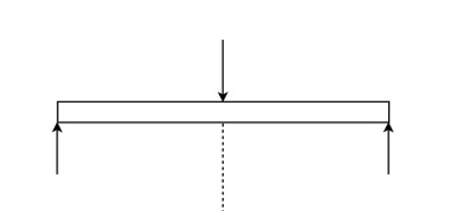

3.75

KN

7.5

K

N

3.75

KN

*Figure*

*4*

*arm force analysis*

**4.1**

## Design of upper plate

Upper plate

-

is a part of the jack which is attached to the top side of arm and which comes in

contact with the object that have to be lifted.

We can also call this one carrier of the weight/load

## 4.1.1

**f**

## orce analysis

The free body diagram of the plate of the upper plate

Where:

F

1

and F

2

are reaction force

P

-

maximum load applied to the jack

P=7.5kn

From dimensional analysis we have

T= 20mm

W=

mm

261.37

which is equal to l

From equilibrium, equation we have

∑

𝐹

𝑌

=

0

F

1

+

F

2

+

P= 0

𝑋

=

0

which is zero since there is no horizontal component force applied

𝑀

𝐴

=0

F

2

(225.23)

-

P

(

/

225.23

2)

=

0

F

2

=

7.5

(

261

.

37

2

)

261

.

37

F

2

3.75KN

=

F

1

+

F

2

=

P

F

1

KN

=3.75

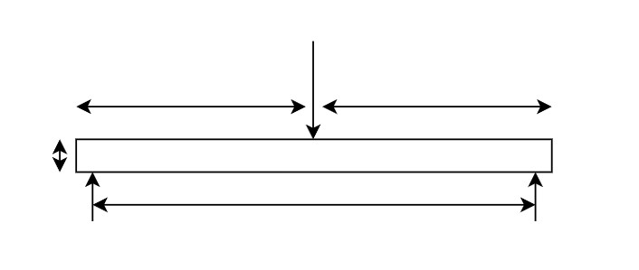

A

B

P

𝑙

2

𝑙

2

l

F

1

F

2

∑ 𝐹 F1= P-F2 = 10KN-5KN= 5KN F2 = 5KN

## 4.1.2 Stress analysis

Stress action on the upper plate is bending stress because when it is lifting the load it forms a bending stress due to the bending moment that is applied on the plate.

Therefore

𝑀𝑚𝑎𝑥 , where 𝜎𝑏- the bending stress 𝜎𝑏 = 𝑧

Mmax- bending moment

Z- section modulus

Maximum moment occurs at a point where the load p is applied

It occurs when shear stress is equal to zero

3

𝑀𝑚𝑎𝑥 = 𝑃𝐿4 =

Mmax= 653,425Nmm

Section modulus is calculated as follows

𝑏

𝑧= 𝐼 = = 𝑏 3 × = 𝑏 2

12

ℎ

2

ℎ

𝑐 2 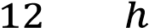 

𝑏2

𝑧= where b=261.37mm

H=t= 20mm

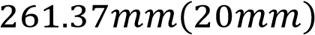2

𝑧=

Z= 17,424.66mm3

The bending stress is calculated as

𝜎𝑏 = 𝑀𝑚𝑧𝑎𝑥 =𝑁𝑚𝑚

𝜎𝑏 = 35.5𝑁𝑚𝑚2 = 35.5 Mpa

𝜎𝑏 = 35.5 𝑀𝑝𝑎

The shear and bending moment diagram are shown below

Free body diagram

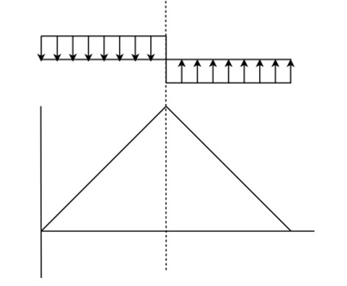

3.75

KN

+

ve

-

ve

3.75

KN

Shear force diagram

Bending moment diagram

*Figure 5 moment diagram*

## 4.1.3 Safety factor allocation

I choose safety factor of 4 (F.S=4 because N=4

* Top plate is under bending stress which make the top plate bend
* If the plate fails a lot of damages may occurs like the damage on the material we are trying to lift to.

* If this plate fails it means the entire lift has failed because this is the part that

comes in contact with load

* Failure of the plate could even cause death so, I had to pick higher safety factor

## 4.1.4 Material Selection

As we have discussed above there is a bending moment on the top plate which is caused by the

weight of the load so the in this section the most important property for our material is high strength.

So, material like stainless steel, mild steel and titanium can be used they fit the required strength being moderately light weight

Since the price of titanium is so high $35-50 per kg compared to stainless steel $1-1.50 and stainless steel $0.6-1, we want the jack to be affordable so we won’t use titanium is this design.

The manufacturing of stainless steel is very hard which requires and 10-12 hours of heating for Mild steel the forming process.

So, I have picked mild steel which has the following characteristics affordability, weldability, and machinability.

**4.1.4**

**Manufacturing**

Mild steel is made similar to how other carbon steels are made. A common way this is done in-

volves a combination of iron ore and coal. Once the coal and iron ore are extracted from the

earth, they are melted together in

a blast furnace. Once melted, the

mixture is moved to

another

furnace to burn off any impurities that they may have, as well as to make any other adjustments

to the mild steel’s chemical composition. Following that, the steel is allowed to solidify into

a

rectangular shape. This slab of mild steel is then usually brought down to the desired size using

processes called

[hot rollin](https://www.metalsupermarkets.com/metals/hot-rolled-steel/)

[g](https://www.metalsupermarkets.com/metals/hot-rolled-steel/)

or

[cold drawin](https://www.metalsupermarkets.com/metals/cold-rolled-steel/)

[g](https://www.metalsupermarkets.com/metals/cold-rolled-steel/)

[,](https://www.metalsupermarkets.com/metals/cold-rolled-steel/)

although there are other methods that can also be

used.

**4.2**

**Design of scissor arm**

Scissor arm is the vertical component of the lift which is actuated by the

hydraulic

cylinder

which further cause’s the movement of t

he lift

**4.2**

**.1**

**Force analysis of the arm**

The free body diagram of the arm is shown below

*Figure*

*6*

*arm reaction force*

The scissor arm should be

designed raised

because the jack carries the load while it is raised

because that’s when the load is maximum

𝐹

1

=

𝑤

4

=

7500

4

=

1875

𝑁

Where:

F

1

& F

2

and are the applied load on the lift

A

x

& A

y

are the reaction of the pin support

R

x

is

the

hydraulic force

R

y

is the bottom plate reaction force

Hot rolling

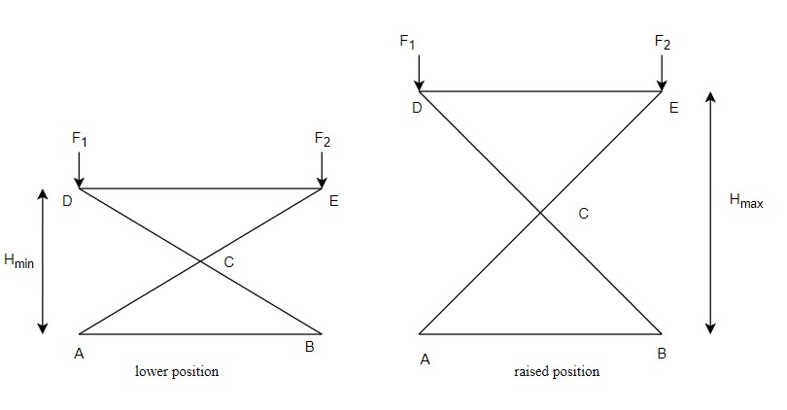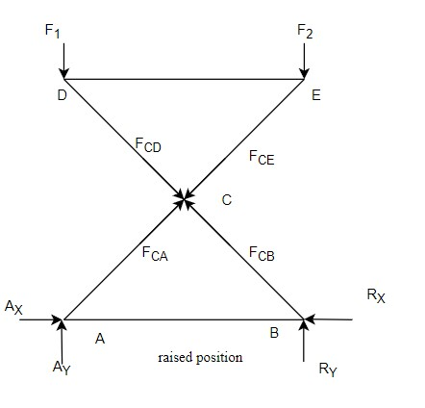

∑ 𝐹𝑥 = 0

*Figure*

*7*

*arm analysis a*

And the other force on diagram

is

internal re-

action force

𝐴

𝑥

−

𝐹

𝐶𝐷

cos

𝛽

=

0

𝐴

𝑥

=

𝐹

𝐶𝐷

cos

𝛽

𝐴

𝑦

+

𝐹

𝐶𝐷

sin

𝛽

−

𝐹

=

0

𝐴

𝑦

=

𝐹

1

−

𝐹

𝐶𝐷

𝑠𝑖𝑛

𝛽

∑

𝑀

𝐹

1

cos

𝛽

−

𝐹

𝐶𝐷

𝐿

2

cos

𝛽

−

𝐹

𝐶𝐷

cos

𝛽

=

0

𝐹

1

𝐿

cos

𝛽

−

𝐹

𝐶𝐷

𝐿

2

(

cos

𝛽

+

cos

𝛽

)

=

0

2

𝐹

1

cos

𝛽

=

(

𝐹

𝐶𝐷

cos

𝛽

+

sin

𝛽

)

𝐹

𝐶𝐷

=

=

𝐴

𝑦

=

𝐹

1

−

𝐹

𝐶𝐷

𝑠𝑖𝑛

60

.

28

=

1875

–

1814.2

sin

60.28

𝐴

𝑥

=

𝐹

𝐶𝐷

𝑐𝑜𝑠

𝛽

=

1814.2

1

cos

60.28

=

899.4

N

∑

𝐹

𝑥

=

0

𝑅

𝑥

−

𝐹

𝑅

𝑥

𝐴

∑

𝐹

𝑌

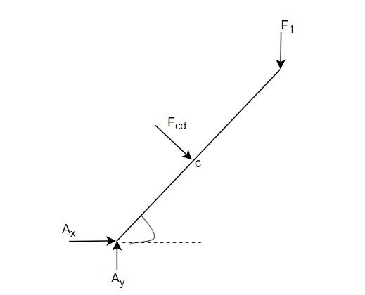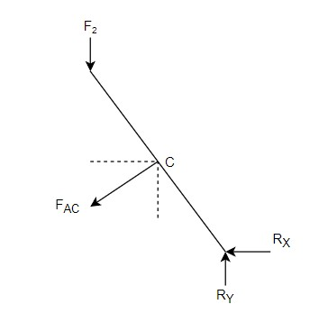

*Figure*

*8*

*arm analysis b*

∑ 𝐹𝑌 = 0

𝐴 =0

𝐿

2

2𝐹1𝑐𝑜𝑠𝛽

𝑐𝑜𝑠 𝐵 + sin 𝛽

2×1875 𝑐𝑜𝑠 60.28

𝑐𝑜𝑠 60.34+𝑠𝑖𝑛 60.28

𝐹

= 1859.11N 𝐶𝐷 = 1859𝑁

𝐴

=691.5N 𝑦 = 691.5N

𝐴𝐶 𝑐𝑜𝑠 𝛽 = 0

= 𝐹 𝑐𝑜𝑠 𝛽

= 0

∑ 𝑀𝐴 =0

𝜎

𝐷

=

10

𝑚𝑚𝑥

30

𝑚𝑚

=

6.04

Mpa

Where

𝐹

1

=

2500

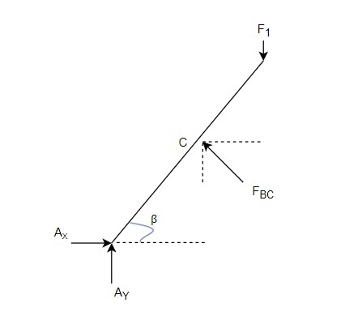

*Figure*

*9*

*-*

*stress analysis of arm*

𝐿

𝐹1𝑙 𝑐𝑜𝑠 𝛽 − 𝐹𝐴𝐶  𝑠𝑖𝑛 𝛽

2

𝐹𝐴𝐶𝑙

𝐹1𝑙 𝑐𝑜𝑠 𝜌 = (𝑐𝑜𝑠 𝛽 + sin 𝛽)

2

2𝐹1 𝑐𝑜𝑠 𝐵

𝐹𝐴𝐶 =

𝑠𝑖𝑛 𝛽 + 𝑐𝑜𝑠 𝛽

2 × 1875𝑐𝑜𝑠 60.28

𝐹𝐴𝑐 =

𝑠𝑖𝑛 60.28 + 𝑐𝑜𝑠 60.28

FAC = 1362.76N

𝑅𝑦 = 𝐹1 − 𝐹𝐶𝐷 𝑠𝑖𝑛 82

𝑅

= 1875 – 1362.76sin 60.28 𝑦 = 691.5N

=691.5N

𝑅𝑥 = 𝐹𝐶𝐷 𝑐𝑜𝑠 𝛽

=1362.76cos 60.28

𝑅

= 670.55N 𝑥 = 670.55N

## 4.2.2 Stress alaysis

The are is subjected to three form of stress

* Direct stress
* Bending stress
* Buckling stress

Direct stress

This is the stress that result because of the compressive load and calculated as

𝜎𝐷 = 𝐹𝐴 let thickness t= 10mm

Width w = 30mm

1362.76

|  |  |
| --- | --- |
| = 126,907.99Nmm  𝑏ℎ2  𝑧=  6  10 𝑋 302  𝑍 =  6  = 1500𝑚𝑚3  126,907.99𝑁𝑚𝑚  𝜎𝑏 = 3  1500𝑚𝑚  𝜎𝑏=84.6Mpa **4.2..3 Saftey factor**  n= 4   * Since this is the part that lift the load that is applied to and hold it in place so a failure of this part will cause a total failure of the lift. * The failure of this part will cause the damage of the load * It can even cause death   **4.2.4 Material selection**  This component is subjected to buckling load and bending load tending to break or cause bending of the components. Hence based on strength, stiffness, plasticity an hardness.  So, material like steel, mild steel and TiAl6V4 Titanium Alloy can be used they fit the required strength being moderately light weight  Since the TiAl6V4 Titanium Alloy the bending stress of the material way more than the stress on the system it would’t be economical to use this. compared to stainless steel $1-1.50 and | 𝜎𝑏=84.6Mpa      N=4            AISI 1020 Steel |
| stainless steel $0.6-1, we want the jack to be affordable so we won’t use titanium is this design.  The manufacturing of stainless steel is very hard which requires and 10-12 hours of heating for the forming process.  Since the part is subjected to a buklng stress and AISI 1020 Steel can support more bukling stress than mild steel and the other propties are required.    𝑛𝜎𝑏 < 𝜎𝑦    4(84.6Mpa)<350  347.6Mpa<350Mpa | |

Bending stress 𝐹𝐵𝐶 = 1362.76

𝐿 𝐿 𝐿

∑𝑀𝐶 = 2 𝑐𝑜𝑠 𝛽𝐹1 + 𝐴𝑌 2 cos 𝛽 − 𝐴𝑋 2 sin 𝛽

## 4.2.5 Manufacturing

AISI 1020 has low hardenability properties and is a low tensile carbon steel with a Brinell

hardness of 119 – 235, and a tensile strength of 410-790 MPa. It has high machinability, high strength, high ductility and good weldability. It is normally used in turned and polished or a

cold drawn condition. Due to its low carbon content, it is resistant to induction hardening or flame hardening. Due to lack of alloying elements, it will not respond to nitriding. However, carburization is possible in order to obtain case hardness more than Rc65 for smaller sections that reduces with an increase in section size. The core strength will remain the same. Alternatively, carbon nitriding can be performed, offering certain benefits over standard carburizing. Cold drawn

AISI 1020 steel can be largely utilized in all industrial sectors in order to enhance weldability or machinability properties. It is used in a variety of applications due to its cold drawn or turned and polished finish property.

pin 𝐹𝑝

*Figure*

*10*

*pin reaction*

**4.3**

**Design of pin**

Pins are on of the most

important

component

the

jack that

is used to join the

scissors

link to-

gether and allo

ws a relative motion between the arms to the perform the lifting process

**4.3.1**

**Force analysis**

∑

F

y

=

0

𝐹

1

−

𝐹

𝑎𝐶

𝑠𝑖𝑛

𝛽

−

𝐹

𝐵

𝑠𝑖𝑛

𝛽

𝐹

1

=

𝐹

𝑎𝐶

𝑠𝑖𝑛

𝛽

+

𝐹

𝐵

𝑠𝑖𝑛

𝛽

=

2

×

𝐹

𝐴𝐶

𝑠𝑖𝑛

𝛽

=2

X 1362.76

sin

60

.

28

=

1186.2

N

…….

T

he shear force acting on the

𝐹

1

𝐹

𝑝

𝐹

1

1186

.

2

𝑁

𝐹

𝑝

=

3628

.

49

𝑁

F

1

1186.2N

=

F

p

=

3628N

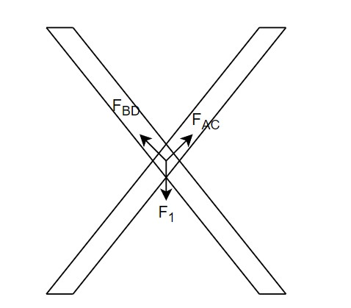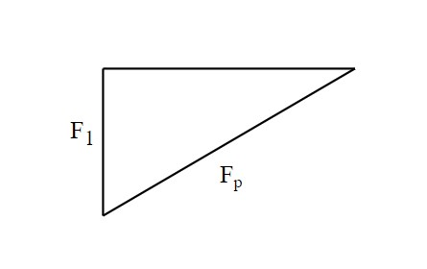

β

𝑠𝑖𝑛 𝛽 =

𝐹𝑃 = =

𝑠𝑖𝑛 𝛽 𝑠𝑖𝑛 60 . 28

## 4.3.2 Stress analysis

There are three stress action on the pin

* Shear stress
* Bending stress
* Crushing stress

4𝐹

𝜏 = 𝛱𝐷𝑝2 𝐷𝑝 = 𝑑𝑖𝑎𝑚𝑒𝑡𝑒𝑟 𝑜𝑓 𝑝𝑖𝑛

Select 𝐷𝑝 on standard pin diameter 𝐷𝑝 = 20𝑚𝑚

𝜏 = 4 ×𝜋(3151202).1

=10Mpa

Length of the pin 𝐿𝑝 depends on the dimension of the rectangular bar used for the arm design

𝐿𝑝 = 2 𝑥 𝑡ℎ𝑖𝑐𝑘𝑛𝑒𝑠𝑠 𝑜𝑓 𝑎𝑟𝑚 + 𝑐𝑙𝑒𝑎𝑟𝑎𝑛𝑐𝑒

= 2 × 10 + 10 assuming the clearance is 10mm

= 30mm

𝐹𝑠

𝜎𝐶 = 𝐴𝑠

𝐴𝑠 = 2𝛱𝑟𝑝(𝐿8 + 𝑟𝑝)

2𝛱 × 10(30 + 10)

= 2513.27𝑚𝑚2

𝑠𝑖𝑛𝑐𝑒 𝐹𝑆 = 𝐹𝑃

𝜎𝑐 = 25133628.27.5𝑚𝑚𝑁 2

= 1.443𝑀𝑝𝑎

τ =10Mpa

𝜎𝐶 = 1.4𝑀𝑝𝑎 Bending stress

𝛴𝑀 = 𝐹1𝐿

=3151.1𝑁 × 30𝑚𝑚

=94533 Nmm

𝜋 3 𝜋×3

𝑧 ==

 

=2094.4𝑚𝑚3

𝑀

𝜎𝑏 = 𝑧

=𝑁𝑚𝑚

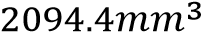

=45.13Mpa σ= =45.13Mpa

## 4.3.3 Safety factor

N= 4

* The factor of safety needed for the pin is the same us the leg
* Since failure of the pin will cause a catastrophic damage that will make the lift fail N=

* The failure of this part will cause the damage of the load

* It can even cause death

## 4.3.4 Material selection

This component is subjected to crushing, shearing and bending load tending to break or cause bending of the components. Hence based on strength, stiffness, plasticity and hardness.

So, material like steel, mild steel and stainless steel can be used they fit the required strength

being moderately light weight

Since the Titanium is expensive. compared to stainless steel $1-1.50 and stainless steel $0.6-1, we want the jack to be affordable so we won’t use titanium is this design.

The manufacturing of stainless steel is very hard which requires and 10-12 hours of heating for

ASTM A36 the forming process.

Mild/low carbon So, we will use mild/ low carbon steel ASTM A36 Mild/low carbon steel steel

𝑛𝜎𝑏 < 𝜎𝑦

4(45.13) <250

142Mpa<250Mpa

## 4.3.5 Manufacturing

Mild steel is made similar to how other carbon steels are made. A common way this is done in-

volves a combination of iron ore and coal. Once the coal and iron ore are extracted from the Cold drawn earth, they are melted together in a blast furnace. Once melted, themixture is moved toanother furnace to burn off any impurities that they may have, as well as to make any other

area multiplied by pressure.

*Figure*

*11*

*handle force analysis*

**4.4**

**D**

**esign of**

**plunger cylinder**

A hydraulic cylinder without a piston or with a piston

without seals is called a plunger cylinder.

A plunger cylinder can only be used as a pushing cylinder;

the maximum force is piston rod

**4.4.1**

**Force analysis**

To calculate the force applied on the plunger cylinder, first we have

c

alculated

the handle force

Assuming the handle can transfer the maximum force to the plunger piston

Where:

𝐹

𝑁

–

Force applied by the operator

𝐹

𝑝

–

Reaction

forces

the plunger applies on the

The average force applied by human on the handle is

;

𝐹

𝑁

130N to 150N

=

Let’s take

𝐹

𝑁

130N

=

𝛴

𝑀

𝐴

=

0

50

𝐹𝑝

𝑐𝑜𝑠

𝜃

−

𝐹

𝐻

𝑐𝑜𝑠

𝜃

𝐹

𝑃

=

𝐹

𝐻

300

𝑐𝑜𝑠

𝜃

F

n

130N

=

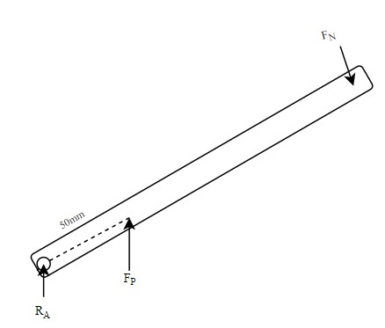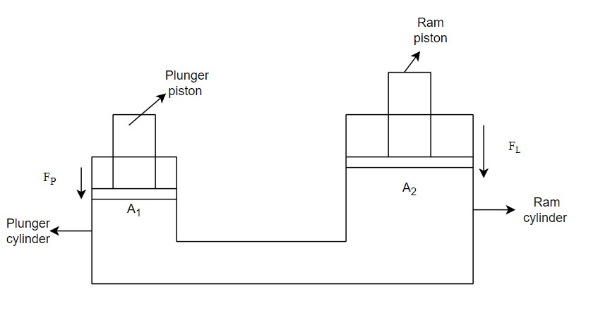

*Figure*

*12*

*pump hydrulic principle*

handle

L – length of the handle

Assuming the length L is 500mm

50 𝑐𝑜𝑠 𝜃

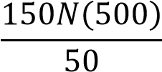

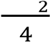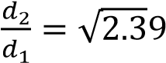𝐹𝑝 = 1500𝑁

Where 𝐹𝐿- lifting force

𝐹𝑙 = 4 x 𝑅𝑥

= 4 x 899.4N

= 3597N FL = 3597N

By applying pascal principle

𝑃1 = 𝑃2

𝐹𝑝 𝐹𝐿

=

𝐴1 𝐴2

𝐹𝐿 𝐴2 𝐴2 𝜋 ⅆ2 42

= , = ×

𝐹𝑝 𝐴1 𝐴1𝜋ⅆ1

𝐴2 𝑑2 2

= ( )

𝐴1 𝑑1

𝐴2 3597.6𝑁

=

𝐴1 1500𝑁

𝐴2

= 2.3

𝐴1

𝐴2 ⅆ2 2

= ( ) ➔

𝐴1 ⅆ1

ⅆ

2 = 1. 54 ⅆ1

ⅆ

2 – the ration of diameter of ram cylinder to diameter of plunger diameter ⅆ1

The standard size of small cylinder is 15mm- 50mm

Let; 𝑑1= 20mm

𝑑2 = 𝑑1(1.54)

= 20(1.54)

𝑑2 = 30.8 mm

|  |  |  |
| --- | --- | --- |
| By shear stress theory |  |  |

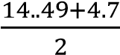=

𝜏 = 9.59Mpa

[metal](https://fractory.com/magnetic-metals-non-magnetic-metals-with-examples/) due to its ferrite content, good malleability with cold-forming possibilities

And stainless steel is also another material that can be used for this application. Since the SAE 1020 Steel plunger is subjected to low stress and the easy machinability of SAE 1020 Steel. I have decided to use this part. 𝑛𝜎𝑏 < 𝜎𝑦

4(9.7) <250Mpa

38.8Mpa<165Mpa

## 4.4.5 Manufacturing

AISI 1020 has low hardenability properties and is a low tensile carbon steel with a Brinell hardness of 119 – 235, and a tensile strength of 410-790 MPa. It has high machinability, high strength, high ductility and good weldability. It is normally used in turned and polished or a

cold drawn condition. Due to its low carbon content, it is resistant to induction hardening or flame hardening. Due to lack of alloying elements, it will not respond to nitriding. However, Cold Drawn carburization is possible in order to obtain case hardness more than Rc65 for smaller sections that reduces with an increase in section size. The core strength will remain the same. Alterna-tively, carbon nitriding can be performed, offering certain benefits over standard carburizing.

Since our component does not require much strength, it will be manufactured by using hot rolled

**4.5**

**Design of Ram cylinder**

R

am cylinder is subjected

to high internal pressure that the liquid exerts due to the load from

the scissor arm and wear

The Ram is the part that will connect to the rod that joins the arm of the scissor and support the

load

**4.5.1**

**Force analysis**

*Figure*

*14*

*ram cylinder*

From the design of the

plunger,

I have

𝐹

𝑝

=

1500

𝑁

𝐹

𝑙

=

3597N

𝑑

2

30.8 mm

=

𝑡

2

=

6.06mm

Since I have calculated the force applied in the design plunger there will be no change here

**4.4.2**

**Stress analysis**

𝑅

1

15.4

=

𝑅

2

= 21.46

𝑃

1

=

𝐹

𝑝

𝐴

1

=

𝐹

𝑙

𝜋

𝑑

1

2

4

=

4

×

3597

.

8

𝑁

𝜋

30

.

8

2

=

4

.

7

Mpa

P

1

=

4.7Mpa

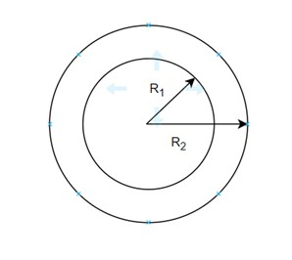

*Figure*

*15*

*ram cylinder analysis*

|  |  |  |
| --- | --- | --- |
| 𝑟 | 𝑟22 + 𝑟12  𝑃1𝑟12 | 𝑟2(𝑟22 − 𝑟12)  𝑝1𝑟12 𝑃1𝑟22 |

|  |  |
| --- | --- |
| 𝑟  𝑟 22 − 𝑟12 𝑟22 − 𝑟12 𝑟22 − 𝑟12  𝜎𝑟= -𝑝1  𝜎𝑟 = −4.7Mpa  the (-) represents it is compressive stress  3. Axial longitudinal stress- is a stress along the length of the cylinder. It is constant at any | 𝜎𝑟 = −4.7Mpa |

There are three types of stress in a thick pressure vessel

1. Tangential (Hoop) stress 𝜎𝐻
2. Radial stress (𝜎𝑟)
3. Axial or longitudinal stress (𝜎𝐿)

1. Tangential (Hoop) stress: - a stress which is tangent to radius if the circle. This stress is

maximum at inner diameter of cylinder and it is minimum at the outer diameter of the

cylinder

𝑃

𝜎𝐻 = 𝑟221+𝑟12𝑟1 = 𝑟22𝑝1−𝑟12𝑟12 + (𝑟22𝑃1−𝑟22𝑟12)

4.7 𝑥 15.42 4.7𝑥 21.462

𝜎𝐻= 21.462−15.42 + 21.62− 15.42

𝜎𝐻= = 14.4𝑀𝑝𝑎

𝜎𝐻= 4.99 + 9.4

= 14.4 𝑀𝑝𝑎

1. Radial stress – stress along radial direction is maximum at the internal radius and zero

at outer radius

𝑃

𝜎 = 1𝑟12 − 𝑝2𝑟22 − 𝑟12𝑟22(𝑃2 − 𝑝1)

𝜎 = = −

radius of the cylinder.

2 − 𝑝2𝑟22

𝑃1𝑟1

𝜎𝑙 = 𝑟2 + 𝑟12

2

𝑠𝑖𝑛𝑐𝑒 𝑝2 = 0

𝑃1𝑟12

𝜎𝑙 = 𝑟2 − 𝑟12

2

4.7 𝑥 15.42

𝜎𝑙 = 21.4 2 − 15.42

𝜎𝑙 = 5.04Mpa

𝜎𝑙 = 5.04Mpa

To calculate the yield stress, we use the theory of energy distortion or maximum shear strain energy per unit length

2𝜎𝑦2 = (𝜎1 − 𝜎2)2 + (𝜎1 − 𝜎3)2 + (𝜎2 − 𝜎3)2

Where:

𝜎1=𝜎𝑙 = 5.04Mpa

𝜎2=𝜎𝐻 = 14.42Mpa

𝜎3=𝜎𝑟= 4.7Mpa

2𝜎𝑦2=(5.04 − 14.42)2 + (5.04 − 4.7)2 + (14.42 − 4.7)2

2𝜎𝑦2 =87.98+0.115 + 94.47

2𝜎𝑦2=182.5

𝜎𝑦= 9.5Mpa

To calculate the principal stress, we use maximum shear strain energy per unit volume theory

2𝜎𝑦2 = (𝜎1 + 𝜎2)2 + (𝜎1 − 𝜎3)2 + (𝜎2 + 𝜎3)2

Where:

𝜎1=𝜎𝑙 = 5.04Mpa

𝜎2=𝜎𝐻 = 14.42Mpa

𝜎3=𝜎𝑟= 4.7Mpa

2𝜎𝑦′2=(5.04 + 14.42)2 + (5.04 − 4.7)2 + (14.42 + 4.7)2

′2 =378.69+0.115 + 365.57

2𝜎𝑦

2=744.3

2𝜎′𝑦

𝜎𝑦′ = 19.29Mpa

By shear stress theory

𝜎𝑚𝑎𝑥 − 𝜎𝑚𝑖𝑛

𝜏𝑚𝑎𝑥 = 2

= 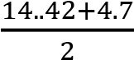

= 9.56Mpa

### 4.5.3 Safety factor

N= 4

* The factor of safety needed for the pin is the same us the leg, pin

N=4

* Since failure of the pin will cause a catastrophic damage that will make the lift fail
* The failure of this part will cause the damage of the load
* It can even cause death

### 4.5.4 Material selection

Carbon steel grade SAE 1020 is a low hardness and low tensile strength alloy. The Brinell hardness of the Hot rolled SAE 1020 Steel Tube ranges between 119 – 235, whereas its tensile

strength is between 410 MPa to 790 MPa. Though it lacks some of the characteristics of a con-

ventional carbon steel grade, the SAE 1020 Steel Tube exhibits other important characteristics such as high strength, high machinability, high ductility as well as good weldability. A low car- bon content in its chemistry makes the pipe resistant to flame hardening or to induction hardening.

Mild steel has impressive properties are responsible for a growing use in a variety of industries.

High tensile strength, High impact strength, good ductility and weldability, A [magnetic](https://fractory.com/magnetic-metals-non-magnetic-metals-with-examples/)  SAE 1020 Steel [metal](https://fractory.com/magnetic-metals-non-magnetic-metals-with-examples/) due to its ferrite content, good malleability with cold-forming possibilities

And stainless steel is also another material that can be used for this application. Since the plunger is subjected to low stress and the easy machinability of SAE 1020 Steel. I have decided to use this part.

𝑛𝜎𝑏 < 𝜎𝑦

4(9.7) <250Mpa 38.8Mpa<165Mpa

### 4.5.5 Manufacturing

AISI 1020 has low hardenability properties and is a low tensile carbon steel with a Brinell

hardness of 119 – 235, and a tensile strength of 410-790 MPa. It has high machinability, high

strength, high ductility and good weldability. It is normally used in turned and polished or a cold drawn condition. Due to its low carbon content, it is resistant to induction hardening or flame hardening. Due to lack of alloying elements, it will not respond to nitriding. However, carburization is possible in order to obtain case hardness more than Rc65 for smaller sections that reduces with an increase in section size. The core strength will remain the same. Alterna- Cold drawing tively, carbon nitriding can be performed, offering certain benefits over standard carburizing.

Even the stress on the rum is a bit higher than the plunger our component does not require

much strength; it will be manufactured by using hot rolled

From the design of plunger

**4.**

**6**

**Design of Piston rod for plunger**

**4.**

**6**

**Force analysis**

**.1**

𝛴

𝐹

𝑦

=

0

exerted by the piston

**4.6.2**

**Stress analysis**

No more stress is induced on the piston because it doesn’t have any

connection

with part that

lift

the load due to the only stress on the piston is

•

normal Compressive stress

•

Buckling stress

𝐴

=

𝜋

𝑑

2

4

𝜋

(

10

2

)

4

= 78.54

𝑚𝑚

2

Normal stress: which is compressive on a piston is

𝜎

𝐶

=

𝐹

𝐴

1500

𝑁

78

.

54

19.09Mpa

=

R=1500N

𝜎

𝑐

=

19

.

09

Mpa

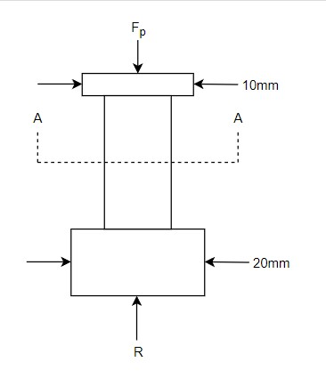

*Figure*

*16*

*piston rod analysis*

𝐹𝑝 = 1500N

R-𝐹𝑝 = 0

R=𝐹𝑝=1500N

R is the reaction force on the fluid or oil

find the are at the section A-A because the stress is high at the notch or shoulder

𝑃

|  |  |
| --- | --- |
| N= 6     * The factor of safety needed is the same us the above parts since the failure will have   the same result N=6   * Since failure of the pin will cause a catastrophic damage that will make the lift fail * The failure of this part will cause the damage of the load * It can even cause death   **4.6.4 Material selection**    This component is subjected to crushing, shearing and bending load tending to break or cause bending of the components. Hence based on strength, stiffness, plasticity and hardness.  So, material like steel, mild steel and stainless steel can be used they fit the required strength being moderately light weight  ASTM A36  Since the Titanium is expensive. compared to stainless steel $1-1.50 and stainless steel $0.6-1, Mild/low carbon | |
| we want the jack to be affordable so we won’t use titanium is this design.  The manufacturing of stainless steel is very hard which requires and 10-12 hours of heating for the forming process.  So, we will use mild/ low carbon steel ASTM A36 Mild/low carbon steel  𝑛𝜎𝑏 < 𝜎𝑦  6(19.09) <250  116Mpa<250Mpa  𝐹𝐸  𝜎𝐶𝑟 =  𝐴  𝜋2𝐸𝐼 𝜋 ⅆ4 𝜋104  𝐹𝐸 = 𝐿2 ,𝐼 = 64 = 64  𝐼 = 490𝑚𝑚2  E =210 for mild steel p  𝜋2210 × 490.8    (100.722)  =100.3KN  𝐹𝐸  𝜎𝐶𝑟 =  𝐴  100.3𝐾𝑁    78.54  = 127.7Mpa  𝜎𝑟 < 𝜎𝑦  127.7<210 | steel |

### 4.6.4 Manufacturing

AISI 1020 has low hardenability properties and is a low tensile carbon steel with a Brinell hardness of 119 – 235, and a tensile strength of 410-790 MPa. It has high machinability, high strength, high ductility and good weldability. It is normally used in turned and polished or a

cold drawn condition. Due to its low carbon content, it is resistant to induction hardening or Hot rolled flame hardening. Due to lack of alloying elements, it will not respond to nitriding. However, carburization is possible in order to obtain case hardness more than Rc65 for smaller sections that reduces with an increase in section size. The core strength will remain the same. Alterna-

tively, carbon nitriding can be performed, offering certain benefits over standard carburizing.

Since our component does not require much strength, it will be manufactured by using hot

rolled

**4.7**

**Design**

**of ram piston rod**

**4.7.1**

**Force analysis**

From the design of plunger

𝐹

𝑝

=

1500N

𝛴

𝐹

𝑦

=

0

R

-

𝐹

𝑝

=

0

R =

𝐹

𝑙

=

3597N

R is the reaction force on the fluid or oil exerted

by the piston

Let the fee body diagram of the arm with hydraulic cylinder becomes

X=

𝐿

2

𝑠𝑖𝑛

60

.

28

−

𝐿

2

𝑠𝑖𝑛

19

=

240

-

46

=194

mm

Assuming the piston has intatally

some distance from the end of the cylinder to reduce friction

between lifting arm and cylinder head

The total length of the ram cylinder (

piston)

𝐿

𝑟

=

100mm + 30mm

=

130mm

𝐷

1

= 30.8

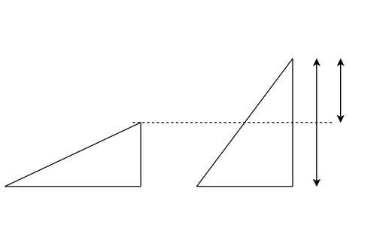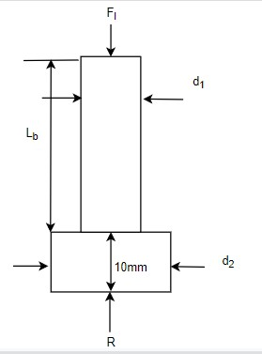

𝐻

𝑚𝑖𝑛

2

𝐻

𝑚𝑖𝑛

2

𝑙

2

𝑙

2

X

*Figure*

*17*

*ram piston rod analysis*

𝐷2=w 42.9

### 4.7.2 Stress analysis

The ram is subjected to :

* Normal compression stress

* Buckling

Normal compression stress induced to the rotation force at both ends at section

4

𝛱𝐷

𝐴 =

4

𝜋 𝑥 30.82

4

=745𝑚𝑚2

𝐹𝐿

𝜎𝐶 = 𝐴 𝜎𝐶 = 4.8𝑀𝑝𝑎

3597𝑁

745

=4.8 Mpa

## 4.7.3Factory of safety

N=10

The ram cylinder is directly connected to the lifting arm.

The failure of this component will cause total failure of the hydraulic system N=10

* The factor of safety needed is the same us the above parts since the failure will have the same result

* Since failure of the pin will cause a catastrophic damage that will make the lift fail

* The failure of this part will cause the damage of the load
* It can even cause death

### 4.7.4 Material selection

This component is subjected to crushing, shearing and bending load tending to break or cause

bending of the components. Hence based on strength, stiffness, plasticity and hardness.

So, material like steel, mild steel and stainless steel can be used they fit the required strength

being moderately light weight

Since the Titanium is expensive. compared to stainless steel $1-1.50 and stainless steel $0.6-1,

we want the jack to be affordable so we won’t use titanium is this design.

|  |  |
| --- | --- |
| The manufacturing of stainless steel is very hard which requires and 10-12 hours of heating for the forming process.  So, we will use mild/ low carbon steel ASTM A36 Mild/low carbon steel  𝑛𝜎𝑏 < 𝜎𝑦  10(4.8) <250  48Mpa<250Mpa  𝐹𝐸  𝜎𝐶𝑟 =  𝐴 | Mild steel |

|  |  |
| --- | --- |
| 7.6Mpa n𝜎𝑟 < 𝜎𝑦  76.4<210    **4.7.4 Manufacturing**  AISI 1020 has low hardenability properties and is a low tensile carbon steel with a Brinell hardness of 119 – 235, and a tensile strength of 410-790 MPa. It has high machinability, high strength, high ductility and good weldability. It is normally used in turned and polished or a cold drawn condition. Due to its low carbon content, it is resistant to induction hardening or flame hardening. Due to lack of alloying elements, it will not respond to nitriding. However, carburization is possible in order to obtain case hardness more than Rc65 for smaller sections that reduces with an increase in section size. The core strength will remain the same. Alternatively, carbon nitriding can be performed, offering certain benefits over standard carburizing.  Since our component does not require much strength, it will be manufactured by using hot rolled | Forging |

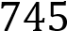 𝐹𝐸 = 𝜋𝐿22𝐸𝐼 ,𝐼 = 𝜋4 = 𝜋 4

𝐼 = 47,119𝑚𝑚2

E =210 for mild steel p

𝜋2 210 × 47119

2)

(130

5778.6

𝐹𝐸

𝜎𝐶𝑟 =

𝐴

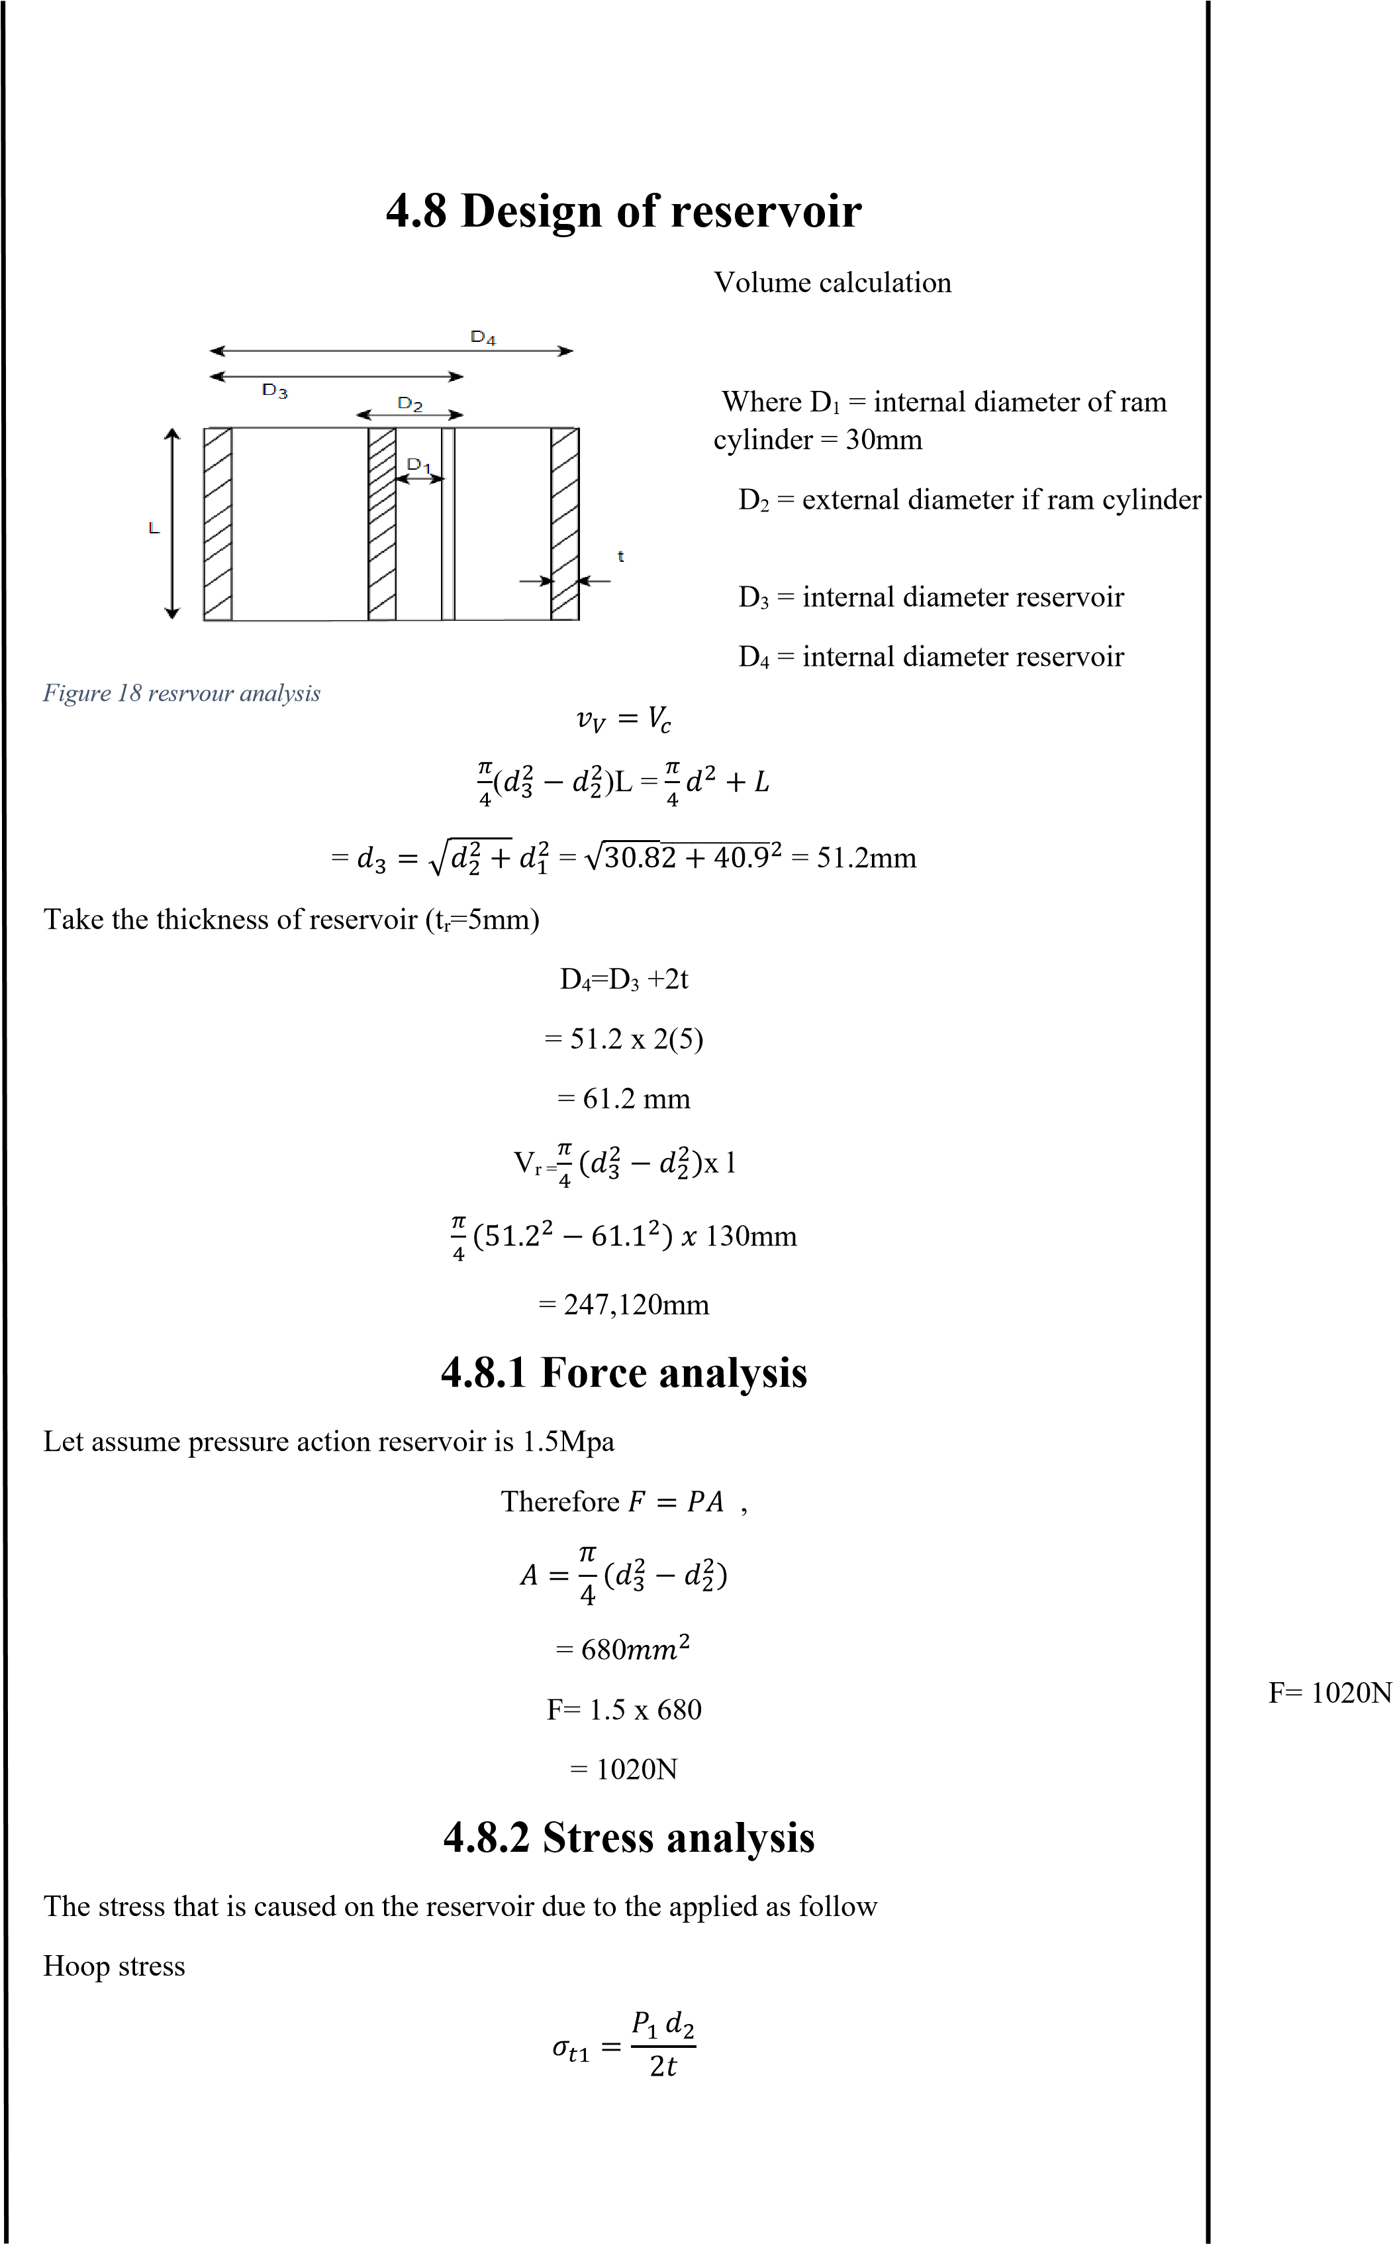= 41.9mm

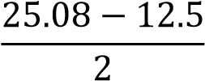4.9 𝑥 51.2𝑚𝑚 𝜎𝑡1= 25.08Mpa

2(5)

= 25.08Mpa

Longitudinal stress

𝑃1 𝑑2

𝜎𝑡2 =

4𝑡𝜎𝑡2 = 12.5

4.9 𝑥 51.2𝑚𝑚

4(5)

=12.5mpa

Maximum shear stress

𝜎𝑡1 − 𝜎𝑡2

𝜏𝑚𝑎𝑥 =

2

𝜏

𝑚𝑎𝑥 = 6.29𝑀𝑝𝑎

= 6.29 Mpa

### 4.8.3 Safety factor allocation

N= 4

Since the revisor is oil storage and is not pressurized it won’t cause harm that would have that many damage

N=4

Even though the hydraulic system won’t fail the failure of this part will cause the spillage of the hydraulic oil which will be inconvenience for us since we can’t use the lift at that time

### 4.8.4 Material selection

Carbon steel grade SAE 1020 is a low hardness and low tensile strength alloy. The Brinell hardness of the Hot rolled SAE 1020 Steel Tube ranges between 119 – 235, whereas its tensile

strength is between 410 MPa to 790 MPa. Though it lacks some of the characteristics of a con-

ventional carbon steel grade, the SAE 1020 Steel Tube exhibits other important characteristics such as high strength, high machinability, high ductility as well as good weldability. A low car- bon content in its chemistry makes the pipe resistant to flame hardening or to induction hardening.

Mild steel has impressive properties are responsible for a growing use in a variety of industries.

High tensile strength, High impact strength, good ductility and weldability, A [magnetic](https://fractory.com/magnetic-metals-non-magnetic-metals-with-examples/)  1020 steel [metal](https://fractory.com/magnetic-metals-non-magnetic-metals-with-examples/) due to its ferrite content, good malleability with cold-forming possibilities

And stainless steel is also another material that can be used for this application. Since the plunger is subjected to low stress and the easy machinability of SAE 1020 Steel. I have decided to use this part.

𝑛𝜎𝑏 < 𝜎𝑦

4(25.08) <165Mpa

100.32Mpa<165Mpa

### 4.8.5 Manufacturing

AISI 1020 has low hardenability properties and is a low tensile carbon steel with a Brinell

hardness of 119 – 235, and a tensile strength of 410-790 MPa. It has high machinability, high strength, high ductility and good weldability. It is normally used in turned and polished or a

cold drawn condition. Due to its low carbon content, it is resistant to induction hardening or Hot Rolled flame hardening. Due to lack of alloying elements, it will not respond to nitriding. However, carburization is possible in order to obtain case hardness more than Rc65 for smaller sections that reduces with an increase in section size. The core strength will remain the same. Alterna-tively, carbon nitriding can be performed, offering certain benefits over standard carburizing.

Even the stress on the rum is a bit higher than the plunger our component does not require much strength; it will be manufactured by using hot rolled

## 4.9 Design of spring

The axial load W

can be calculated as

W= P x A

s

W =

4

.

9

𝑥

𝜋

2

2

4

15.39N

=

direct stress

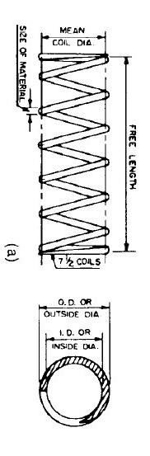

*Figure*

*19*

*spring analysis*

We start by assuming the diameter of the spring

Diameter, d=2mm

Spring index, c=5mm

𝐷

Where c=

ⅆ

D=Cd

= 2 x 5

10mm

Stress concentration factor (Ks)

Ks = 1+21𝑐

1 +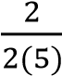

Ks = 1.1

Where P – pressure of the cylinder

As - area of the spring

W=15.39N

### 4.9.2 Stress analysis

The maximum shear stress induced in the wire is equal to the summation of tortional stress and

𝜏𝑚𝑎𝑥 = 𝜏1 + 𝜏2

Where τ1  - tortional stress

τ2 – direct stress

8𝑤𝐷

𝜏1 = 𝛱𝑑2

8 × 15.39𝑥10

3)

𝛱(2

𝜏1 = 48.9 Mpa

𝜏2 = 4𝑤

𝜋ⅆ2

4 × 15.39

2

𝜋2

𝜏2= 4.89

𝜏𝑚𝑎𝑥 = 𝜏1 + 𝜏2

𝜏𝑚𝑎𝑥 = 53.79 Mpa

𝜏𝑚𝑎𝑥 = 53.79 Mpa

### 4.9.3 Factor of safety

N= 4

* The factor of safety needed is the same us the above parts since the failure will have the same result

* Since failure of the spring will cause a catastrophic damage that will make the lift fail

N=4

* The failure of this part will cause the damage of the load

* It can even cause death

### 4.9.4 Material selection

This component is subjected to crushing, shearing and bending load tending to break or cause bending of the components. Hence based on strength, stiffness, plasticity and hardness.

So, material like steel, mild steel and stainless steel can be used they fit the required strength

being moderately light weight

Since the Titanium is expensive. compared to stainless steel $1-1.50 and stainless steel $0.6-1, we want the jack to be affordable so we won’t use titanium is this design.

The manufacturing of stainless steel is very hard which requires and 10-12 hours of heating for the forming process.

So, we will use mild/ low carbon steel ASTM A36 Mild/low carbon steel

𝑛𝜎𝑏 < 𝜎𝑦

4(53.79) <250

215Mpa<250Mpa

E= 200Gpa

G= 78Gpa

Calculating stress factor for (K)

4𝑐 − 1 0.165

𝑘 = 4𝐶 − 4 + 𝑐

4(2) − 1 0.165

+

4(2) − 4 2

K= 2.575

|  |  |  |  |
| --- | --- | --- | --- |
| spring rate or spring constant |  |  | 5    𝐿𝑓 = 𝑃 + 𝑛 × 2𝑑  Where Ls – solid length    Lf – free length  N- no of active turn    p- pitch of coils      K= 𝑓𝑜𝑟𝑐𝑒  ⅆ𝑒𝑓𝑙𝑒𝑐𝑡𝑖𝑜𝑛 |

|  |  |  |
| --- | --- | --- |
|  | 8𝑤𝐷 𝑁𝑎 𝐺𝑑4 |  |
| Solid length      Free length | Na = 78×109(2×10−3)^34)^3  8×30780 𝑥 (10 𝑥 10  Na = 5  Nt = 5 +2 = 7    Ls = (Na+2) d  = 7 x 2 14mm | Na = 5  Nt =7  Ls =14Nm        Lf =20.5 |
| Lf = 𝑁𝑡d x 𝛿𝑚𝑎𝑥 x (𝑁𝑡 − 1) x 1mm  The clearance between two adjacent coil is 1mm  𝐿𝑓 = 7x2 + 0.5 + (7-1) == 20.5mm | |

The deflection of the spring δ is assumed to be 0.5mm and the spring is assumed to be square ground and spring

𝑁𝑎

=

𝐺

ⅆ

80

3

𝑘

𝜔

For square end ground and spring type

𝐿 = (𝑛 + 2)𝑑

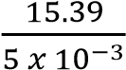

K = 30780 N/m

Number of total coils:

Nt = Na + 2

Where Na – number of active turns of the coil

Number of active turns of the coil

4 Where K = 𝐹

𝛿

P= 3.14mm

|  |
| --- |
| **4.9.5 Manufacturing**  Mild steel is made similar to how other carbon steels are made. A common way this is done involves a combination of iron ore and coal. Once the coal and iron ore are extracted from the earth, they are melted together in a blast furnace. Once melted, themixture is moved toanother furnace to burn off any impurities that they may have, as well as to make any other adjustments to the mild steel’s chemical composition. Following that, the steel is allowed to solidify into a rectangular shape Steel pins can be carbon steel or stainless steel, and are made from steel wire which is fed through a punch and die in order to form the desired shape. [Cold heading,](https://www.coldheadedparts.com/cold-heading/) or cold forming, is a process used to create simple metal parts without using heat to alter the shape of the metal |

𝐿𝑓

𝑃 =

𝑁𝑡 − 1

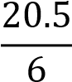

**4.10**

**Design of release valve**

Release valve has geometry

like bolt with a head

Major

diameter of

the resale valve threaded section > fluid flow path

depth (diameter)

The flow path depth = 5mm

Major diameter of the release valve threaded section is 10mmm greater than the flow path

depth

From standard thread type

IS:4218(path III)1976 of coarsed th

readed major nominal diameter (D)= 10mm, threaded sec-

tion

Matric designation, M10

Pitch(P)= 1.5mm

Pitch diameter (Dp)=

External thread= 9.026mm

Internal thread= 9.026mm

Minor core diameter

External thread= 8.16mm

Internal thread= 8.876mm

Depth of the external thread = 0.92

From standard designation of bolt head

W=1.5D +3mm

=

1.5(10)

+3

W= 18mm

*Figure*

*20*

*valve*

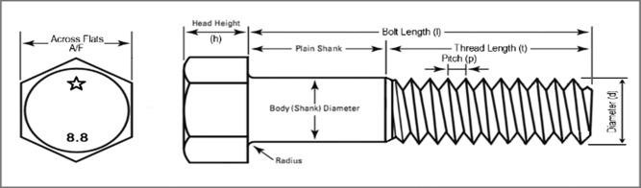

|  |  |
| --- | --- |
| Equivalent twisting moment Te | = 1,170Nmm |

### 4.10.1 Force analysis

The release valve is subjected to two types of force

1. Twisting force: when the valve is open and closed

A man can averagely apply force of 130N

1. Force due to fluid pressure

𝑎𝑑𝑗

𝑐𝑜𝑠 𝜃 =

ℎ𝑦𝑝

Θ= cos−1 2.5

5

Θ=60

= 2 x 60

120

The area that the fluid is in contact with the release valve is:

A= flow path diameter x length of (5 x 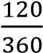 𝑥 𝜋𝑑)

A= (5 x 𝑥 𝜋10)

A= 52.36mm2

F2 = P x A

= 4.9 x 52.36mm2

F2= 256N

F2= 256N

### 4.10.2 Stress analysis

Bending moment by the fluid pressure

M= F2 x 𝑓𝑙𝑜𝑤 𝑝𝑎𝑡ℎ ⅆ𝑒𝑝𝑡ℎ

2

= 256 x

M=640Nmm

twisting torque T

T= F1 x 𝑤

2

= 130 x 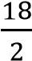

Te 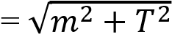

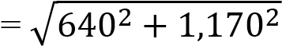

|  |  |
| --- | --- |
| = 986.8Nmm  Bending stress  32𝑚𝑒  𝜎𝑏 = 3  𝜋𝐷𝑐  32 × 980.8    𝜋 × (8.16)3  =18.4Mpa  Shear stress  16𝑇𝑒  𝜏 = 3  𝜋𝐷𝑐  16 × 1333.6    𝜋 × (8.16)2  = 102.33Mpa  **4.10.3 Factory of safety**  N=2  Release valve just helps us open a valve to make the oil return to the reservoir so I can take a lower factor of safety since the failure of this component won’t cause any serious problems.  Other than the inconvenience of not using the lift at the moment  **4.10.4 Material selection**  So, material like steel, mild steel and stainless steel can be used they fit the required strength being moderately light weight | 𝜎𝑏 = 18.4𝑀𝑝𝑎          𝜎𝑏 = 102.33𝑀𝑝𝑎          N=2 |
| Since the Titanium is expensive. compared to stainless steel $1-1.50 and stainless steel $0.6-1,    we want the jack to be affordable so we won’t use titanium is this design.  Mild steel  The manufacturing of stainless steel is very hard which requires and 10-12 hours of heating for the forming process.  So, we will use mild/ low carbon steel ASTM A36 Mild/low carbon steel  𝑛𝜎𝑏 < 𝜎𝑦  2(18.4) <250  36.5Mpa<250Mpa | |

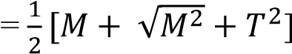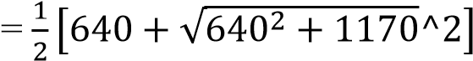 = 1,333.6Nmm

Equivalent bending moment Me

Me

𝑛𝜏𝑏 < 𝜎𝑦

2(102.33) <250

204.66 <250 its safe

### 4.10.5 Manufacturing

AISI 1020 has low hardenability properties and is a low tensile carbon steel with a Brinell hardness of 119 – 235, and a tensile strength of 410-790 MPa. It has high machinability, high strength, high ductility and good weldability. It is normally used in turned and polished or a

cold drawn condition. Due to its low carbon content, it is resistant to induction hardening or flame hardening. Due to lack of alloying elements, it will not respond to nitriding. However,

carburization is possible in order to obtain case hardness more than Rc65 for smaller sections Forging

that reduces with an increase in section size. The core strength will remain the same. Alternatively, carbon nitriding can be performed, offering certain benefits over standard carburizing.

Since our component does not require much strength, it will be manufactured by using hot rolled

**4.11**

**Design of**

**Bolt and**

**Nut**

It is a cylindrical bar with threaded for the nut at end and headed at the other end

Cylindrical part of the bolt is known as shank

It is used to fasten two parts together and clamp them securely to each other as the nut is

screwed on to the threaded end

.

*Figure*

*21*

*bolt and nut analysis*

Geometry

Major and nominal diameter of bolt D=8mm

Taking M8 from table

Thickness pf the bolt head is = 0.75 x 8 = 6mm

Diameter of the bold head = 2D= 2 x 8 = 16mm

**4.11.1**

**Force analysis**

This component is subjected to shear and crushing stress and no force is acting on it other

tha

t

to tighten it

The force applied by average human is 130N

F=130N

**4.11.2**

**Stress analysis**

Shear stress during

tightening

the housing with the basement

𝑇

=

𝐹

×

𝐷

2

130

x

8

2

T= 520Nmm

𝜏

=

1600

𝜋

(

𝑧

)

2

=

7.96Mpa

F=130N

𝜏

=

7

.

96

𝑀𝑝𝑎

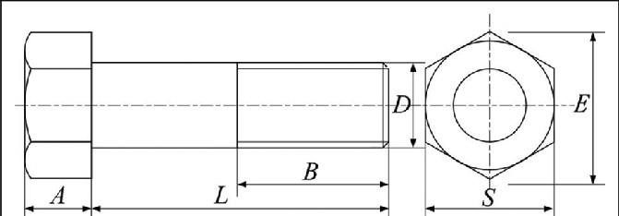

|  |  |  |  |  |  |  |
| --- | --- | --- | --- | --- | --- | --- |
| |  |  |  | | --- | --- | --- | | Shear stress across the thread section  𝑃  𝜏 =  𝜋 × 𝑑𝑖 𝑥 𝑏 𝑥 𝑛  = 50002  𝜋 𝑥 8 𝑥 1 𝑥 5  = 4.97Mpa Crushing stress compression stress on thread  𝑃  𝜎𝑐 = 2 − 𝑏12)  𝜋(𝑏0    5000    𝜋(82 − 62)  = 14.6Mpa  **4.11.3 Factor of safety**  N= 4   * The factor of safety needed is the same us the above parts since the failure will have the same result * Since failure of the spring will cause a catastrophic damage that will make the lift fail * The failure of this part will cause the damage of the load • It can even cause death   **4.11.4 Material selection**  Carbon steel grade SAE 1020 is a low hardness and low tensile strength alloy. The Brinell hardness of the Hot rolled SAE 1020 Steel Tube ranges between 119 – 235, whereas its tensile strength is between 410 MPa to 790 MPa. Though it lacks some of the characteristics of a conventional carbon steel grade, the SAE 1020 Steel Tube exhibits other important characteristics such as high strength, high machinability, high ductility as well as good weldability. A low carbon content in its chemistry makes the pipe resistant to flame hardening or to induction hardening.  Mild steel has impressive properties are responsible for a growing use in a variety of industries. High tensile strength, High impact strength, good ductility and weldability, A [magnetic metal](https://fractory.com/magnetic-metals-non-magnetic-metals-with-examples/) due to its ferrite content, good malleability with cold-forming possibilities  And stainless steel is also another material that can be used for this application. Since the plunger is subjected to low stress and the easy machinability of SAE 1020 Steel. I have decided to use this part.  𝑛𝜎𝑏 < 𝜎𝑦  4(14.6) <165Mpa  58.4Mpa<165Mpa | 𝜏= 4.7MPa        𝜎𝑐 = 14.6𝑀𝑝𝑎 | | |  | N=4              1020 steel | |  |

### 4.11.5 Manufacturing

AISI 1020 has low hardenability properties and is a low tensile carbon steel with a Brinell hardness of 119 – 235, and a tensile strength of 410-790 MPa. It has high machinability, high strength, high ductility and good weldability. It is normally used in turned and polished or a cold drawn condition. Due to its low carbon content, it is resistant to induction hardening or

flame hardening. Due to lack of alloying elements, it will not respond to nitriding. However, Forging

carburization is possible in order to obtain case hardness more than Rc65 for smaller sections that reduces with an increase in section size. The core strength will remain the same. Alternatively, carbon nitriding can be performed, offering certain benefits over standard carburizing.

Even the stress on the rum is a bit higher than the plunger our component does not require much strength; it will be manufactured by using hot rolled

|  |  |
| --- | --- |
| From newton 3rd law | assume |
| Faction = Freaction | L= 200mm |
| Faxial = w = 10kn | B=150mm |
| Faxial is the load acting on the base  Compressed area  Shear area | T= 20mm  Ac = 𝐿 𝑥 𝑏  = 200 x150  = 30,000mm2 |

**4.12 Design of hydraulic system base**

The base is the part of the hydraulic system that holds all the component of the hydraulic system

### 4.12.1 Force analysis

The force on the base is due to the load of the scissor jack that carries the maximum force on the cylinder how ram is the force on the basement it is axial force

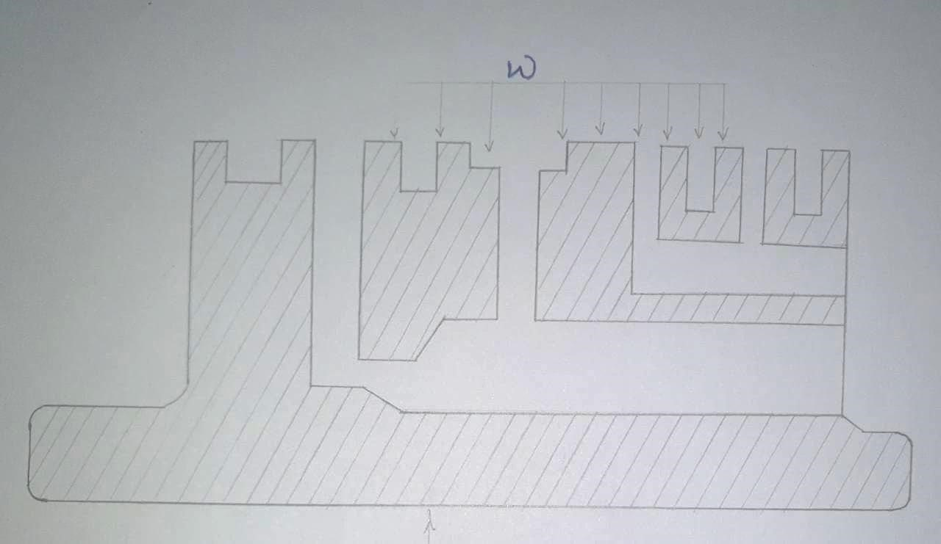

*Figure 22 hydraulic system base*

As = πdtb

= π x 57.28 x 28 x 30

= 5395.4mm2 where

tb thickness of base plate

|  |  |
| --- | --- |
| 𝐹𝑎𝑥𝑖𝑎𝑙  𝜎𝐶 =  𝐴𝑐  10𝐾𝑁    30,000  =0.333Mpa  Shear stress  𝐹  𝜏 = 𝑎𝑥𝑖𝑎𝑙  𝐴𝑠  = 10𝐾𝑁  539.55  = 18Mpa  **4.12.3 Factor of safety**  N= 4   * The factor of safety needed is the same us the above parts since the failure will have the same result * Since failure of the spring will cause a catastrophic damage that will make the lift fail * The failure of this part will cause the damage of the load • It can even cause death   **4.12.4 Material selection**  Carbon steel grade SAE 1020 is a low hardness and low tensile strength alloy. The Brinell hardness of the Hot rolled SAE 1020 Steel Tube ranges between 119 – 235, whereas its tensile strength is between 410 MPa to 790 MPa. Though it lacks some of the characteristics of a conventional carbon steel grade, the SAE 1020 Steel Tube exhibits other important characteristics such as high strength, high machinability, high ductility as well as good weldability. A low carbon content in its chemistry makes the pipe resistant to flame hardening or to induction hardening.  Mild steel has impressive properties are responsible for a growing use in a variety of industries. High tensile strength, High impact strength, good ductility and weldability, A [magnetic metal](https://fractory.com/magnetic-metals-non-magnetic-metals-with-examples/) due to its ferrite content, good malleability with cold-forming possibilities    And stainless steel is also another material that can be used for this application. Since the plunger is subjected to low stress and the easy machinability of SAE 1020 Steel. I have decided to use this part.  𝑛𝜎𝑏 < 𝜎𝑦  4(14.6) <165Mpa | 𝜏 = 18𝑀𝑝𝑎          N=4                      steel |

### 4.12.2 Stress analysis

There are two stresses acting on the base

Compressive stress

58.4Mpa<165Mpa

### 4.12.5 Manufacturing

AISI 1020 has low hardenability properties and is a low tensile carbon steel with a Brinell

hardness of 119 – 235, and a tensile strength of 410-790 MPa. It has high machinability, high

strength, high ductility and good weldability. It is normally used in turned and polished or a cold drawn condition. Due to its low carbon content, it is resistant to induction hardening or flame hardening. Due to lack of alloying elements, it will not respond to nitriding. However,

Forging carburization is possible in order to obtain case hardness more than Rc65 for smaller sections that reduces with an increase in section size. The core strength will remain the same. Alternatively, carbon nitriding can be performed, offering certain benefits over standard carburizing.

Let

**4.13**

**Design of base plate**

The base plate is the part of the jack that all component is attached to it.

**4.13.1**

**Force analysis**

The maximum load at base plate A

x

, A

y

, R

x

and R

y

where from the analysis of arm

R

y

=924.4

N

A

y

=

924.4N

R

x

899.4N

=

A

x

=

899.4N

The shape of the base plate is

The free body diagram at the maximum height become

𝛴

𝐹

𝑥

=

0

R

x

A

=

x

𝛴

𝐹

𝑦

=

0

𝐹

𝑅

=

𝐴

𝑥

+

𝐴𝑦

=2(924

.4

)

=

1848.8N

𝐹

𝑅

=

1848

.

8

𝑁

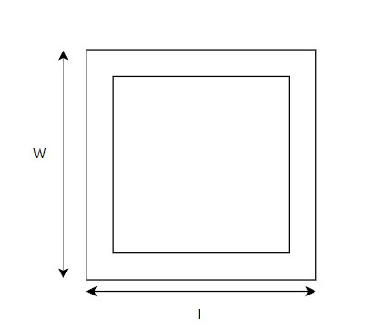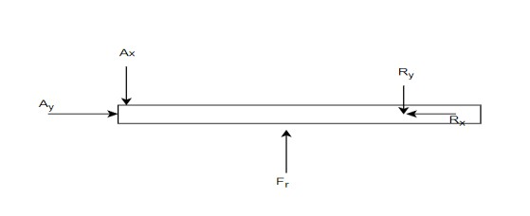

*Figure*

*23*

*base plate analysis*

t= 40mm w= 400m

L= 533mm

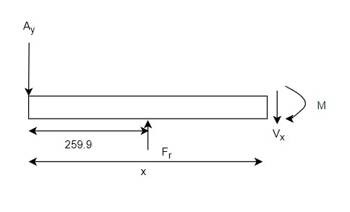

**4.13.2**

**Stress analysis**

Section 1

-

1

(0

≤

x

≤

259.9)

𝛴

𝐹

𝑦

=

0

A

y

+

V

y

=

0

V

y

=

924.4N

𝛴

𝑀

𝑥

=

0

A

y

X

-

M

x1

=0

At X= 259.8 mm

M

x

=

259.9 x 924.4

=

240,251Nmm

Section

2

-

2

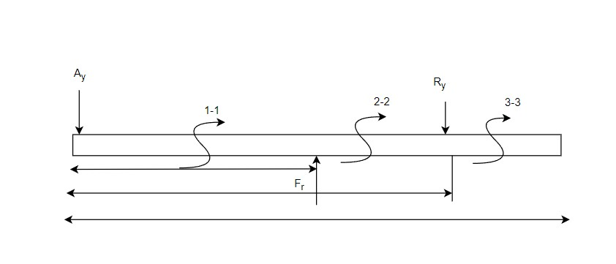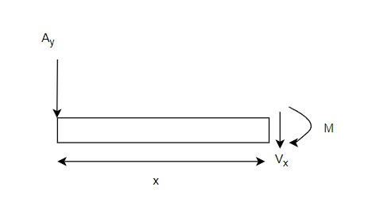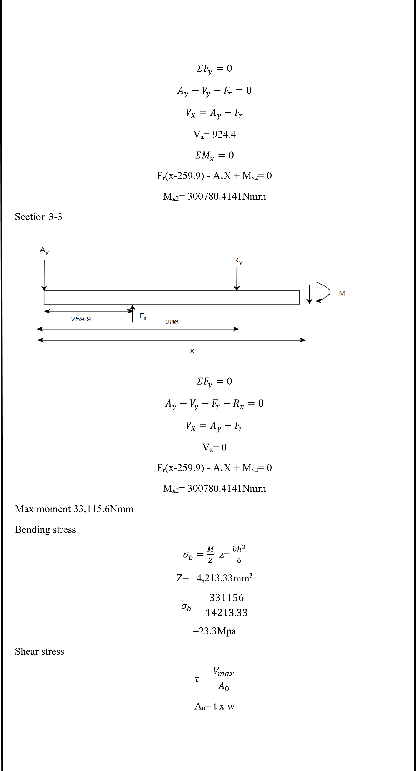

|  |  |
| --- | --- |
| =8.06Mpa    **4.13.3 Factor of safety**    N= 4     * The factor of safety needed is the same us the above parts since the failure will have the same result * Since failure of the spring will cause a catastrophic damage that will make the lift fail * The failure of this part will cause the damage of the load      * It can even cause death     **4.13.4 Material selection**    Carbon steel grade SAE 1020 is a low hardness and low tensile strength alloy. The Brinell  hardness of the Hot rolled SAE 1020 Steel Tube ranges between 119 – 235, whereas its tensile strength is between 410 MPa to 790 MPa. Though it lacks some of the characteristics of a con- ventional carbon steel grade, the SAE 1020 Steel Tube exhibits other important characteristics such as high strength, high machinability, high ductility as well as good weldability. A low carbon content in its chemistry makes the pipe resistant to flame hardening or to induction hardening.  Mild steel has impressive properties are responsible for a growing use in a variety of industries. High tensile strength, High impact strength, good ductility and weldability, A [magnetic](https://fractory.com/magnetic-metals-non-magnetic-metals-with-examples/)  [metal](https://fractory.com/magnetic-metals-non-magnetic-metals-with-examples/) due to its ferrite content, good malleability with cold-forming possibilities  And stainless steel is also another material that can be used for this application. Since the plunger is subjected to low stress and the easy machinability of SAE 1020 Steel. I have decided to use this part.  𝑛𝜎𝑏 < 𝜎𝑦  4(23.3) <165Mpa  93.2Mpa<165Mpa  **4.13.5 Manufacturing**    AISI 1020 has low hardenability properties and is a low tensile carbon steel with a Brinell hardness of 119 – 235, and a tensile strength of 410-790 MPa. It has high machinability, high strength, high ductility and good weldability. It is normally used in turned and polished or a cold drawn condition. Due to its low carbon content, it is resistant to induction hardening or | N= 4  1020 steel  Casting |

= 40 x 400

=160mm2

Vmax = 1289.6

τ = 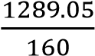 τ = 8.06Mpa

flame hardening. Due to lack of alloying elements, it will not respond to nitriding. However,

## 4.14 Design of Roller

Roller is part of the hydraulic jack which slides side way during the up and down movement

### 4.14.1 Force analysis

Selection of rolling contact bearing

Fx= 899.4N

There are r2 bearing used in our design but only rolling bearing which are placed at the base plate

F

Fx= 899.4N y=924.4N

Fy=924.4N

### 4.14.2 Stress analysis

From the principal dimension for ball bearing

Bearing number Bore (mm) D0(mm) Width(mm)

2000 10 30 9

201 12 32 10

1. 10 35 11

1. 12 37 12

In our case the diameter is 10mm the use 10mm bore diameter bearing

Bearing number 200

D0= 30mm

W=9mm

The area on which the force act on is a rectangular cross-section

A= W x D0

= 9 x 30

270mm2

Stress that induced on the bearing becomes

𝐹

𝜎 = 𝜎 = 34.22𝑀𝑝𝑎

𝐴

= 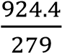

= 34.22Mpa

### 4.14.3 Factor of safety

N= 4

|  |  |
| --- | --- |
| * Since failure of the spring will cause a catastrophic damage that will make the lift fail      * The failure of this part will cause the damage of the load * It can even cause death   **4.14.4 Material selection**    Carbon steel grade SAE 1020 is a low hardness and low tensile strength alloy. The Brinell hardness of the Hot rolled SAE 1020 Steel Tube ranges between 119 – 235, whereas its tensile strength is between 410 MPa to 790 MPa. Though it lacks some of the characteristics of a conventional carbon steel grade, the SAE 1020 Steel Tube exhibits other important characteristics such as high strength, high machinability, high ductility as well as good weldability. A low car- bon content in its chemistry makes the pipe resistant to flame hardening or to induction hardening.  Mild steel has impressive properties are responsible for a growing use in a variety of industries. High tensile strength, High impact strength, good ductility and weldability, A [magnetic](https://fractory.com/magnetic-metals-non-magnetic-metals-with-examples/) | N=4  1020 steel |

• The factor of safety needed is the same us the above parts since the failure will have the same result

[metal](https://fractory.com/magnetic-metals-non-magnetic-metals-with-examples/) due to its ferrite content, good malleability with cold-forming possibilities

And stainless steel is also another material that can be used for this application. Since the plunger is subjected to low stress and the easy machinability of SAE 1020 Steel. I have decided to use this part.

𝑛𝜎𝑏 < 𝜎𝑦

3(34.22) <165Mpa 102.66Mpa<165Mpa **4.14.5 Manufacturing**

AISI 1020 has low hardenability properties and is a low tensile carbon steel with a Brinell

hardness of 119 – 235, and a tensile strength of 410-790 MPa. It has high machinability, high

strength, high ductility and good weldability. It is normally used in turned and polished or a cold drawn condition. Due to its low carbon content, it is resistant to induction hardening or flame hardening. Due to lack of alloying elements, it will not respond to nitriding. However,

Die forging carburization is possible in order to obtain case hardness more than Rc65 for smaller sections that reduces with an increase in section size. The core strength will remain the same. Alternatively, carbon nitriding can be performed, offering certain benefits over standard

**4.15**

**Design of handle**

the handle is part of the jack in which the user or technician hold and strokes to operate the jack

**4.15.1**

**Fore analysis**

Assuming the handle can transfer the maximum force to

the plunger piston

Where:

𝐹

𝑁

–

Force applied by the operator

𝐹

𝑝

–

Reaction forces the plunger applies on the handle

L

–

length of the handle

Assuming the length L is 500mm

The average force a

pplied by human on the handle is;

𝐹

𝑁

=

130N to 150N

Let’s take

𝐹

𝑁

=

130N

𝛴

𝑀

𝐴

=

0

50

𝐹𝑝

𝑐𝑜𝑠

𝜃

−

𝐹

𝐻

𝑐𝑜𝑠

𝜃

𝐹

𝑃

=

𝐹

𝐻

300

𝑐𝑜𝑠

𝜃

50

𝑐𝑜𝑠

𝜃

120

𝑁

(

500

)

50

𝐹

𝑝

=

1200

𝑁

𝛴

𝐹

𝑦

=

0

R

a

=

F

p

+

F

m

=

1200

-

120

=

1080N

**4.15.2**

**Stress analysis**

Lets

assume diameter of the handle arm is 20mm

R

a

=

1080

N

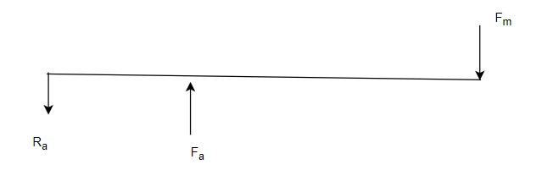

*Figure*

*24*

*handle analysis*

At section 1

-

1

(0

≤

x

≤

50)

𝛴

𝐹

𝑦

=

0

V

x

=

1080N

𝛴

𝑀

𝑥

=

0

M

x

-

R

a

X=0

Mx = 1080 x 50 5400Nmm

𝛴

𝐹

𝑦

=

0

F

p

+

v

x

-

R

a

=

V

x

=

1

2

N

0

M

x

-

R

a

X

+

F

p

(

x

-

50) =

0

At x = 50

Mx = 1080 x 50 5400Nmm

𝜎

𝑏

=

𝑀

𝑧

Z=

𝜋

ⅆ

3

32

=

𝜋

2

3

32

=

785.4mm

2

𝜎

𝑏

=

54000

785

.

4

=

68.75Mpa

**4.1**

**5**

**.3**

**F**

**actor of safety**

N=

2

•

The handle is the least import part of the jack we can even use any rods instead of the

handle so and it won’t cause any damage to the lift we can just use something else

𝜎

𝑏

=

68

.

37

𝑀𝑝𝑎

N=2

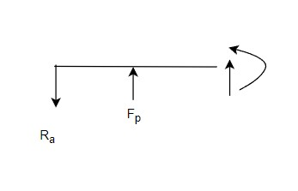

### 4.15.4 Material selection

Carbon steel grade SAE 1020 is a low hardness and low tensile strength alloy. The Brinell hardness of the Hot rolled SAE 1020 Steel Tube ranges between 119 – 235, whereas its tensile strength is between 410 MPa to 790 MPa. Though it lacks some of the characteristics of a conventional carbon steel grade, the SAE 1020 Steel Tube exhibits other important characteristics such as high strength, high machinability, high ductility as well as good weldability. A low car- bon content in its chemistry makes the pipe resistant to flame hardening or to induction hardening.

Mild steel has impressive properties are responsible for a growing use in a variety of industries.

High tensile strength, High impact strength, good ductility and weldability, A [magnetic](https://fractory.com/magnetic-metals-non-magnetic-metals-with-examples/)

1020 steel [metal](https://fractory.com/magnetic-metals-non-magnetic-metals-with-examples/) due to its ferrite content, good malleability with cold-forming possibilities

And stainless steel is also another material that can be used for this application. Since the plunger is subjected to low stress and the easy machinability of SAE 1020 Steel. I have decided to use this part.

𝑛𝜎𝑏 < 𝜎𝑦

1(68.75) <165Mpa

68.75Mpa<165Mpa

### 4.15.5 Manufacturing

AISI 1020 has low hardenability properties and is a low tensile carbon steel with a Brinell hardness of 119 – 235, and a tensile strength of 410-790 MPa. It has high machinability, high strength, high ductility and good weldability. It is normally used in turned and polished or a cold drawn condition. Due to its low carbon content, it is resistant to induction hardening or flame hardening. Due to lack of alloying elements, it will not respond to nitriding. However,

Rolling carburization is possible in order to obtain case hardness more than Rc65 for smaller sections

that reduces with an increase in section size. The core strength will remain the same. Alternatively, carbon nitriding can be performed, offering certain benefits over standard area multiplied by pressure.

**4.**

**16**

**Design of plunger cylinder**

**for leg**

**support**

A hydraulic cylinder without a piston or with a piston without seals is called a plunger cylinder.

A plunger cylinder can only be used as a pushing cylinder;

the maximum force is piston rod

**4.**

**16**

**Force analysis**

**.1**

To calculate the force applied on the plunger cylinder, first we have calculated the handle force

𝐹

𝑝

–

Reaction forces the plunger applies on the

handle

L

–

length of the handle

Assuming the length L is 500mm

The average force applied by human on the handle is;

𝐹

𝑁

130N to

=

150

N

Let’s take

𝐹

𝑁

=

130N

𝛴

𝑀

𝐴

=

0

𝐹

𝑃

=

𝐹

𝐻

300

𝑐𝑜𝑠

𝜃

50

𝑐𝑜𝑠

𝜃

150

𝑁

(

500

)

50

𝐹

𝑝

=

1500

𝑁

𝐹

𝑁

=

130N



*Figure*

*25*

*leg cylinder analysis*

Assuming the handle can transfer the maximum force to the plunger piston Where:

𝐹𝑁 – Force applied by the operator

50𝐹𝑝 𝑐𝑜𝑠 𝜃 − 𝐹𝐻 𝑐𝑜𝑠 𝜃

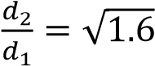Where 𝐹𝐿- lifting force 𝐹𝑙 =2500N

𝐹𝑙 = 𝐿𝑜𝑎ⅆ4

10,000

=

4

= 2500

By applying pascal principle

𝑃1 = 𝑃2

𝐹𝑝 𝐹𝐿

=

𝐴1 𝐴2

𝐹𝐹𝑝𝐿 = 𝐴𝐴21 , 𝐴𝐴21 = 𝜋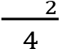 ⅆ2 × 𝜋4ⅆ12

𝐴2 𝑑2 2

= ( )

𝐴1 𝑑1

𝐴2 2500𝑁

𝐴1 = 1500𝑁

𝐴2

= 1.6

𝐴1

𝐴2 = ⅆ2 2 ➔

( )

𝐴1 ⅆ1

ⅆ2 = 1. 24

ⅆ1

ⅆⅆ21 – the ration of diameter of ram cylinder to diameter of plunger diameter

The standard size of small cylinder is 15mm- 50mm

Let; 𝑑1= 20mm

𝑑2 = 𝑑1(1.24)

= 20(1.24)

𝑑2 = 24.8 mm

### 4.16.2 Stress analysis

To withstand high pressure the cylinder should be thick. The cylinder said to thick cylinder if

and only if the ratio of it is thicker than the diameter by over ten times. Thick cylinder, 𝑡 > 1

ⅆ 10

Thin cylinder, 𝑡 < 1

ⅆ 10

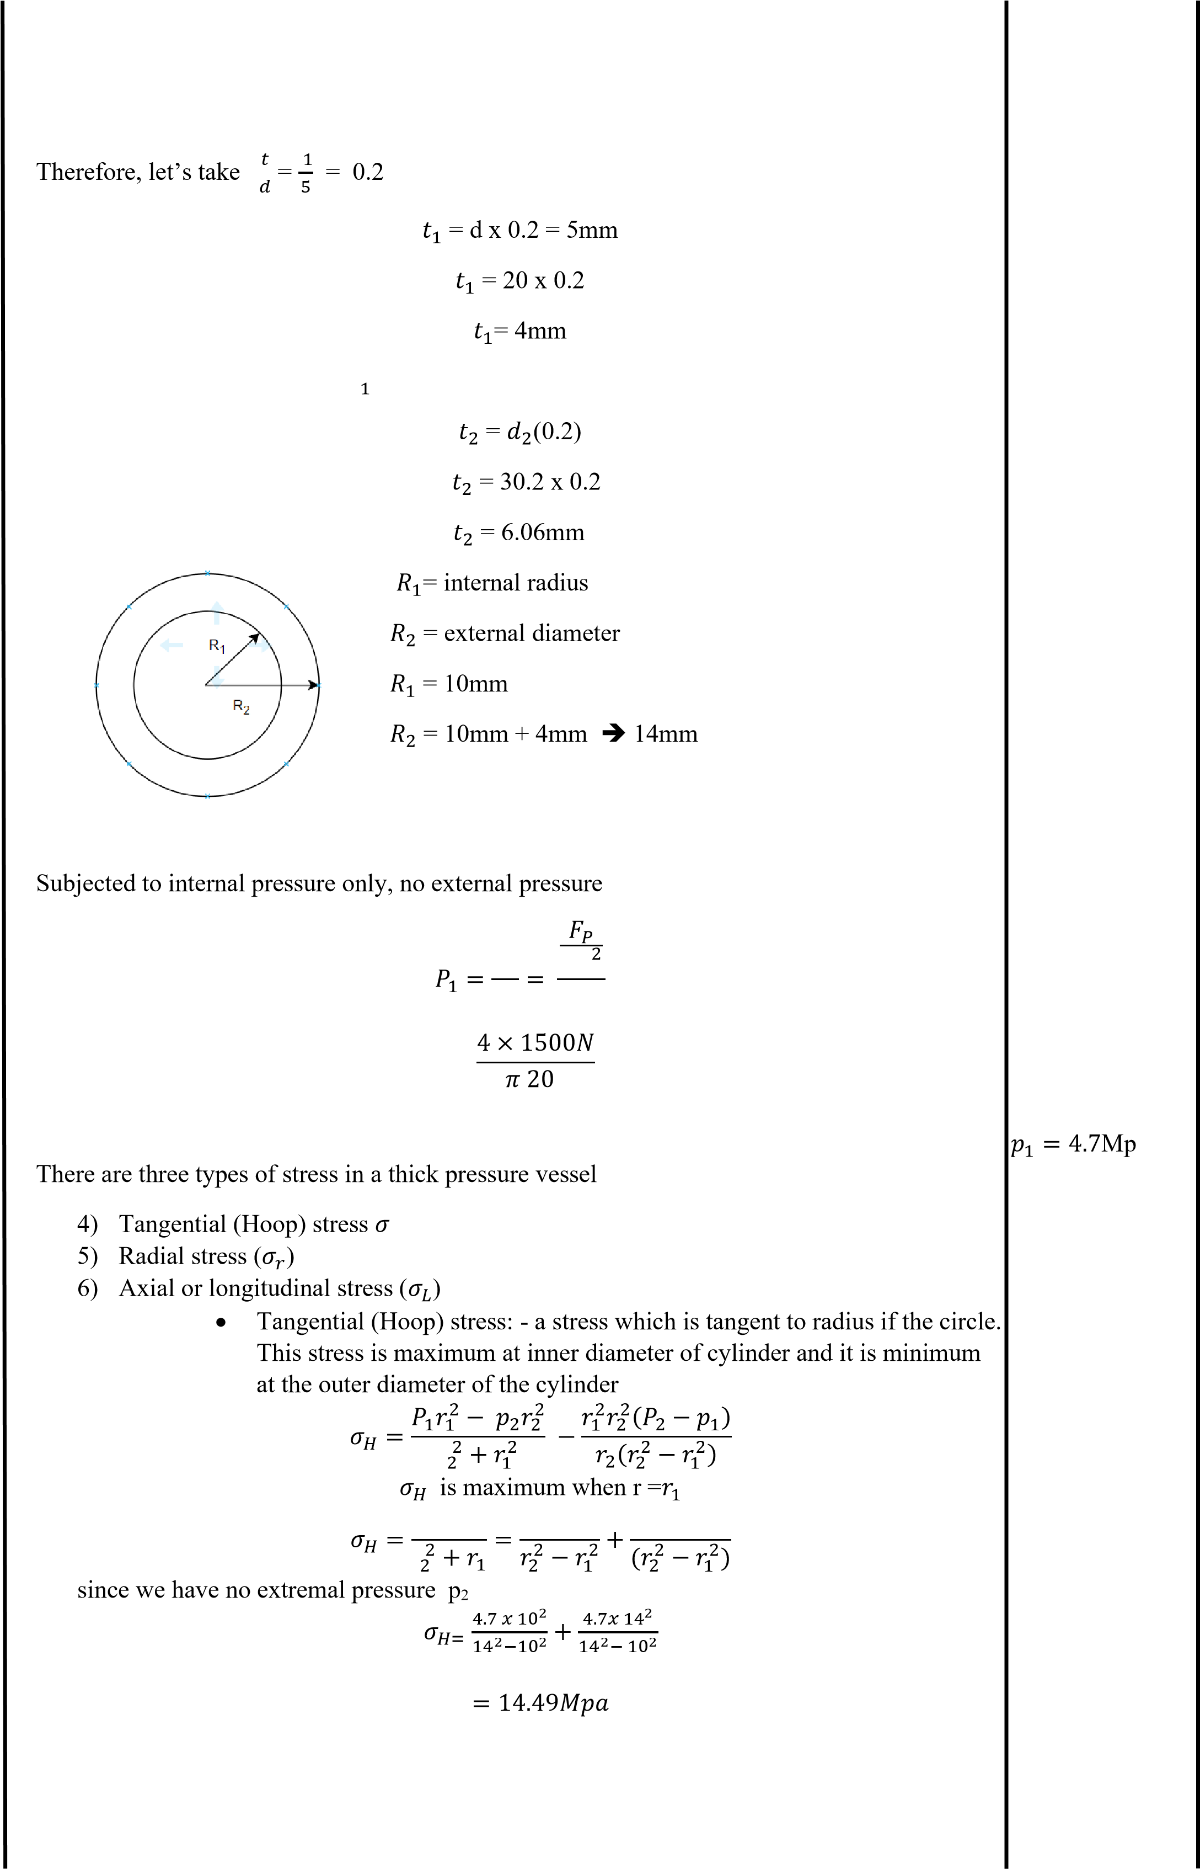𝑡 = 5mm for the plunger cylinder

𝐹𝑝 𝜋𝑑1

𝐴1 4

= 2

𝑝1 = 4.7Mpa

𝐻

𝑟

𝑃1𝑟12 𝑝1𝑟12 𝑃1𝑟22

𝑟

𝜎𝐻 = 1.656Mpa + 3.24Mpa

𝜎𝐻 = 14.49𝑀𝑝𝑎

Radial stress – stress along radial direction is maximum at the internal radius and zero at The outer radius

𝑃1𝑟12 − 𝑝2𝑟22 𝑟12𝑟22(𝑃2 − 𝑝1)

𝜎𝑟 = 𝑟2 + 𝑟12 − 𝑟2(𝑟22 − 𝑟12)

2

𝑃1𝑟12 𝑝1𝑟12 𝑃1𝑟22

𝜎𝑟 = 𝑟2 − 𝑟12 = 𝑟22 − 𝑟12 − 𝑟22 − 𝑟12 𝜎𝑟 = −4.7Mpa

2

𝜎𝑟= -𝑝1

𝜎𝑟 = −4.7Mpa pressive stress

Axial longitudinal stress- is a stress along the length of the cylinder. It is constant at any radius of the cylinder.

𝑃

𝜎𝑙 = 1𝑟𝑟122 −+ 𝑝𝑟122𝑟22

2

𝑠𝑖𝑛𝑐𝑒 𝑝2 = 0

𝑃1𝑟12

𝜎𝑙 = 𝑟2 − 𝑟12

2

4.7 𝑥 102𝜎𝑙 = 4.89Mpa

𝜎𝑙 = 14 2 − 102

𝜎𝑙 = 4.89Mpa

To calculate axial yield stress, we use theory of distribution of energy or maximum strain energy

2𝜎𝑦2 = (𝜎1 − 𝜎2)2 + (𝜎1 − 𝜎3)2 + (𝜎2 − 𝜎3)2

Where:

𝜎1=𝜎𝑙 = 4.89Mpa

𝜎2=𝜎𝐻 = 14.49Mpa

𝜎3=𝜎𝑟= 4.7Mpa

2𝜎𝑦2=(4.89 − 14.49)2 + (4.89 − 4.7)2 + (14.49 − 4.7)2

2𝜎𝑦2 =92.16+0.19 + 95.84

2𝜎𝑦2=188.19

𝜎

𝜎𝑦= 9.7Mpa 𝑦= 9.7Mpa

By shear stress theory

𝜎𝑚𝑎𝑥 − 𝜎𝑚𝑖𝑛 𝜏𝑚𝑎𝑥 =

2

= 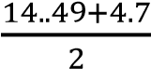 𝜏𝑚𝑎𝑥*= 9.59Mpa*

= 9.59Mpa

### 4.16.3 Safety factor

N= 4

* The factor of safety needed for the pin is the same us the leg, pin

* Since failure of the pin will cause a catastrophic damage that will make the lift fail

* The failure of this part will cause the damage of the load

N=4

* It can even cause death

### 4.16.4 Material selection

Carbon steel grade SAE 1020 is a low hardness and low tensile strength alloy. The Brinell Hardness of the Hot rolled SAE 1020 Steel Tube ranges between 119 – 235, whereas its tensile strength is between 410 MPa to 790 MPa. Though it lacks some of the characteristics of a con- ventional carbon steel grade, the SAE 1020 Steel Tube exhibits other important characteristics such as high strength, high machinability, high ductility as well as good weldability. A low car-bon content in its chemistry makes the pipe resistant to flame hardening or to induction harden- ing.

Mild steel has impressive properties are responsible for a growing use in a variety of industries. High tensile strength, High impact strength, good ductility and weldability, A [magnetic](https://fractory.com/magnetic-metals-non-magnetic-metals-with-examples/)  [metal](https://fractory.com/magnetic-metals-non-magnetic-metals-with-examples/) due to its ferrite content, good malleability with cold-forming possibilities

And stainless steel is also another material that can be used for this application. Since the SAE 1020 Steel plunger is subjected to low stress and the easy machinability of SAE 1020 Steel. I have decided to use this part.

𝑛𝜎𝑏 < 𝜎𝑦

4(9.7) <250Mpa 38.8Mpa<165Mpa **4.16.5 Manufacturing**

AISI 1020 has low hardenability properties and is a low tensile carbon steel with a Brinell hardness of 119 – 235, and a tensile strength of 410-790 MPa. It has high machinability, high strength, high ductility and good weldability. It is normally used in turned and polished or a cold drawn condition. Due to its low carbon content, it is resistant to induction hardening or flame hardening. Due to lack of alloying elements, it will not respond to nitriding. However, carburization is possible in order to obtain case hardness more than Rc65 for smaller sections that reduces with an increase in section size. The core strength will remain the same. Alterna-tively, carbon nitriding can be performed, offering certain benefits over standard carburizing.

Since our component does not require much strength, it will be manufactured by using hot Hot Rolled rolled

**4.**

**17**

**Design of Ram cylinder**

**for leg support**

Ram cylinder is subjected to high internal pressure that the liquid exerts due to the load from

the scissor arm and wear

The Ram is the part that will connect to the rod that joins the arm of the scissor and support the

load

**4.**

**17**

**.1**

**Force analysis**

*Figur*

*e*

*26*

*leg ram support analysis*

From the design of the plunger, I have

𝐹

𝑝

=

1500

𝑁

𝐹

𝑙

=

2500

N

𝑑

2

=

24

.8

mm

𝑡

2

=

6.06mm

Since I have calculated the force applied in the design plunger there will be no change her

e

**4.**

**17**

**.2**

**Stress analysis**

𝑅

1

=

12.4

𝑅

2

=

18.46

𝑃

1

=

𝐹

𝑝

𝐴

1

=

𝐹

𝑙

𝜋

𝑑

1

2

4

=

4

×

2500

𝑁

𝜋

24

.

8

2

=

5

.

175

Mpa



|  |  |  |
| --- | --- | --- |
| 𝐻= 18.462−12.42 18.4.62− 12.42 |  |  |
| 𝜎𝐻= 4.2 + 9.4 = 13.6𝑀𝑝𝑎    5. Radial stress – stress along radial direction is maximum at the internal radius and zero at outer radius  𝑃1𝑟12 − 𝑝2𝑟22 𝑟12𝑟22(𝑃2 − 𝑝1) |  | 𝜎𝐻= 13.6𝑀𝑝𝑎 |

There are three types of stress in a thick pressure vessel

1. Tangential (Hoop) stress 𝜎𝐻
2. Radial stress (𝜎𝑟)
3. Axial or longitudinal stress (𝜎𝐿)

4. Tangential (Hoop) stress: - a stress which is tangent to radius if the circle. This stress is maximum at inner diameter of cylinder and it is minimum at the outer diameter of the

cylinder

𝑃

𝜎𝐻 = 𝑟21+𝑟12𝑟1 = 𝑟22𝑝1−𝑟12𝑟12 + (𝑟22𝑃1−𝑟22𝑟12)

2

5.17 𝑥 12.42 5.17𝑥 18.462

𝜎 +

𝜎𝑟 = 𝑟2 + 𝑟12 − 𝑟2(𝑟22 − 𝑟12)

2

𝑃1𝑟12 𝑝1𝑟12 𝑃1𝑟22𝜎𝑟 = −5.17Mpa

𝜎𝑟 = 𝑟2 − 𝑟12 = 𝑟22 − 𝑟12 − 𝑟22 − 𝑟12

2

𝜎𝑟= -𝑝1

𝜎𝑟 = −5.17Mpa

the (-) represents it is compressive stress

6. Axial longitudinal stress- is a stress along the length of the cylinder. It is constant at any radius of the cylinder.

𝑃1𝑟12 − 𝑝2𝑟22

𝜎𝑙 = 𝑟22 + 𝑟12

𝑠𝑖𝑛𝑐𝑒 𝑝2 = 0

𝑃1𝑟12 𝜎𝑙 = 4.11Mpa

𝜎𝑙 = 𝑟2 − 𝑟12 2

5.17 𝑥 12.42

𝜎𝑙 = 18.46 2 − 12.42

𝜎𝑙 = 4.11Mpa

To calculate the yield stress, we use the theory of energy distortion or maximum shear strain

energy per unit length

2𝜎𝑦2 = (𝜎1 − 𝜎2)2 + (𝜎1 − 𝜎3)2 + (𝜎2 − 𝜎3)2

Where:

𝜎1=𝜎𝑙 = 4.11Mpa

|  |  |  |  |
| --- | --- | --- | --- |
| N= 4  •  •  •  • | = 9.38Mpa  **4.17.3 Safety factor**  The factor of safety needed for the pin is the same us the leg, pin  Since failure of the pin will cause a catastrophic damage that will make the lift fail  The failure of this part will cause the damage of the load It can even cause death  **4.17.4 Material selection** |  | N=4 |
| Carbon steel grade SAE 1020 is a low hardness and low tensile strength alloy. The Brinell | |

𝜎2=𝜎𝐻 = 13.6Mpa

𝜎3=𝜎𝑟= 5.17Mpa

2𝜎𝑦2=(4.11 − 13.6)2 + (4.11 − 5.17)2 + (13.6 − 5.17)2

2𝜎𝑦2 =90+1.123 + 71.046 𝜎𝑦= 9Mpa

2𝜎𝑦2=162.19

𝜎𝑦= 9Mpa

To calculate the principal stress, we use maximum shear strain energy per unit volume theory

2𝜎𝑦2 = (𝜎1 + 𝜎2)2 + (𝜎1 − 𝜎3)2 + (𝜎2 + 𝜎3)2

Where:

𝜎1=𝜎𝑙 = 4.11Mpa

𝜎

𝜎2=𝜎𝐻 = 13.6Mpa 𝑟= 5.175Mpa

𝜎3=𝜎𝑟= 5.175Mpa

2𝜎𝑦′2=(4.11 + 13.6)2 + (4.11 − 5.17)2 + (13.6 + 5.17)2

2𝜎𝑦′2 =313.64+1.123 + 352.5

2𝜎′2𝑦=667.26

𝜎𝑦′ = 18.2Mpa

By shear stress theory

𝜎𝑚𝑎𝑥 − 𝜎𝑚𝑖𝑛

𝜏𝑚𝑎𝑥 = 𝜏𝑚𝑎𝑥 = 9.38𝑀𝑝𝑎

2

= 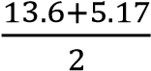

hardness of the Hot rolled SAE 1020 Steel Tube ranges between 119 – 235, whereas its tensile

|  |  |  |
| --- | --- | --- |
| Mild steel has impressive properties are responsible for a growing use in a variety of industries. High tensile strength, High impact strength, good ductility and weldability, A [magnetic metal](https://fractory.com/magnetic-metals-non-magnetic-metals-with-examples/) due to its ferrite content, good malleability with cold-forming possibilities  And stainless steel is also another material that can be used for this application. Since the plunger is subjected to low stress and the easy machinability of SAE 1020 Steel. I have decided | | 1020 steel  Forging |
| to use this part.  𝑛𝜎𝑏 < 𝜎𝑦  4(9.38) <250Mpa  37.54Mpa<165Mpa  **4.17.5 Manufacturing**  AISI 1020 has low hardenability properties and is a low tensile carbon steel with a Brinell hardness of 119 – 235, and a tensile strength of 410-790 MPa. It has high machinability, high strength, high ductility and good weldability. It is normally used in turned and polished or a cold drawn condition. Due to its low carbon content, it is resistant to induction hardening or flame hardening. Due to lack of alloying elements, it will not respond to nitriding. However, carburization is possible in order to obtain case hardness more than Rc65 for smaller sections |  |

strength is between 410 MPa to 790 MPa. Though it lacks some of the characteristics of a conventional carbon steel grade, the SAE 1020 Steel Tube exhibits other important characteristics such as high strength, high machinability, high ductility as well as good

weldability. A low carbon content in its chemistry makes the pipe resistant to flame hardening or to induction hardening. that reduces with an increase in section size. The core strength will remain the same. Alternat ively, carbon nitriding can be performed, offering certain benefits over standard carburizing.

Even the stress on the rum is a bit higher than the plunger our component does not require much strength; it will be manufactured by using hot rolled

### 4.18.1 Force analysis

**4.**

**18**

**Design of Piston rod for plunger**

**for leg**

𝛴

𝐹

𝑦

=

0

R

-

𝐹

𝑝

=

0

R=

𝐹

𝑝

N

=1500

R is the reaction force on the fluid or oil

exerted by the piston

**4.**

**18**

**.2**

**Stress analysis**

No more stress is induced on the piston because it doesn’t have any connection with part that

lift the load due to the only stress on the piston is

•

normal Compressive stress

•

Buckling stress

find the are at the section A

-

A because the stress is high at t

he notch or shoulder

𝐴

=

𝜋

𝑑

4

𝜋

(

10

2

)

4

= 78.54

𝑚𝑚

Normal stress: which is compressive on a piston is

𝜎

𝐶

=

𝐹

𝑃

𝐴

1500

𝑁

78

.

54

19.09Mpa

=

𝜎

𝐶

=

19

.

09

𝑀𝑃𝑎



*Figure*

*27*

*plunger piston rod*

From the design of plunger 𝐹𝑝 = 1500N

|  |  |
| --- | --- |
| **4.18.3 Safety factor**  N= 6   * The factor of safety needed is the same us the above parts since the failure will have the same result * Since failure of the pin will cause a catastrophic damage that will make the lift fail * The failure of this part will cause the damage of the load • It can even cause death   **4.18.4 Material selection**  So, material like steel, mild steel and stainless steel can be used they fit the required strength being moderately light weight  Since the Titanium is expensive. compared to stainless steel $1-1.50 and stainless steel $0.6-1, we want the jack to be affordable so we won’t use titanium is this design.  The manufacturing of stainless steel is very hard which requires and 10-12 hours of heating for the forming process.  So, we will use mild/ low carbon steel ASTM A36 Mild/low carbon steel    𝑛𝜎𝑏 < 𝜎𝑦  6(19.09) <250  16Mpa<250Mpa  𝐹𝐸  𝜎𝐶𝑟 =  𝐴  𝜋2𝐸𝐼 𝜋 ⅆ4 𝜋104  𝐹𝐸 = 𝐿2 ,𝐼 = 64 = 64  𝐼 = 490𝑚𝑚2  E =210 for mild steel p  𝜋2210 × 490.8    (100.722)  =100.3KN  𝐹𝐸  𝜎𝐶𝑟 =  𝐴  100.3𝐾𝑁    78.54  = 127.7Mpa | N=6                  Mild steel |

### 4.18.5 Manufacturing

AISI 1020 has low hardenability properties and is a low tensile carbon steel with a Brinell hardness of 119 – 235, and a tensile strength of 410-790 MPa. It has high machinability, high strength, high ductility and good weldability. It is normally used in turned and polished or a cold drawn condition. Due to its low carbon content, it is resistant to induction hardening or flame hardening. Due to lack of alloying elements, it will not respond to nitriding. However, carburization is possible in order to obtain case hardness more than Rc65 for smaller sections that reduces with an increase in section size. The core strength will remain the same. Alterna-

tively, carbon nitriding can be performed, offering certain benefits over standard carburizing.

Since our component does not require much strength, it will be manufactured by using hot

Hot rolled rolled

**4.**

**19**

**Design of ram piston rod**

**for leg support**

**4.**

**19**

**.1**

**Force analysis**

From the design of plunger

𝐹

𝑝

1500N

=

𝛴

𝐹

𝑦

=

0

R

-

𝐹

𝑝

=

0

R =

𝐹

𝑙

3597N

=

R is the reaction force on the fluid or oil exerted

by the piston

Let the fee body diagram of the arm with hydraulic cylinder becomes

X=

𝐿

2

𝑠𝑖𝑛

60

.

28

−

𝐿

2

𝑠𝑖𝑛

19

=240

-

46

mm

=194

Assuming the piston has

ini

tially

some distance from the end of the cylinder to reduce friction

between lifting arm and cylinder head

The total length of the ram cylinder (piston)

𝐿

𝑟

=

100mm + 30mm

=

130mm

𝐹

𝑙

=

3597N



𝐻

𝑚𝑖𝑛

2

𝐻

𝑚𝑖𝑛

2

𝑙

2

𝑙

2

X

*Figure*

*28*

*leg ram piston reaction force*

𝐷1= 24.8 𝐷2= 38.8

### 4.19.2 Stress analysis

The ram is subjected to :

* Normal compression stress
* Buckling

Normal compression stress induced to the rotation force at both ends at section

𝛱𝐷4

𝐴 =

4

𝜋 𝑥 24.82𝜎𝐶=4.8 Mpa

4

=745𝑚𝑚2

𝜎𝐶 = 𝐹𝐿

𝐴

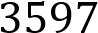𝑁

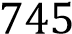

=4.8 Mpa

### 4.19.3Factory of safety

N=10

The ram cylinder is directly connected to the lifting arm.

The failure of this component will cause total failure of the hydraulic system

* The factor of safety needed is the same us the above parts since the failure will have N=10 the same result
* Since failure of the pin will cause a catastrophic damage that will make the lift fail
* The failure of this part will cause the damage of the load
* It can even cause death

#### 4.19.4 Material selection

This component is subjected to crushing, shearing and bending load tending to break or cause bending of the components. Hence based on strength, stiffness, plasticity and hardness.

So, material like steel, mild steel and stainless steel can be used they fit the required strength being moderately light weight

Since the Titanium is expensive. compared to stainless steel $1-1.50 and stainless steel $0.6-1,

we want the jack to be affordable so we won’t use titanium is this design.

The manufacturing of stainless steel is very hard which requires and 10-12 hours of heating for Mild steel the forming process.

So, we will use mild/ low carbon steel ASTM A36 Mild/low carbon steel

𝑛𝜎𝑏 < 𝜎𝑦

10(4.8) <250

48Mpa<250Mpa

𝐹𝐸

𝜎𝐶𝑟 =

𝐴

𝜋2𝐸𝐼 𝜋 4 𝜋4

𝐹𝐸 = 𝐿2 ,𝐼 = =

𝐼 = 47,119𝑚𝑚2

E =210 for mild steel p

𝜋2 210 × 47119

2)

(130

5778.6

𝐹𝐸

𝜎𝐶𝑟 = 𝐴

5.𝐾𝑁

7.6Mpa n𝜎𝑟 < 𝜎𝑦 76.4<210

#### 4.19.5 Manufacturing

AISI 1020 has low hardenability properties and is a low tensile carbon steel with a Brinell hardness of 119 – 235, and a tensile strength of 410-790 MPa. It has high machinability, high

strength, high ductility and good weldability. It is normally used in turned and polished or a Hot rolled

cold drawn condition. Due to its low carbon content, it is resistant to induction hardening or flame hardening. Due to lack of alloying elements, it will not respond to nitriding. However, carburization is possible in order to obtain case hardness more than Rc65 for smaller sections that reduces with an increase in section size. The core strength will remain the same. Alterna-tively, carbon nitriding can be performed, offering certain benefits over standard carburizing.

Since our component does not require much strength, it will be manufactured by using hot rolled

# Chapter 5

## Hydraulic Scissor Jack Parts

**5.1**

**drawing of top plate**

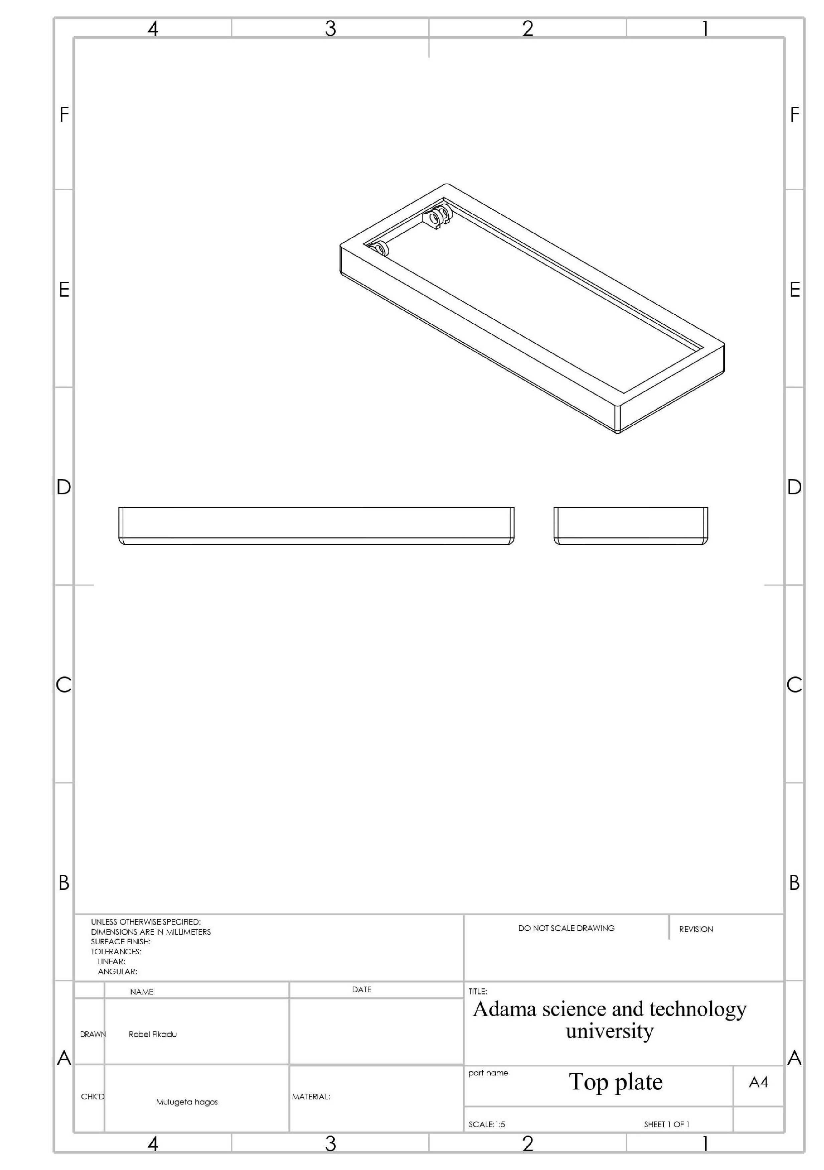

**5.2**

**drawing of arm**

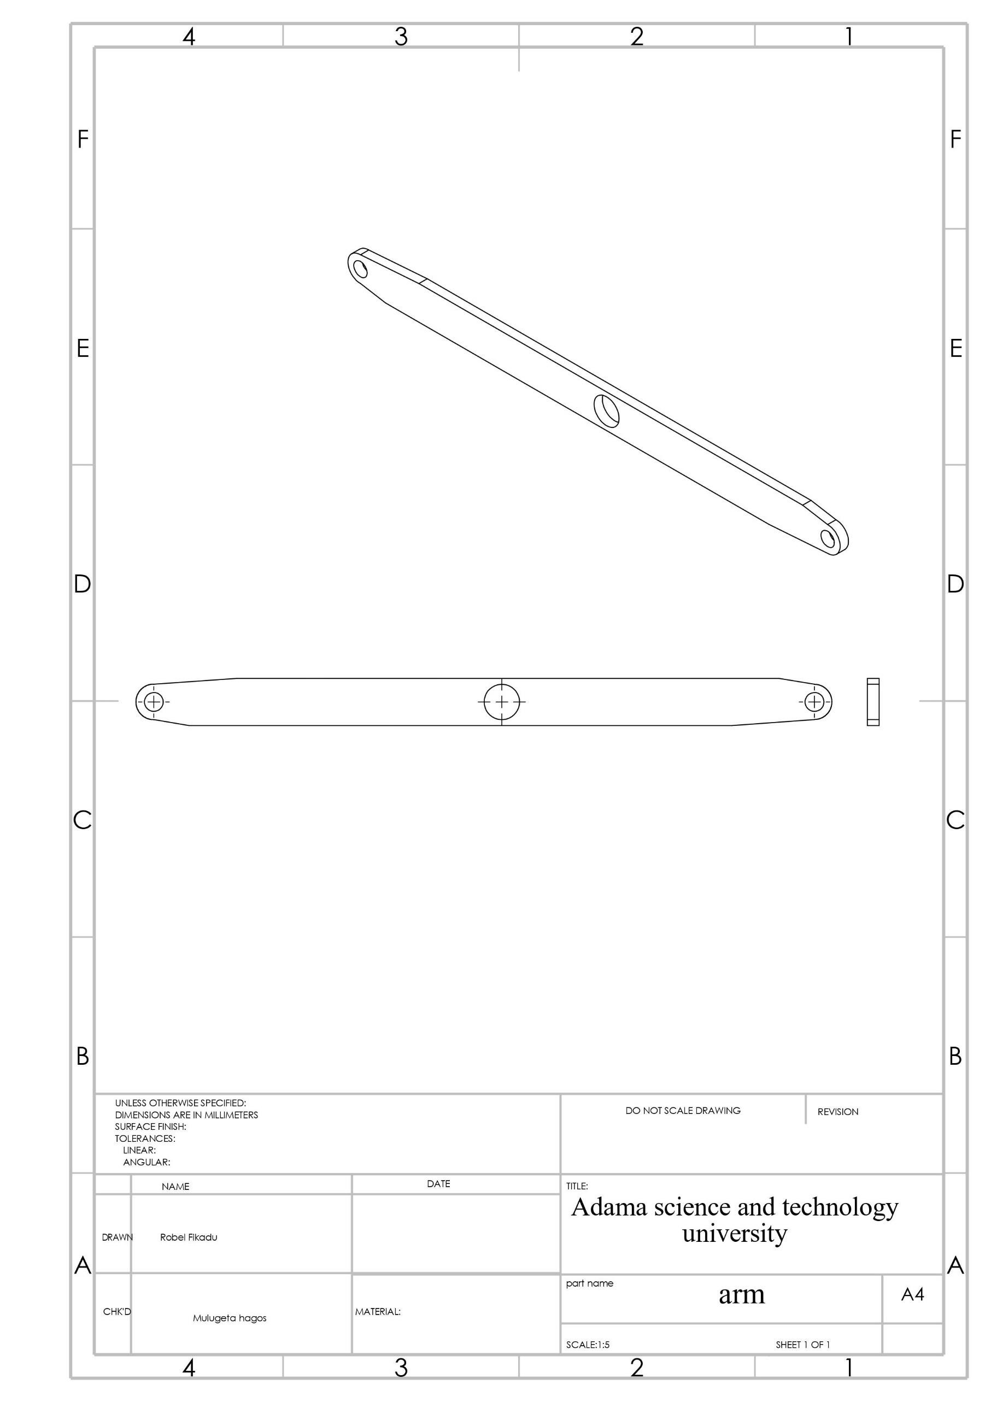

**5.3**

**drawing of pin**

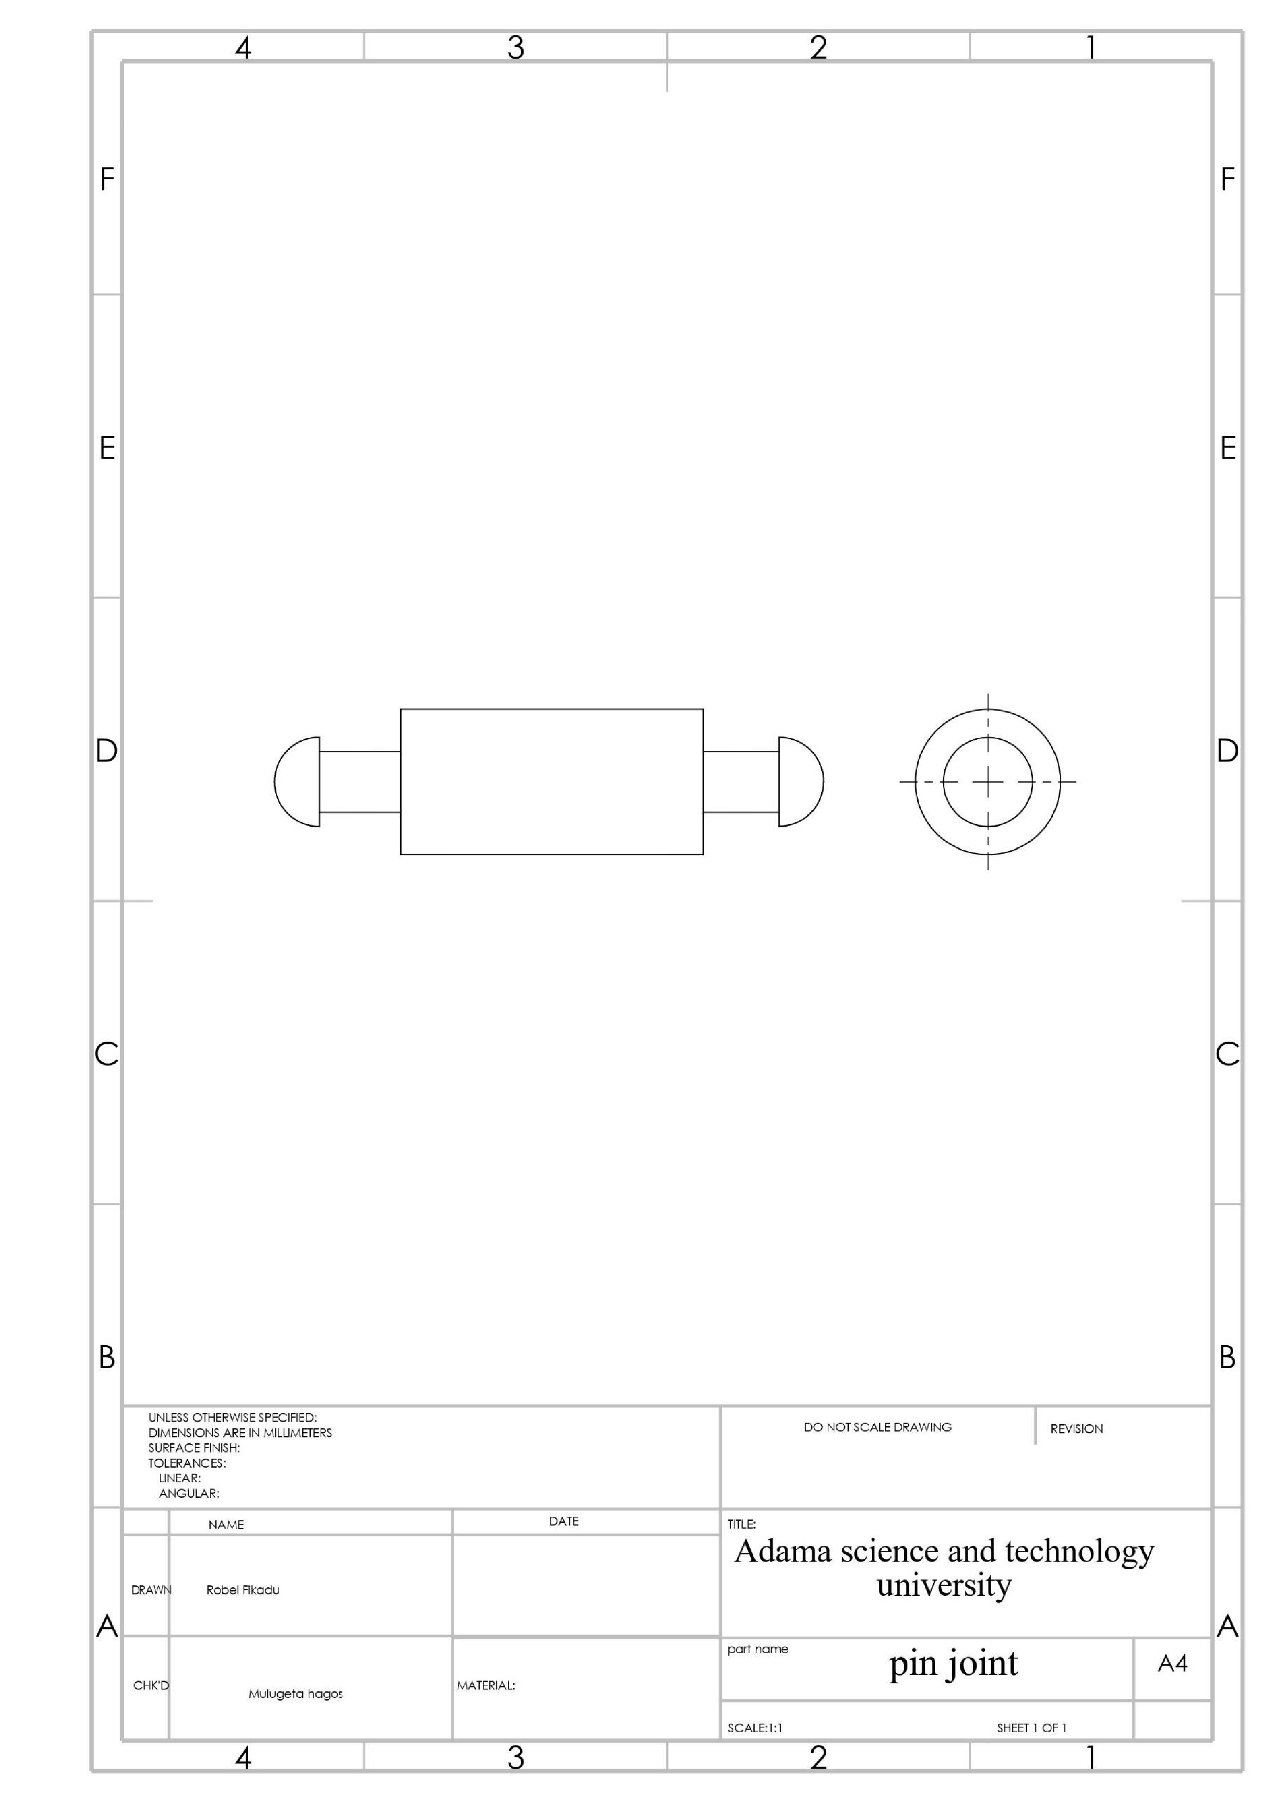

**5.4**

**drawing of plunger cylinder**

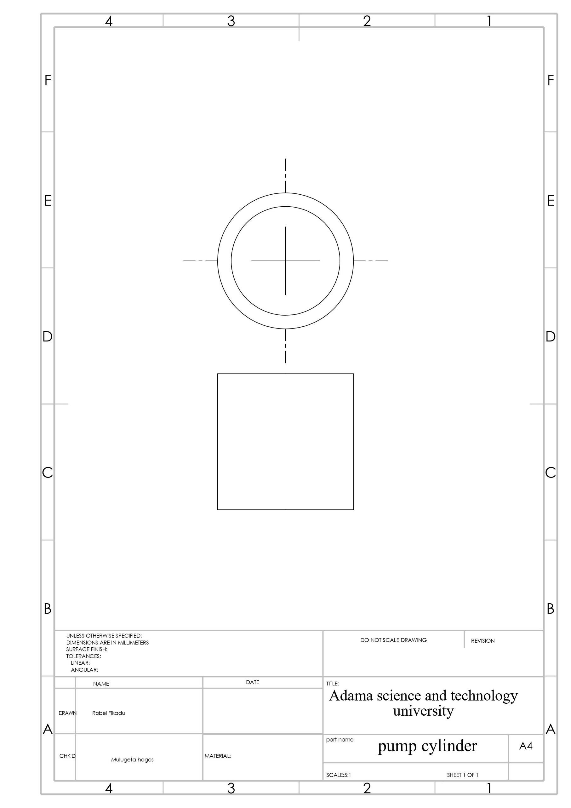

**5.5**

**drawing of ram cylinder**

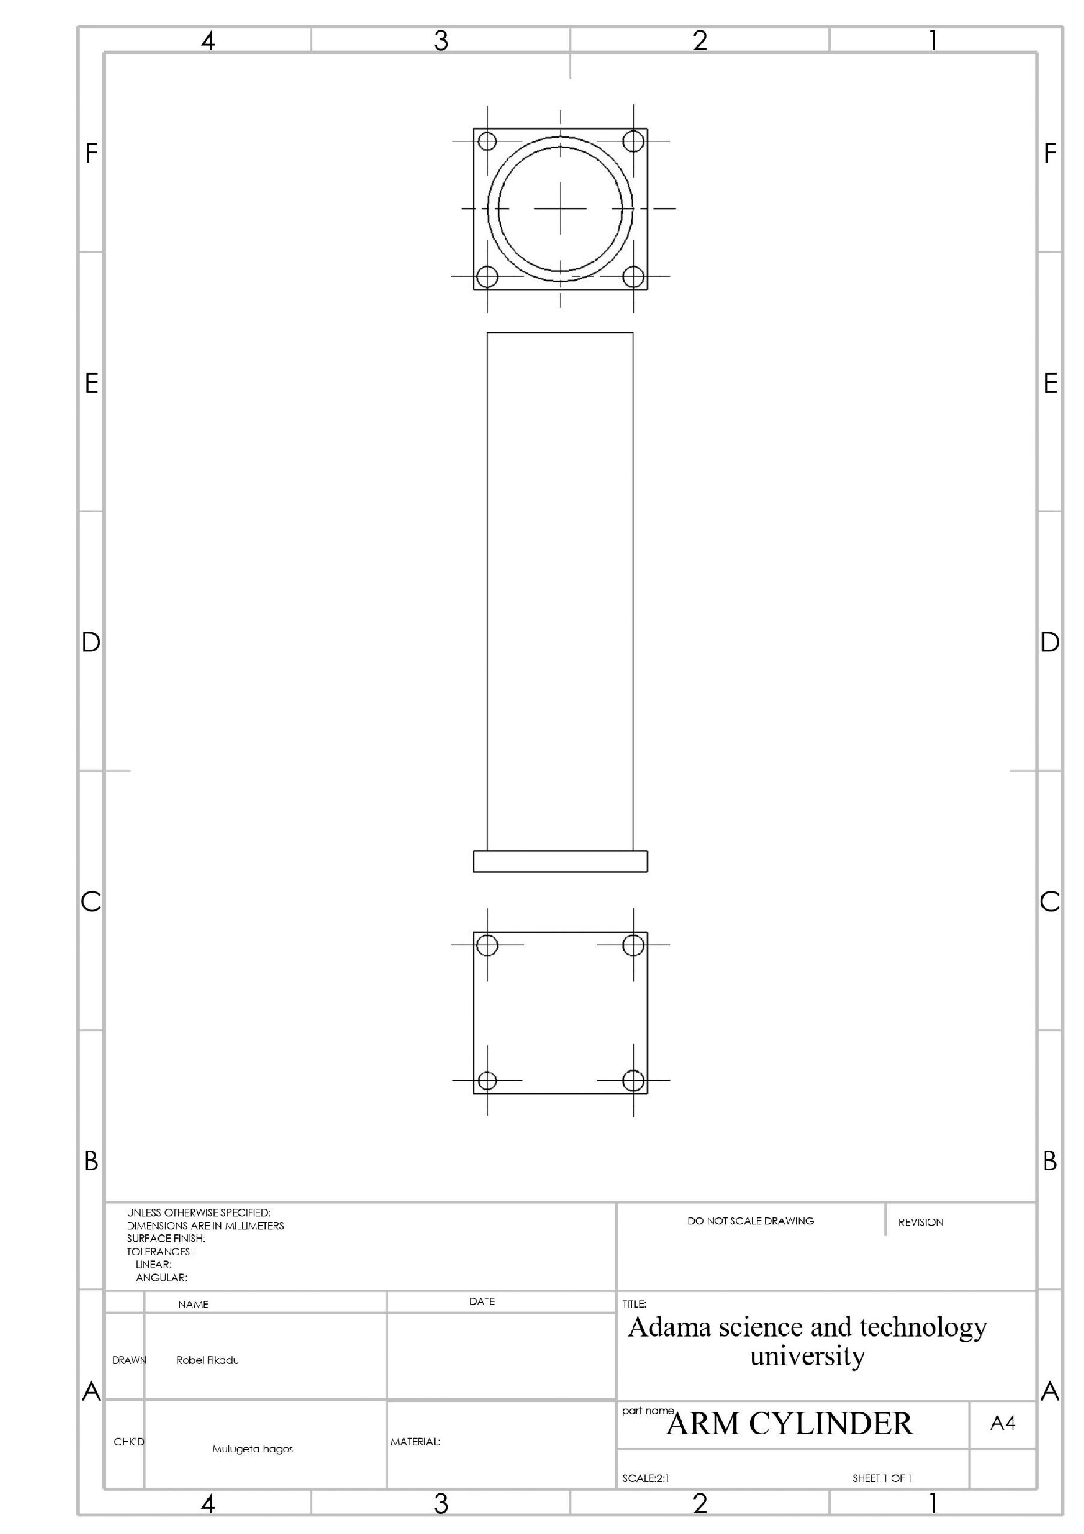

**5.6**

**drawing of piston rod for plunger**

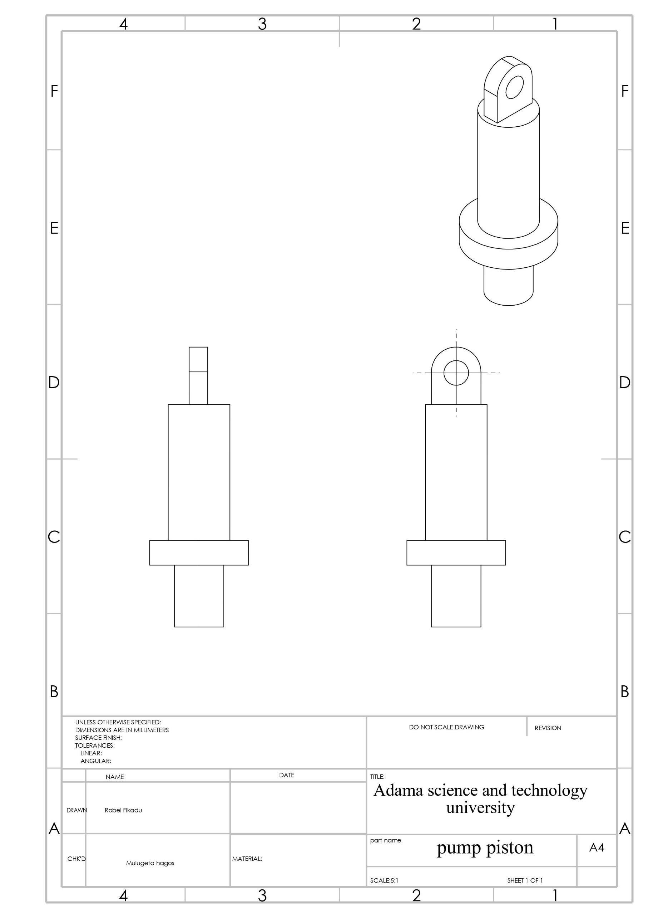

**5.7**

**Drawing of ram piston rod**

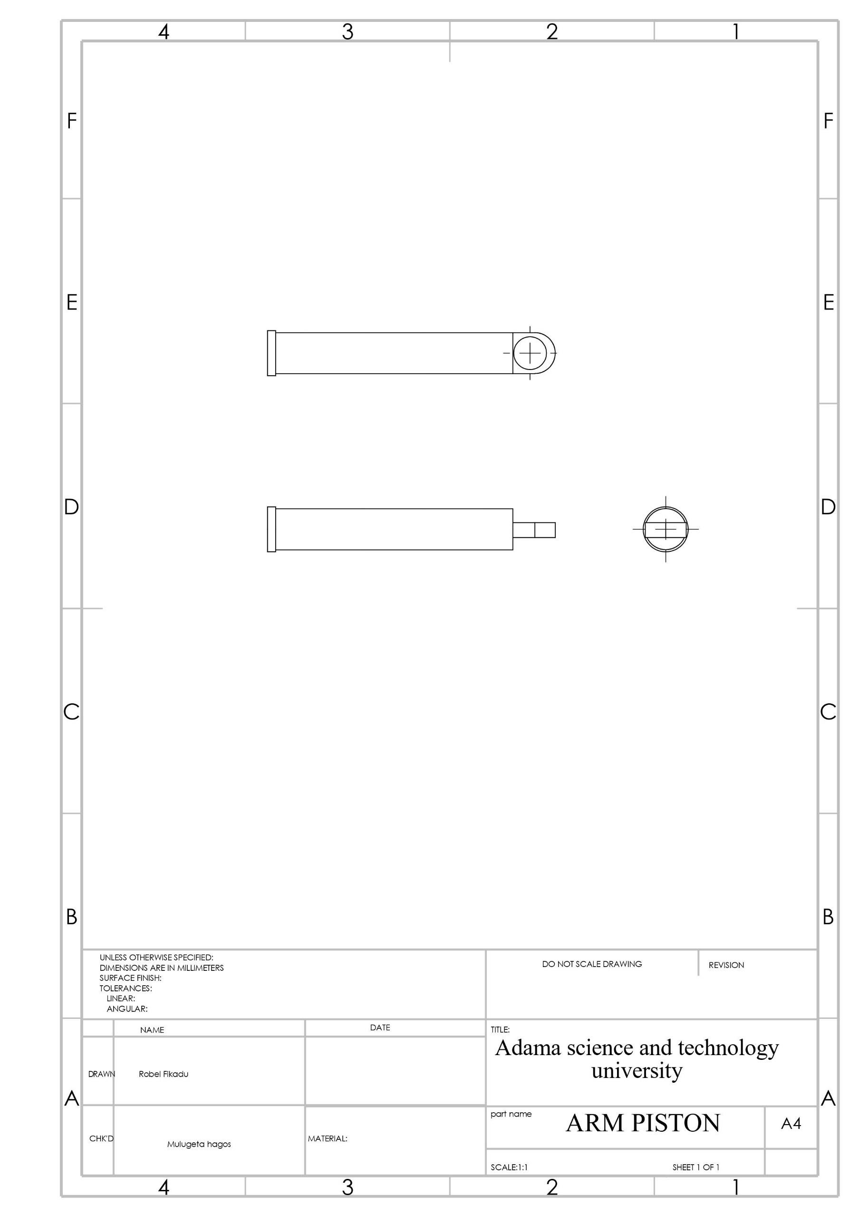

**5.8**

**drawing of reservoir**

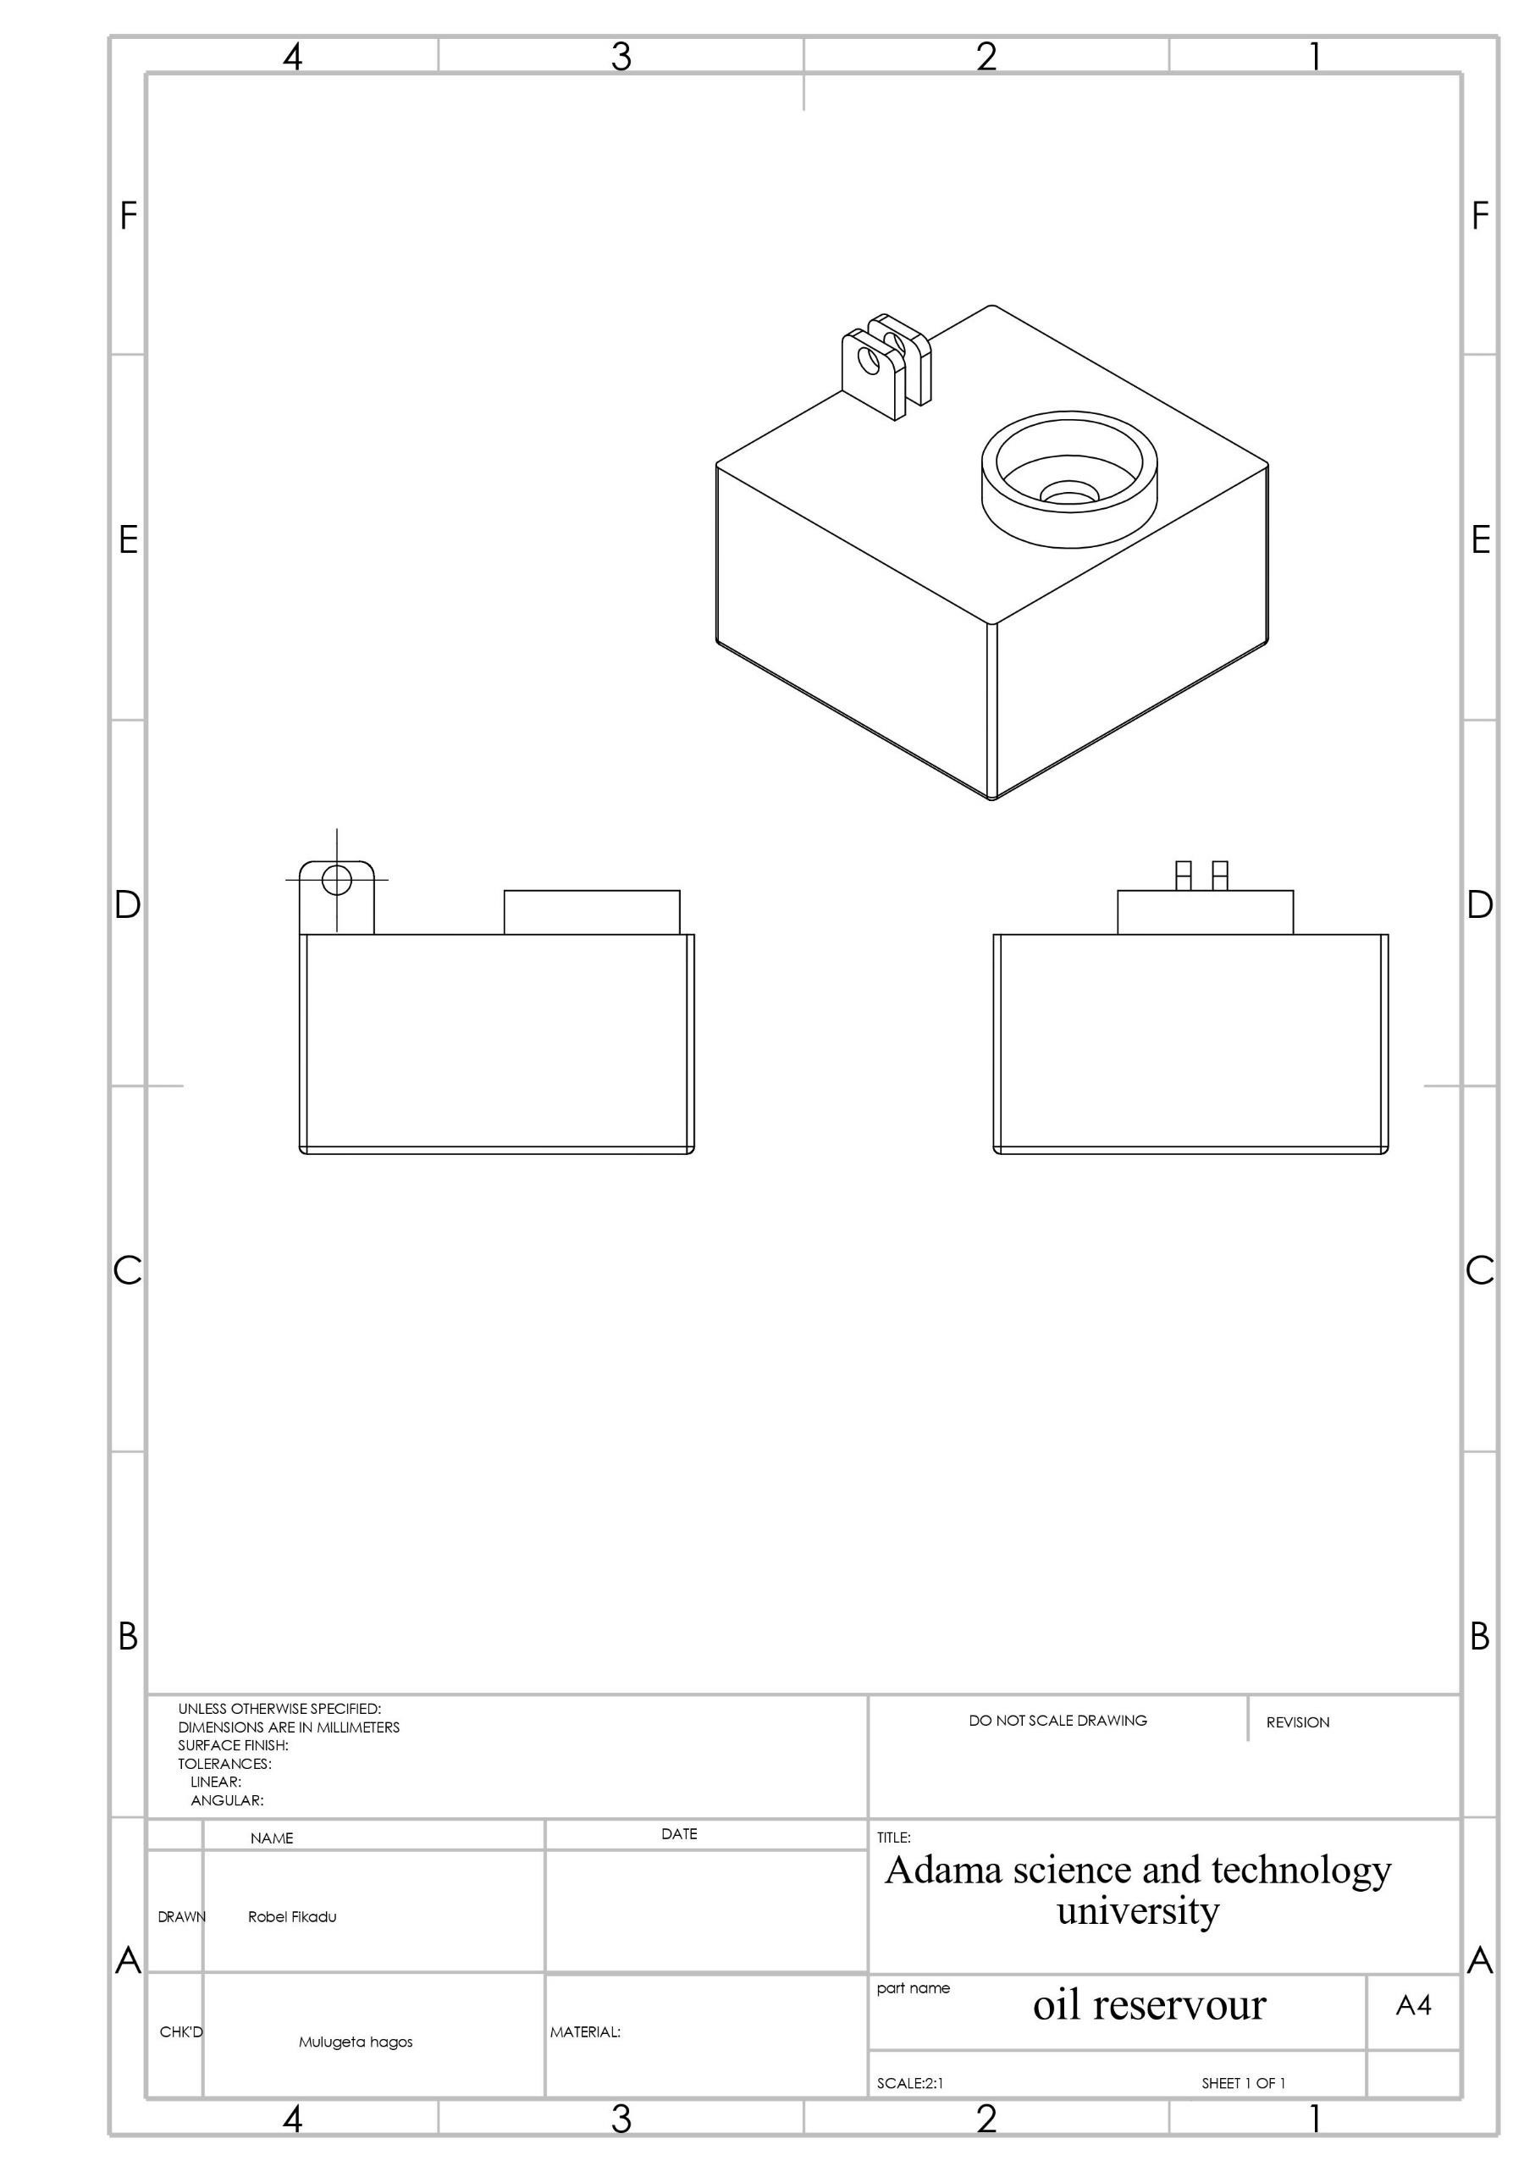

**5.9**

**drawing of spring**

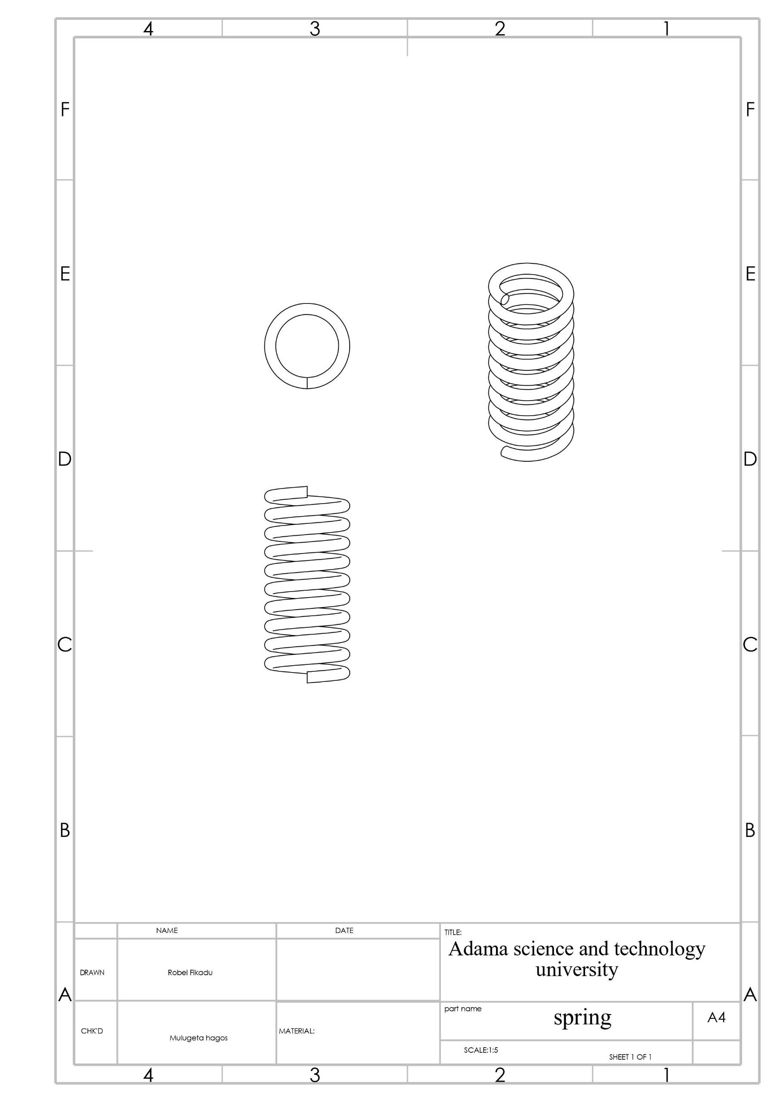

**5.10**

**drawing of valve**

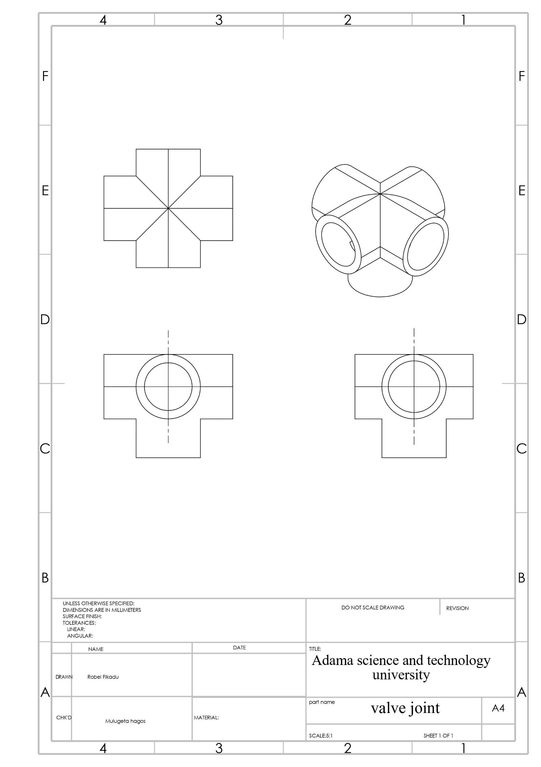

**5.11**

**valve support**

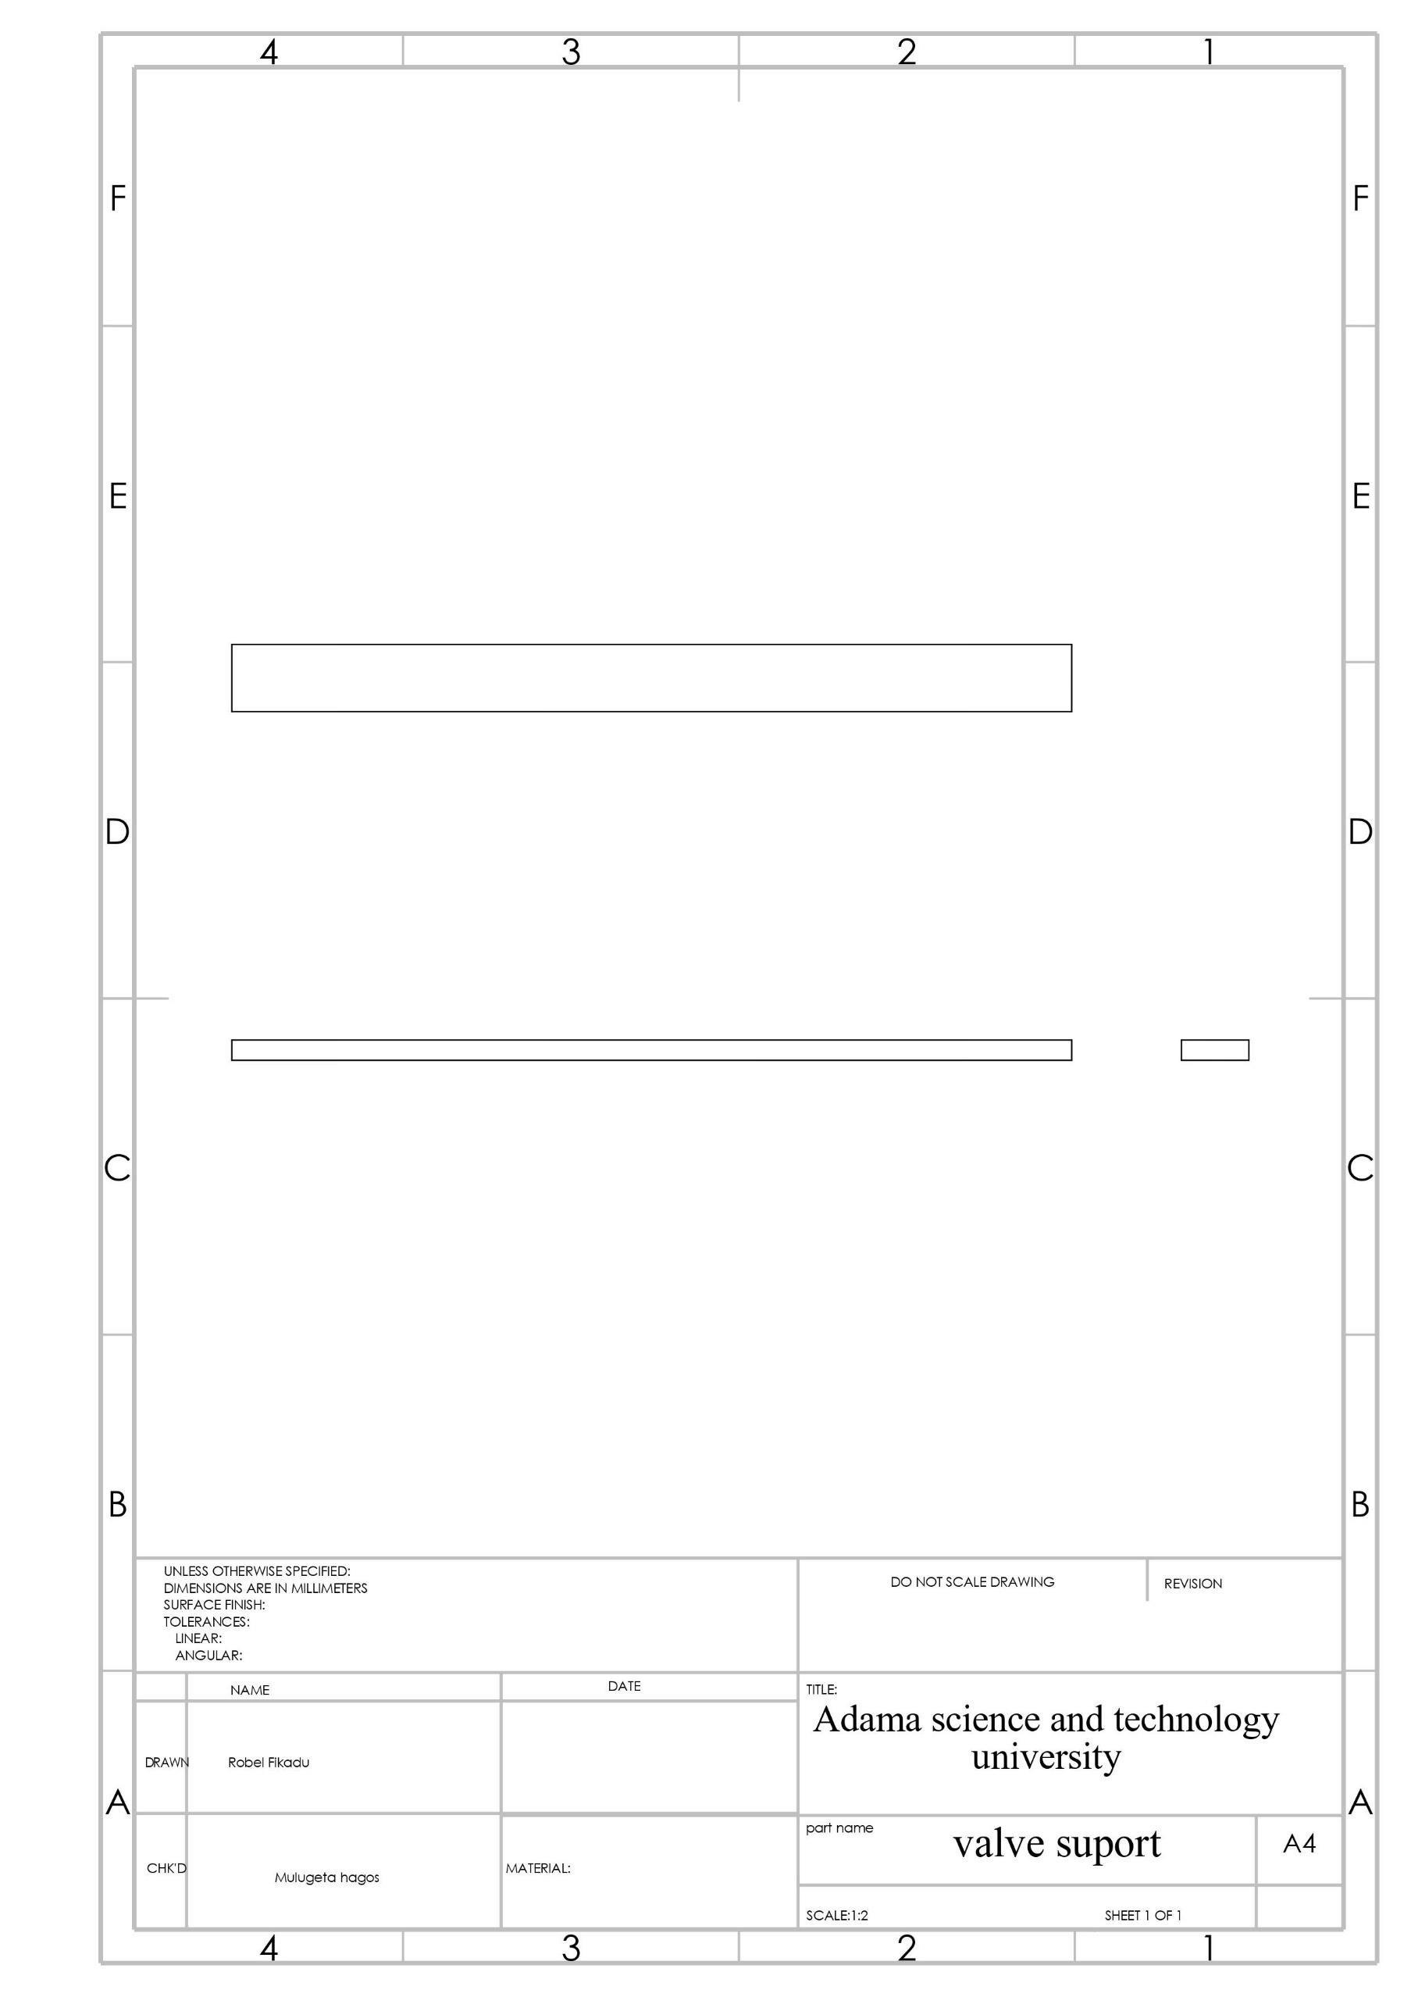

**5.12**

**drawing**

**of base plate**

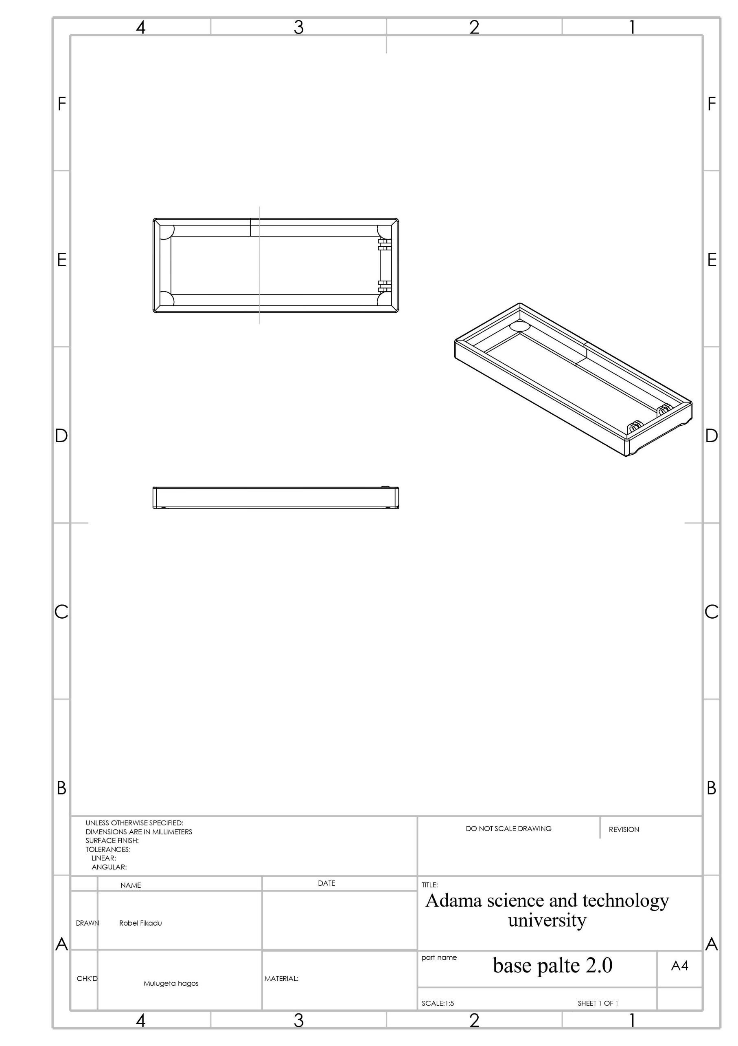

**5.13**

**ram cylinder for leg**

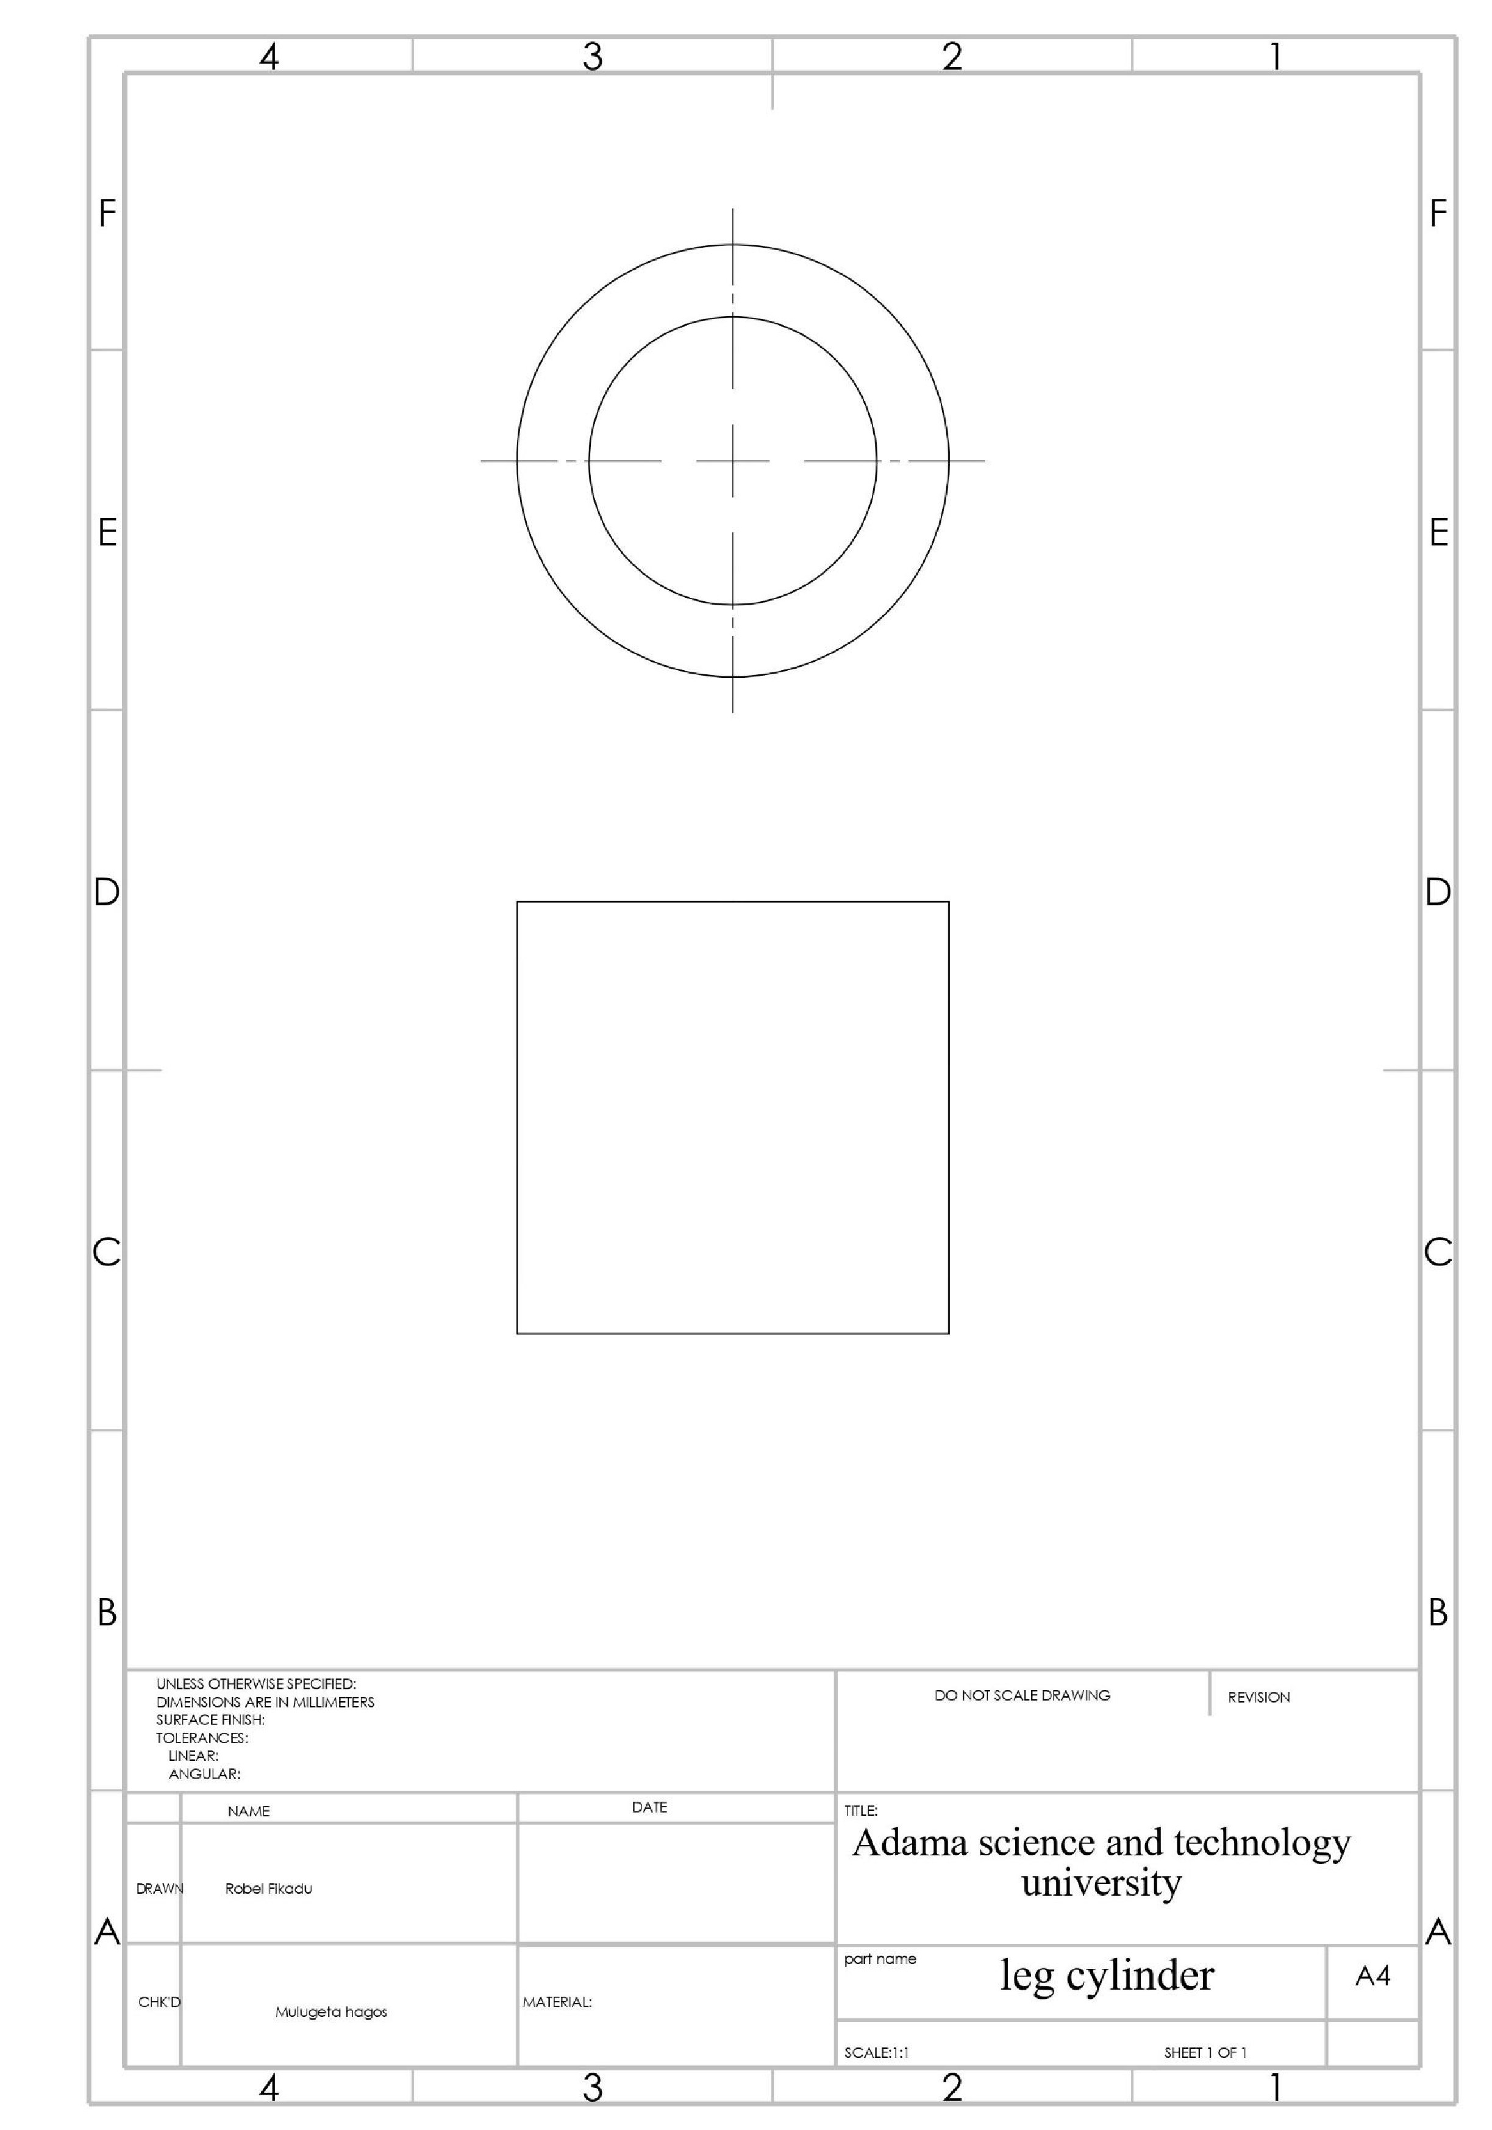

**5.14**

**drawing of piston for leg**

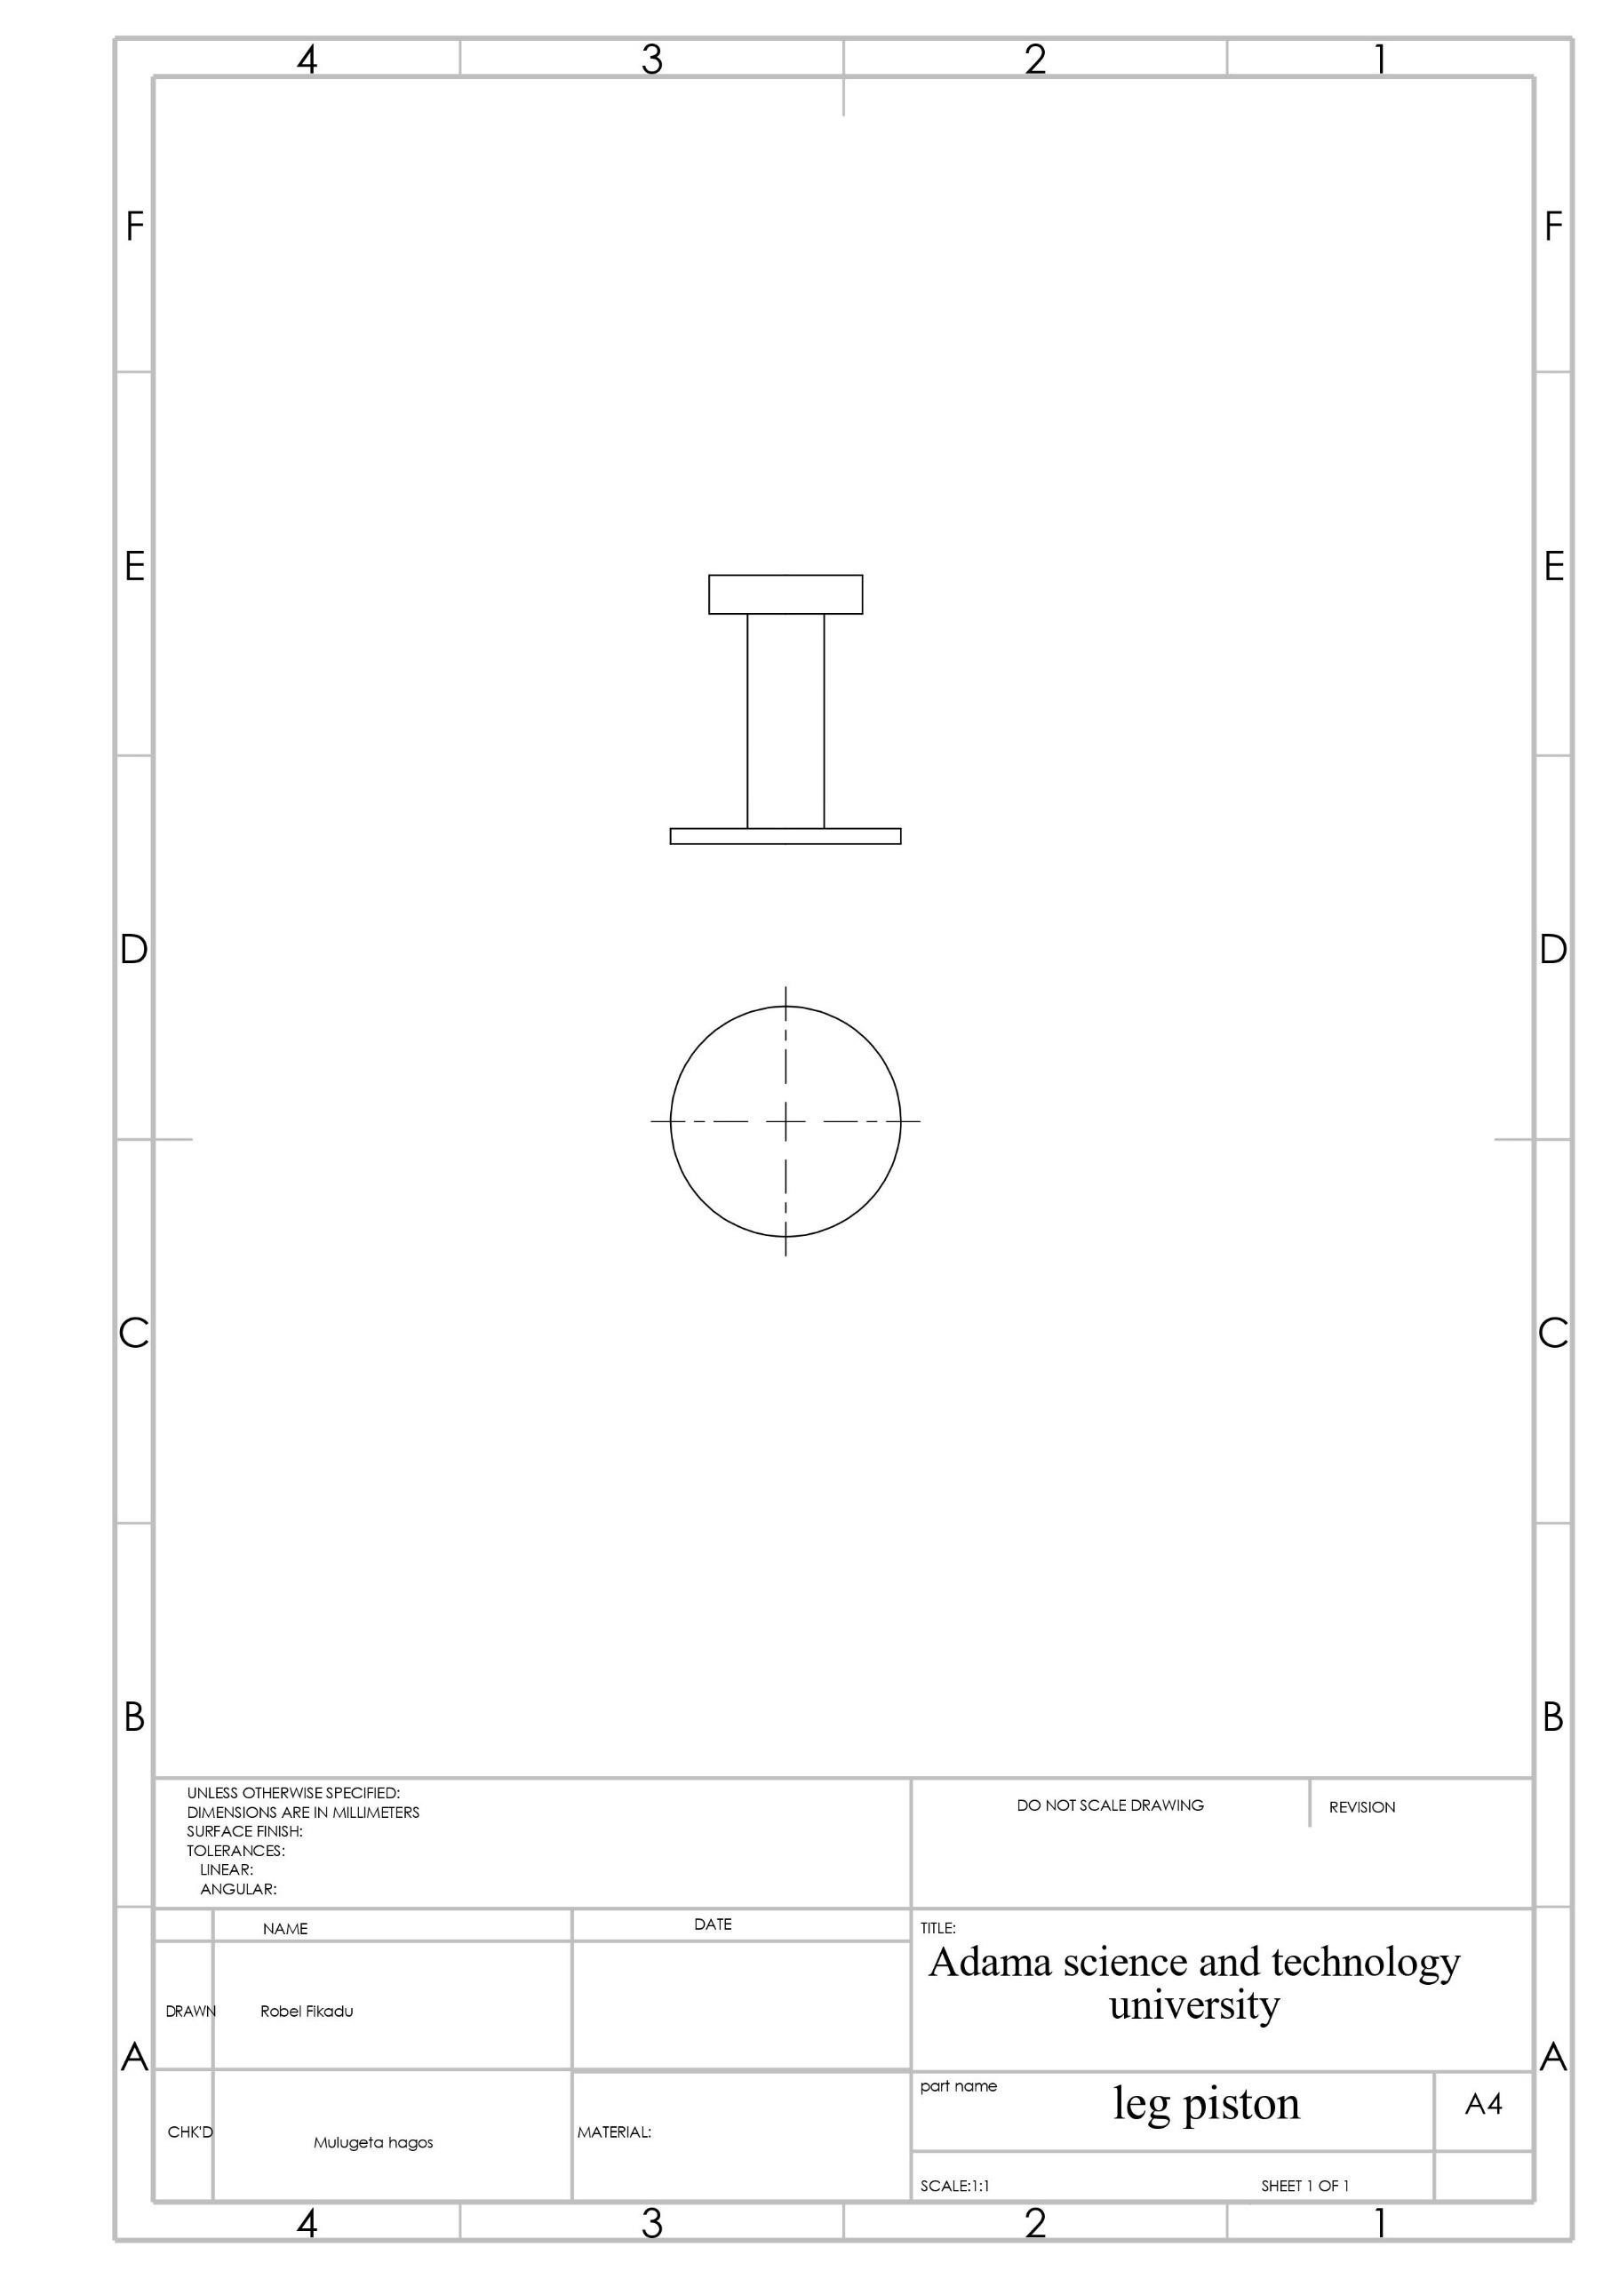

**5.1**

**5**

**drawing of handle**

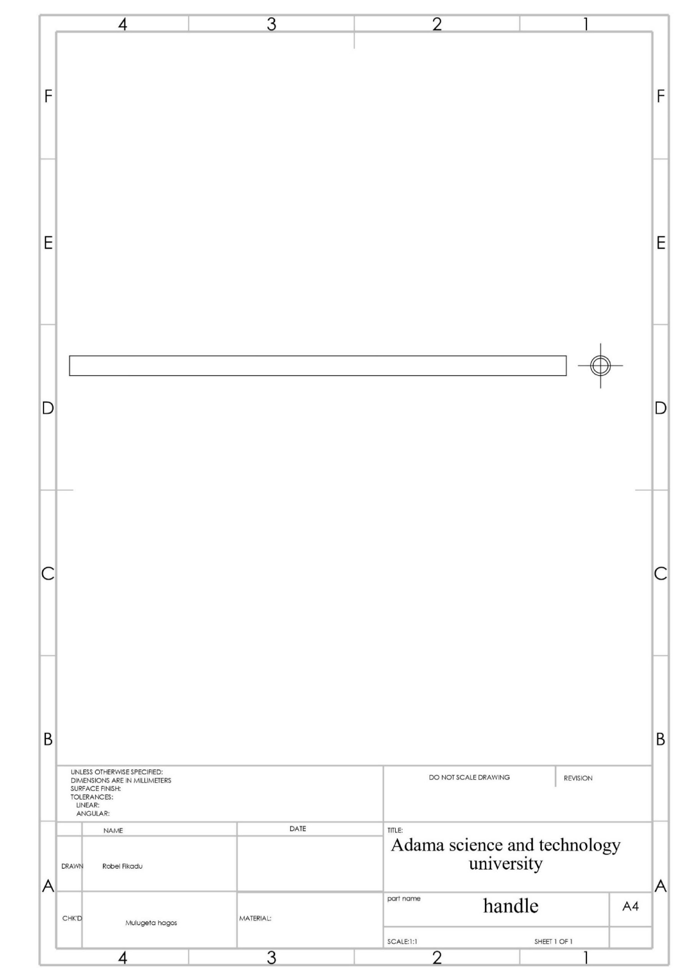

# Chapter 6

## Hydraulic Scissor Jack Assembley

**6.1**

**assembly view drawing**

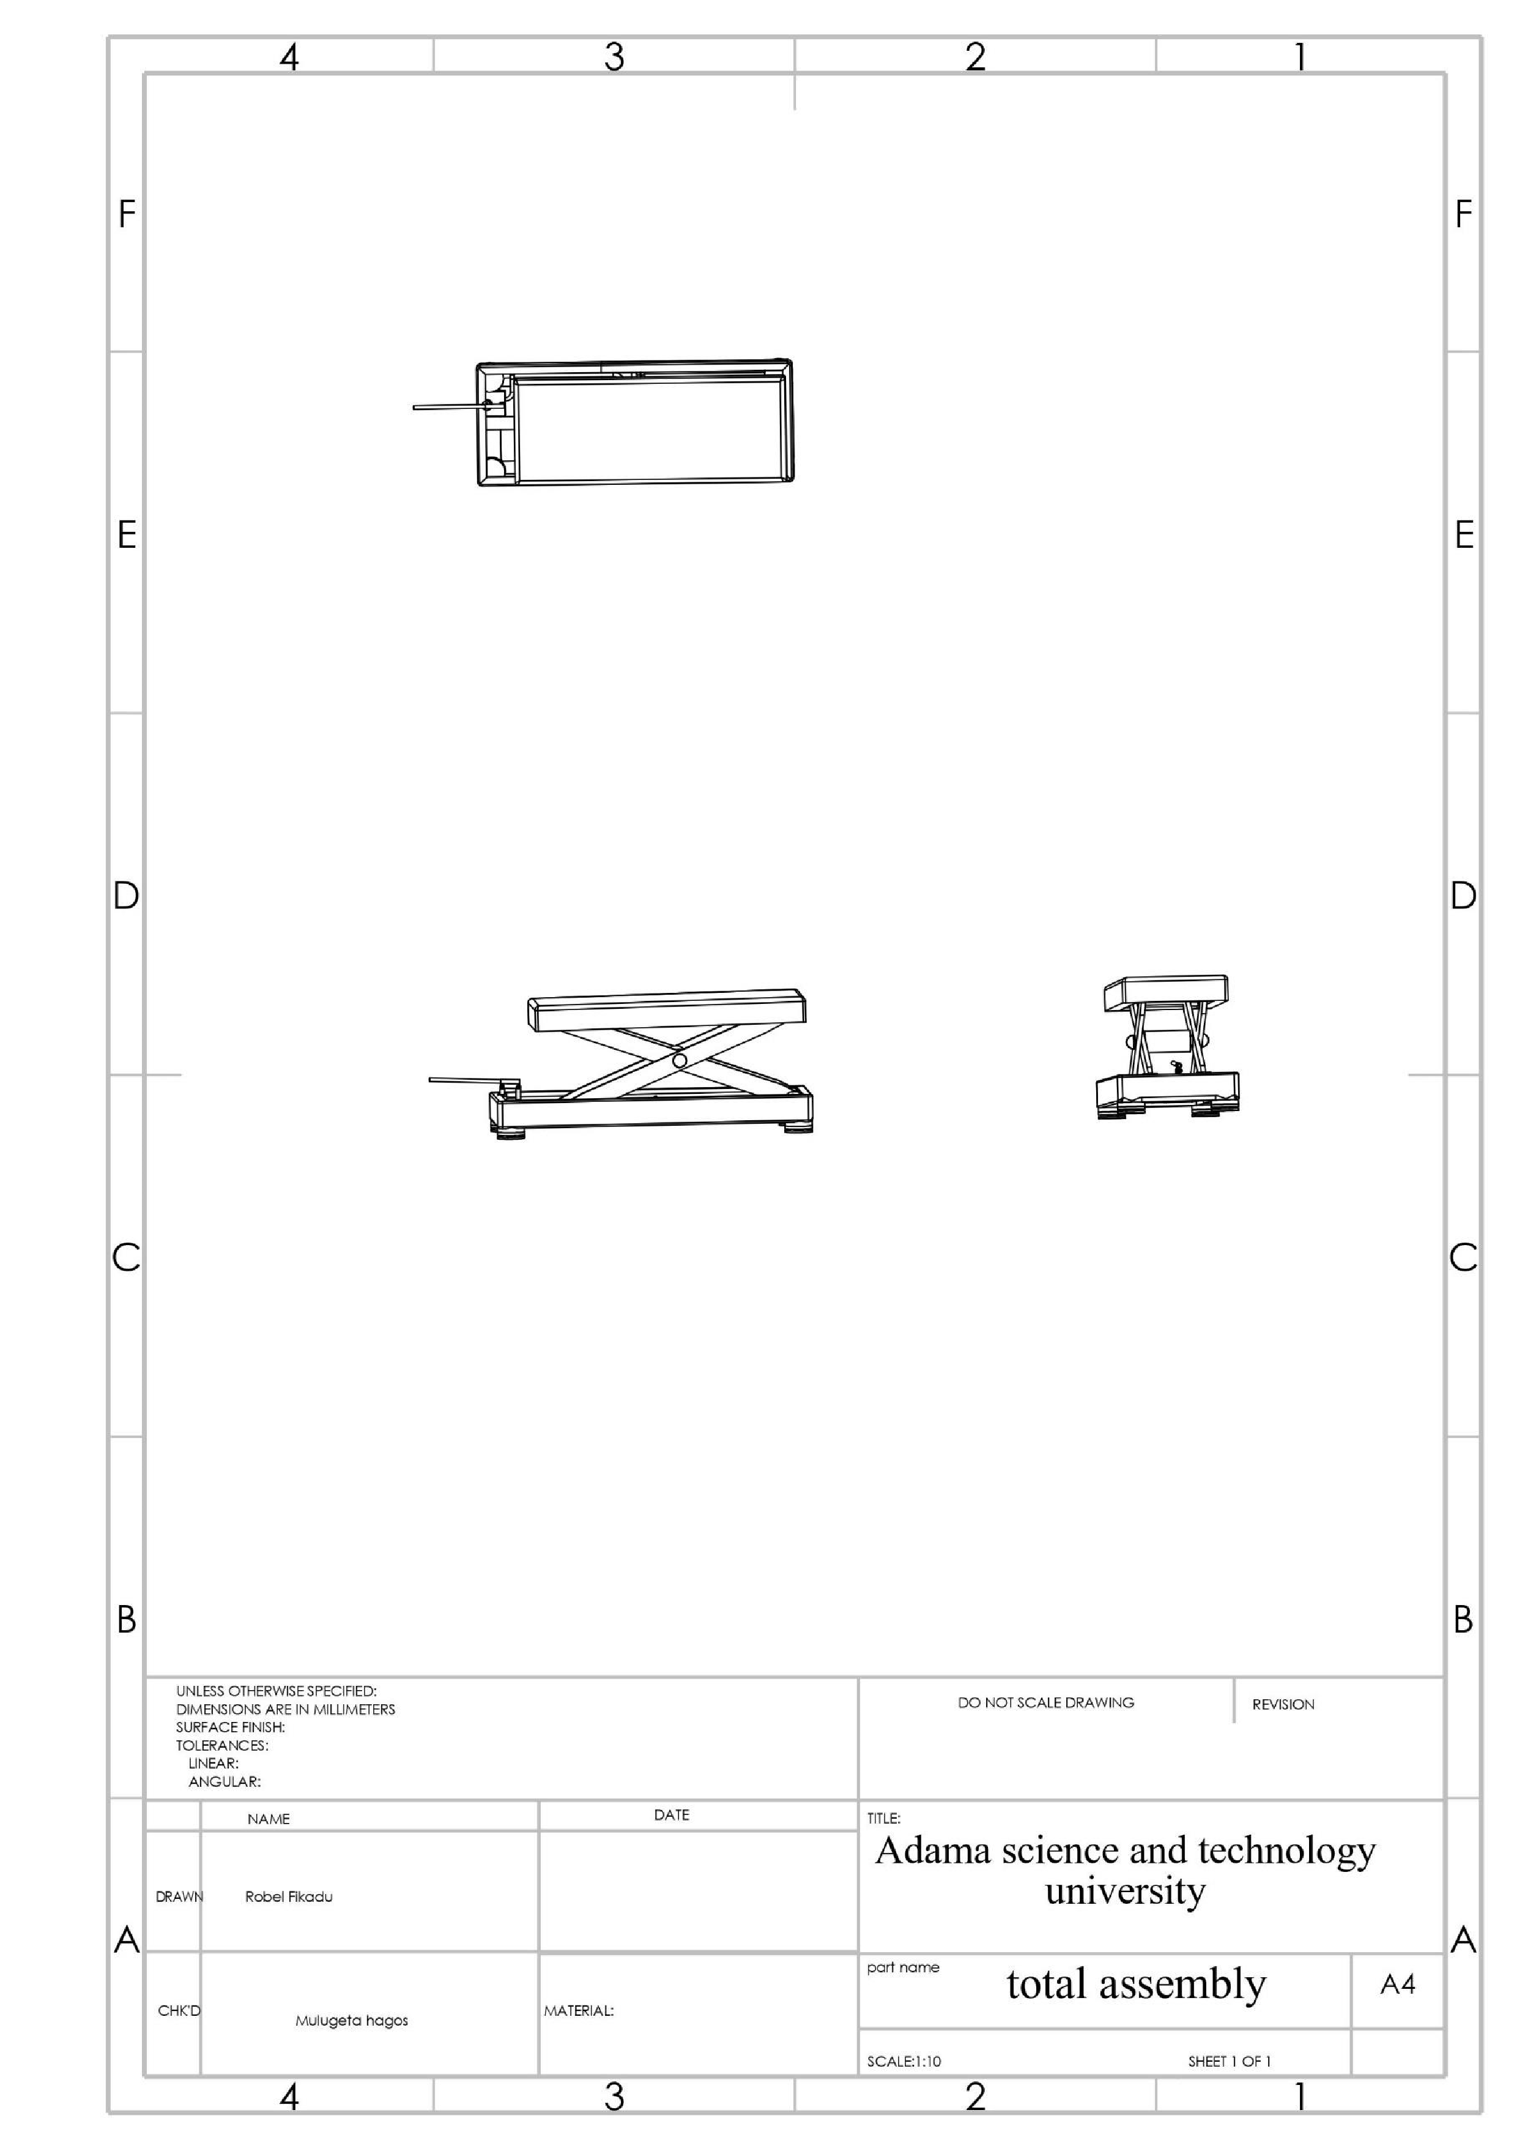

**6.2**

**assembly**

**pictorial**

**drawing**

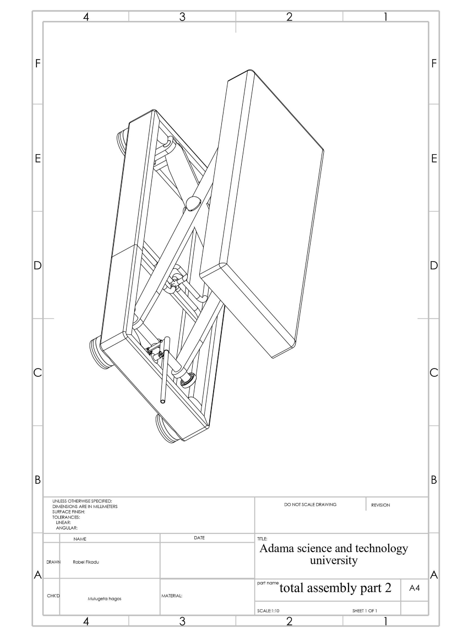

# Conclusion

The project was carried out successfully according to the project plan. The outcome of the hydraulic scissors lift design meets the objective of the project. As a result, the project designed the electro-hydraulic parallelogram lift. The general section described the classification, purpose and technical characteristics of the lift, and the mechanism and operation principle of the designed lift.

In the design section, the lift calculation is done, where the forces acting in the cylinder and emerging stresses in the system were calculated. A 3D model was created.

After completed this project, I have gained some skills and knowledge in this field. I have learnt many things in terms of utilizing engineering mechanisms in a proper manner. Finally, the experience I have obtained throughout this project will certainly help me to be a creative engineer in the future.

# Reference

* R.S. khurmi j.k. gupta machine design 14th edition
* Beer & Johnston Vector Mechanics for Engineers Statics 9th edition
* Georgy Olenin,(2016) Design of hydraulic scissor lifting
* platform, Saimaa University Of Applied Sciences
* Lappeenranta
* Machine Drawing: Narayana 3rd edition
* CAD Graphic Design Guides 2nd edition
* Youtube.com/solidworks

### Code for dimensional analysis

